

DATA PROTECTION USING HYBRID ENCRYPTION AND STEGANOGRAPHY
CipherVeil: AES-256-GCM for the data, RSA-OAEP for the key, LSB steganography in a PNG for concealment
A project report submitted in partial fulfilment of the requirements for the award of the degree of
BACHELOR OF TECHNOLOGY
in
COMPUTER SCIENCE AND ENGINEERING
Submitted by
ALLAM RAKESH | 23K91A0509
BOLLEDDU SHANKER | 23K91A0543
AGARAM SRI SARVAGNA | 23K91A0506
B AKSHAY | 24K915A0504
Batch A15 (CSE-A)
Under the esteemed guidance of
RAJALAKSHMI
[DESIGNATION]
DEPARTMENT OF COMPUTER SCIENCE AND ENGINEERING
TKR COLLEGE OF ENGINEERING & TECHNOLOGY (AN AUTONOMOUS INSTITUTION)
Medbowli, Meerpet, Balapur, Hyderabad, Telangana - 500 097
Academic year [ACADEMIC YEAR]

CERTIFICATE
This is to certify that the project report entitled "Data Protection Using Hybrid Encryption and Steganography" is a bonafide record of the work carried out by ALLAM RAKESH (23K91A0509), BOLLEDDU SHANKER (23K91A0543), AGARAM SRI SARVAGNA (23K91A0506), B AKSHAY (24K915A0504), in partial fulfilment of the requirements for the award of the degree of Bachelor of Technology in Computer Science and Engineering, during the academic year [ACADEMIC YEAR], under my supervision.

Project Guide | Head of the Department | Principal
Rajalakshmi | [HOD NAME] | [PRINCIPAL NAME]
[DESIGNATION] | Department of Computer Science and Engineering | TKR College of Engineering & Technology

External Examiner: [NAME AND SIGNATURE]
Place: [PLACE]
Date: [DATE]

DECLARATION
We hereby declare that the project report entitled "Data Protection Using Hybrid Encryption and Steganography", submitted to the Department of Computer Science and Engineering, TKR College of Engineering & Technology, in partial fulfilment of the requirements for the award of the degree of Bachelor of Technology in Computer Science and Engineering, is a record of original work carried out by us under the guidance of Rajalakshmi, [DESIGNATION]. The results embodied in this report have not been submitted to any other university or institution for the award of any degree or diploma.

ALLAM RAKESH 23K91A0509
BOLLEDDU SHANKER 23K91A0543
AGARAM SRI SARVAGNA 23K91A0506
B AKSHAY 24K915A0504

Place: [PLACE]
Date: [DATE]

ACKNOWLEDGEMENT
We express our sincere gratitude to our project guide, Rajalakshmi, [DESIGNATION], for valuable guidance, encouragement and constructive suggestions throughout this project.
We thank [HOD NAME], Head of the Department of Computer Science and Engineering, for providing the facilities and support needed to complete this work, and [PRINCIPAL NAME], Principal, TKR College of Engineering & Technology, for the encouragement given to us.
We thank the project coordinators and all faculty and staff members of the department for their help, and our families and friends for their constant support.
We also acknowledge the authors of the base paper and of the supporting papers, the maintainers of the open-source software used in this project (Python, FastAPI, SQLAlchemy, the cryptography library, Pillow, NumPy, scikit-image, matplotlib, React, Vite, Tailwind CSS, Recharts, pytest and Playwright), and the providers of the public-domain and CC0 sample images shipped with scikit-image.

ALLAM RAKESH
BOLLEDDU SHANKER
AGARAM SRI SARVAGNA
B AKSHAY

ABSTRACT
Encryption protects the content of a message but shows that a secret is moving; hiding conceals the message but protects nothing once it is found. This project builds CipherVeil, which combines both: a file is encrypted with a fresh AES-256-GCM key, the key is wrapped with the receiver's RSA public key (OAEP, SHA-256), and the resulting bundle is hidden in the least significant bits of a PNG image. The receiver extracts the bundle, unwraps the key, verifies the authentication tag and recovers the file byte for byte. A FastAPI and React application provides key management, analysis, robustness and benchmark views.
On six cover images the file was restored exactly in 22 of 22 runs, with PSNR from 52.5 to 74.6 dB, SSIM of at least 0.9958 and a capacity of 3.0 bits per pixel; a closed-form model predicts PSNR within 0.053 dB, and all 240 single-bit tamper trials were rejected. The payload survives only lossless handling (5 of 18 attacks), and chi-square steganalysis flagged all 30 embedded prefixes, so the hiding is imperceptible but not undetectable. 39 tests pass. The base paper's homomorphic computation and provable security are not implemented.
Keywords: hybrid encryption, AES-GCM, RSA-OAEP, steganography, LSB, data security, information hiding, PSNR, SSIM, secure communication.

TABLE OF CONTENTS
CERTIFICATE i
DECLARATION ii
ACKNOWLEDGEMENT iii
ABSTRACT iv
TABLE OF CONTENTS v
LIST OF FIGURES viii
LIST OF TABLES x
LIST OF ABBREVIATIONS xi
CHAPTER 1: INTRODUCTION 1
1.1 Domain Overview 1
1.2 Background and Motivation 1
1.3 Problem Statement 2
1.4 Need for the Project 3
1.5 Objectives 3
1.6 Scope 4
1.7 Contributions 5
1.8 Limitations and Assumptions 6
1.9 Organisation of the Report 6
CHAPTER 2: LITERATURE SURVEY 7
2.1 Overview 7
2.2 Base Paper Analysis 7
2.3 Related Work by Theme 10
2.4 Datasets and Algorithms Used 12
2.5 Strengths and Limitations of Existing Work 13
2.6 Research Gap 14
2.7 Summary 14
CHAPTER 3: FEASIBILITY STUDY 15
3.1 Introduction 15
3.2 Technical Feasibility 15
3.3 Economic Feasibility 16
3.4 Operational Feasibility 16
3.5 Schedule Feasibility 17
3.6 Advantages and Constraints 17
CHAPTER 4: SYSTEM REQUIREMENTS AND ANALYSIS 18
4.1 Introduction 18
4.2 Existing System and Its Limitations 18
4.3 Proposed System and Its Advantages 18
4.4 Functional Requirements 19
4.5 Non-Functional Requirements 19
4.6 Hardware Requirements 20
4.7 Software Requirements 20
4.8 User Roles and Constraints 20
4.9 Requirements Traceability 20
4.10 Summary 21
CHAPTER 5: SYSTEM DESIGN 22
5.1 Design Goals and Architecture 22
5.2 High-Level Workflow and Core Algorithm 23
5.3 Data Flow Diagrams 25
5.4 UML Design 27
5.5 Data Design 29
5.6 Module Design 30
5.7 API Design 30
5.8 Security Design 31
5.9 User Interface Design 31
5.10 Design Decisions and Alternatives 33
5.11 Summary 33
CHAPTER 6: METHODOLOGY AND SOFTWARE IMPLEMENTATION 34
6.1 Overall methodology 34
6.2 Data 35
6.3 Preprocessing 36
6.4 Algorithm choice and justification 36
6.5 Mathematical formulation 37
6.6 Pipeline architecture 40
6.7 Application architecture 41
6.8 API design 42
6.9 Security and error handling 43
6.10 Installation and execution 44
CHAPTER 7: SYSTEM TESTING 45
7.1 Testing strategy 45
7.2 Unit tests 45
7.3 Integration testing 46
7.4 Functional testing 46
7.5 Security testing 47
7.6 Validation and edge cases 49
7.7 Performance testing 49
7.8 User acceptance 51
7.9 Limits of the testing done 52
CHAPTER 8: RESULTS AND OUTPUT SCREENS 53
8.1 Experimental set-up 53
8.2 Output screens 54
8.2.1 Keys 54
8.2.2 Send 55
8.2.3 Analysis 56
8.2.4 Receive 57
8.2.5 Robustness and benchmark 57
8.2.6 Operation log 58
8.3 Core evaluation: imperceptibility, capacity and speed 58
8.4 Fill-ratio study and the closed-form PSNR model 60
8.5 Key size, stage timings and API latency 61
8.6 What encryption adds to the embedded bits 63
8.7 Robustness: what survives 64
8.8 Steganalysis and tamper evidence 65
8.9 Comparison with the base paper and the supporting papers 67
8.10 Sample inputs and outputs 69
8.11 Success and failure analysis 69
8.12 Limitations of these results 70
8.13 Objectives against outcomes 71
CHAPTER 9: CONCLUSION 72
9.1 Summary of the work 72
9.2 Objectives achieved 72
9.3 Key findings 72
9.4 Practical applications 73
9.5 Known limitations 73
9.6 Lessons learned 73
9.7 Concluding remarks 73
CHAPTER 10: FUTURE SCOPE 74
10.1 Improvements to the existing system 74
10.2 Additional features 74
10.3 Scalability and deployment 74
10.4 Further research 75
REFERENCES 76
APPENDIX A: IMPORTANT CODE 78
A.1 Hybrid encryption: building and opening the bundle (`crypto.py`) 78
A.2 LSB embedding and extraction (`lsb.py`) 78
A.3 Send and receive pipeline (`pipeline.py`) 79
A.4 Imperceptibility measures (`metrics.py`) 79
A.5 Robustness attack runner (`robustness.py`) 79
A.6 Database models (`db.py`) 80
APPENDIX B: INSTALLATION AND USER GUIDE 81
B.1 Requirements 81
B.2 One-click start 81
B.3 Starting by hand and running the checks 81
B.4 Settings (`.env`) 81
B.5 Using the application 82
B.6 Troubleshooting 82
APPENDIX C: ADDITIONAL SCREENS 83

LIST OF FIGURES
Figure 1: High-level workflow of CipherVeil: key exchange, encrypt, wrap, embed at the sender, and extract, unwrap, decrypt, verify at the receiver. 4
Figure 2: System architecture of CipherVeil: React console, FastAPI application with 24 endpoints, service layer, and the SQLite database and output files. 22
Figure 3: High-level workflow: the sender's path (encrypt, wrap, check capacity, embed, measure) and the receiver's path (extract, unwrap, verify). 23
Figure 4: Flowchart of the core algorithm: encrypt and embed, extract and decrypt, with the refusal branches. 24
Figure 5: Layout of the CVL1 bundle that is hidden in the image, and its position in the LSB stream. 24
Figure 6: Data flow diagram, level 0: the user, the cover and payload files and the receiver exchange data with the CipherVeil platform. 25
Figure 7: Data flow diagram, level 1: authenticate, manage keys, encrypt and embed, extract and decrypt, analyse, attack and benchmark, and log. 25
Figure 8: Data flow diagram, level 2: process 3.0 expanded into header, AES-GCM, key wrap, capacity check, embedding and metrics. 26
Figure 9: UML class diagram: the ORM classes, the service modules, the two error classes and the FastAPI routers. 27
Figure 10: Sequence diagram of the main flow: the sender sends a file, the receiver extracts and decrypts it. 28
Figure 11: Use-case diagram with the sender, the receiver and the evaluator. 29
Figure 12: Entity-relationship diagram of the SQLite database: users, keypairs and the operation log. 29
Figure 13: Keys page: two generated RSA-3072 keypairs and one imported public-only RSA-2048 key, with fingerprints. 32
Figure 14: Send page: key, file and cover selected before the request. 32
Figure 15: Send result: stego PNG, PSNR 57.642 dB, SSIM 0.9991, 22.445 % of capacity, hash of the sent file. 32
Figure 16: Receive result: tag verified, both SHA-256 values identical, file restored. 32
Figure 17: Analysis page: PSNR, SSIM, MSE, largest change, share of values changed and capacity used. 32
Figure 18: Methodology as a pipeline: key generation, encryption, wrapping, capacity check, embedding, extraction, decryption and measurement. 35
Figure 19: Measured PSNR against the fraction of capacity used for the six covers, with the closed-form curve. 39
Figure 20: Layout of the CVL1 bundle and its placement in the least significant bits of the cover. 40
Figure 21: Flowchart of the send and receive algorithm with the points at which a request is rejected. 40
Figure 22: System architecture of CipherVeil: browser console, FastAPI application, services and storage. 42
Figure 23: Outcome of the 240 single-bit tamper trials by region of the bundle. 48
Figure 24: Median time of each stage of the pipeline for the evaluated payload sizes. 50
Figure 25: Key generation and private-key operation time at 2048, 3072 and 4096 bits. 50
Figure 26: Median API latency of the main calls. 51
Figure 27: Output screen: Keys. Two generated RSA-3072 keypairs (Receiver key, Spare key) and one imported public-only RSA-2048 partner key, each with its fingerprint and download actions. 54
Figure 28: Output screen: Send, before the run. Receiver key, confidential_memo.pdf (21.0 KiB) and the astronaut cover (holds 96.0 KiB) are selected; the capacity estimate is shown before anything is sent. 55
Figure 29: Output screen: Send result. The stego PNG with PSNR 57.642 dB, SSIM 0.9991, 22.445 % of the cover used (0.67331 bits per pixel), the SHA-256 of the file and the per-stage timings. 55
Figure 30: Output screen: Analysis. PSNR 57.642 dB, SSIM 0.999054, MSE 0.111911, largest change 1 / 255, 11.1911 % of values changed (88,010 of 786,432), cover and stego side by side. 56
Figure 31: Output screen: Analysis, histograms of cover and stego per colour channel. 56
Figure 32: Output screen: Analysis, bit planes 0, 1 and 7 of the red channel, cover and stego. 56
Figure 33: Output screen: Receive. The file is restored byte for byte, the AES-GCM tag is verified, and the SHA-256 recorded at send time equals the SHA-256 of the restored file. 57
Figure 34: Output screen: Robustness, the nine attacks with their verdict and LSB error rate. 57
Figure 35: Output screen: Robustness, LSB error-rate chart and the plain-language verdict. 57
Figure 36: Output screen: capacity per cover, 14.6 KiB (200 x 200) to 337.5 KiB (1280 x 720), 3.0 bits per pixel. 58
Figure 37: Output screen: speed and quality benchmark rows (RSA-2048), including a row blocked by the capacity check. 58
Figure 38: Output screen: operation log of the session (login, key generate and import, sends, receives, robustness, benchmark; failed operations in red). 58
Figure 39: Output screen: log detail of one send, with sizes, timings, quality and key fingerprint but no key material. 58
Figure 40: Maximum hidden bundle per cover: capacity is proportional to the pixel count at 3.0 bits per pixel. 60
Figure 41: Measured PSNR against fill ratio for the six covers, with the closed-form model; the 50 dB line marks the usual limit of visibility. 61
Figure 42: Measured SSIM against fill ratio for the six covers. 61
Figure 43: Absolute difference between cover and stego, amplified, for the 22 % fill of the Send screen: the changes are scattered values of 1 in the rows used. 61
Figure 44: RSA key size against key-generation time, wrap time and unwrap time (median). 62
Figure 45: Median time of the four cryptographic and embedding stages for payloads of 1 to 128 KiB (RSA-3072): the unwrap dominates and everything else is below 2 ms. 62
Figure 46: API latency per call (median, with 95th percentile or maximum). 63
Figure 47: Fraction of 1-bits and byte entropy of plain files and of the encrypted bundles. 64
Figure 48: Payload recovery and LSB error rate for the 18 attacks over the six covers. 65
Figure 49: Chi-square p-value and weighted-stego estimate against the true fill, for cover and stego images. 66
Figure 50: Outcome of 240 single-bit flips by bundle field: every flip is rejected. 67
Figure 51: PSNR range reported for SCReedSolo and measured for CipherVeil. Covers and payloads differ, so the bars indicate order of magnitude only. 68
Figure 52: Failure case: a 22,063-byte bundle does not fit the 14,996-byte 200 x 200 cover; the send is refused with the exact numbers. 70
Figure 53: Failure case: receiving with the Spare keypair; the RSA unwrap fails and no data is released. 70
Figure 54: Additional screen: landing page, headline and the measured-results tiles. 83
Figure 55: Additional screen: landing page, how it works and features. 83
Figure 56: Additional screen: sign in and create account, with the demo credentials pre-filled. 83

LIST OF TABLES
Table 1: Abbreviations used in this report xi
Table 2: Objectives of the batch objectives sheet and their status 3
Table 3: The base paper and CipherVeil side by side 8
Table 4: Related work compared 12
Table 5: Strengths and limitations of the main approaches 13
Table 6: Technical risks and the measurements that addressed them 15
Table 7: Planned schedule (weeks) 17
Table 8: Advantages and constraints of the chosen approach 17
Table 9: Existing approaches and their limitations 18
Table 10: Functional requirements 19
Table 11: Non-functional requirements and how they were checked 19
Table 12: Hardware used for development and measurement 20
Table 13: Software used 20
Table 14: Objectives, requirements and verification 21
Table 15: Principal classes and modules 27
Table 16: Database schema 30
Table 17: Backend modules 30
Table 18: The 24 endpoints (all under /api; JWT required except health and auth) 30
Table 19: Main design decisions 33
Table 20: Cover images used in every experiment. 35
Table 21: Payloads used in the experiments. 35
Table 22: Algorithm choices. 36
Table 23: Measured PSNR and the closed form, averaged over the six covers (five payload seeds each). 39
Table 24: Backend modules and their responsibilities. 41
Table 25: The 24 API routes. 42
Table 26: Errors the application detects and what the user sees. 43
Table 27: Test levels, tools and results. 45
Table 28: Unit tests by file. 45
Table 29: Functional test cases. 47
Table 30: Tamper study: one flipped LSB in each region of the bundle. 47
Table 31: Edge cases and their outcomes. 49
Table 32: RSA key size: time and overhead (median of 30 operations on a 4 KiB payload; key generation median of 5, with range). 50
Table 33: API latency (median and 95th percentile or maximum, ms). 51
Table 34: Data used in the evaluation 53
Table 35: Capacity of each cover (1 bit per colour value, 32-bit length header) 59
Table 36: Quality and speed of the 22 runs that fit (RSA-3072, median of 3 repeats) 59
Table 37: Imperceptibility against fill ratio (mean over the six covers and five payload seeds) 60
Table 38: RSA key size study (4 KiB payload; 30 wraps and unwraps, 5 key generations) 62
Table 39: API latency on the measurement machine (127.0.0.1, demo user) 63
Table 40: Plain versus encrypted payloads in the same cover 63
Table 41: Payload recovery after each attack (6 covers) 64
Table 42: Steganalysis of the stego images (selected fill levels; full 30 cases in the experiment file) 66
Table 43: Outcome of single-bit tampering by field 67
Table 44: Qualitative comparison (different goals, covers and payloads) 68
Table 45: The five messages of the demonstration session 69
Table 46: The six objectives of the project and what was measured 71
Table 47: The six objectives and their status 72
Table 48: Requirements to run CipherVeil 81
Table 49: Settings that matter 81
Table 50: Common problems 82

LIST OF ABBREVIATIONS
Table 1: Abbreviations used in this report
Abbreviation | Expansion
AES | Advanced Encryption Standard
API | Application Programming Interface
bpp | Bits Per Pixel
CSV | Comma-Separated Values
DCT | Discrete Cosine Transform
DFD | Data Flow Diagram
DWT | Discrete Wavelet Transform
ER | Entity-Relationship
GCM | Galois/Counter Mode
HTTP | Hypertext Transfer Protocol
JPEG | Joint Photographic Experts Group (lossy image format)
JSON | JavaScript Object Notation
JWT | JSON Web Token
KEM | Key Encapsulation Mechanism
LSB | Least Significant Bit
MSE | Mean Squared Error
OAEP | Optimal Asymmetric Encryption Padding
PEM | Privacy-Enhanced Mail (text format for keys)
PNG | Portable Network Graphics
PSNR | Peak Signal-to-Noise Ratio
REST | Representational State Transfer
RGB | Red, Green, Blue
RS | Reed-Solomon (error-correcting code)
RSA | Rivest-Shamir-Adleman
SHA | Secure Hash Algorithm
SQL | Structured Query Language
SSIM | Structural Similarity Index Measure
UI | User Interface
UML | Unified Modeling Language
WS | Weighted Stego (steganalysis estimator)

CHAPTER 1: INTRODUCTION

1.1 Domain Overview
This project belongs to cyber security and information security. Two older disciplines meet in it. Cryptography makes the content of a message unreadable to anyone without the key; its standard tools are the symmetric cipher AES [20], used in the authenticated Galois/Counter mode [21], and the public-key system RSA [22] with OAEP padding [23], [24]. Steganography hides the fact that a message exists by placing it inside an ordinary carrier such as a photograph [8], [9]. A cryptographic message is obviously secret, however well protected; a steganographic message looks ordinary, however easily read once found. The two protect different things, which is why combining them is an old and natural idea.
The simplest carrier is a digital image and the simplest hiding method is least-significant-bit (LSB) substitution [10], [11]: each colour value of a pixel is a number from 0 to 255, and replacing its lowest bit changes the value by at most one, a difference the eye cannot see. A 512 x 512 colour image therefore offers 786,432 value positions, each able to carry one bit. The price is fragility and detectability: LSB data lives only in the exact pixel values, and statistical tests can notice that the lowest bit plane has been overwritten by random-looking bits [15], [16], [17]. Image quality after hiding is measured by the peak signal-to-noise ratio (PSNR) and the structural similarity index (SSIM) [27], [26].
Terms used throughout: the cover is the original image and the stego image the one carrying data; the bundle is the byte string that CipherVeil hides (a magic marker, the RSA-wrapped session key, a nonce, and the AES-GCM ciphertext with its tag); capacity is the number of bundle bytes a cover can hold; and fill ratio is the share of that capacity actually used.

1.2 Background and Motivation
Sensitive information is exchanged over the Internet constantly, and interception is a standing risk. Encryption protects the content of a message but reveals that a secret message exists: an encrypted attachment is an invitation to attack, to surveillance of who talks to whom or to legal pressure to hand over the key. Steganography hides the existence of the message, but a hiding method on its own offers no protection once the payload is discovered, because a plain message is readable by whoever finds it. Using both together gives two independent layers: an observer must first suspect and find the hidden data, and then break the encryption.
Hybrid encryption removes the key-distribution weakness of a purely symmetric scheme. A fast symmetric cipher encrypts the bulk data under a fresh random key, and a public-key system encrypts only that key for the receiver [25]. The sender needs nothing but the receiver's public key, so no secret has to be shared in advance. AES-GCM adds authentication: any change to the ciphertext is detected before a single byte is released. Hiding the resulting bundle in a PNG image, which is lossless, makes the transfer look like the sending of an ordinary picture.
The base paper of this batch, ProSt by Ahmad and Rass [1], shows how far the LSB idea can be pushed theoretically: it hides secret bits at a secret position among random decoy bits and lets an untrusted cloud compute on them with reversible Fredkin gates, with a security argument about the adversary's advantage. It is not a file-transfer tool and it reports no PSNR, SSIM or capacity. The gap the batch identifies is the practical counterpart: a hybrid AES-RSA plus LSB pipeline that is built as a working application and evaluated end to end on capacity, imperceptibility and speed. That is the motivation for CipherVeil.

1.3 Problem Statement
Encryption alone signals that sensitive data is being transmitted, inviting attack. Steganography alone offers no protection once the hidden payload is discovered. Symmetric encryption is fast but its key exchange remains the weak point. Naive LSB embedding degrades the cover image and is detectable by steganalysis.
The problem addressed in this report is to design, build and evaluate a two-layer data-protection system that encrypts a file with hybrid AES-RSA encryption, hides the result imperceptibly inside a cover image, recovers the file byte for byte at the receiver, and states with measurements how much of the claimed protection survives imperceptibility tests, capacity limits, lossy handling of the image and statistical steganalysis.
The problem is broken into five questions that the later chapters answer with measurements:
1. How invisible is the hidden data? How does the PSNR depend on how full the cover is, and is there a floor?
2. How much can a cover hold, and what does the key-wrapping step cost in bytes and in time?
3. Is the combined scheme tamper-evident: does any change to the stego image, the key or the length field prevent the file from being released?
4. Which kinds of image handling destroy the payload, and which leave it intact?
5. Is the hidden payload invisible to a statistical test, or only to the eye?

1.4 Need for the Project
• A single layer is not enough. Encryption without hiding announces a secret; hiding without encryption leaves the secret readable once found. The project builds and measures both layers together.
• Key exchange must not need a shared secret. A fresh AES session key per message, wrapped by the receiver's RSA public key, means the sender needs only a public key and one leaked message key never opens another message.
• Imperceptibility has to be measured, not assumed. PSNR and SSIM against the original cover, and bit planes and histograms, show where the change lives and how large it is.
• Robustness claims must be tested. Whether a hidden payload survives re-saving, JPEG, noise, resizing and cropping is an experimental question; the project answers it for eighteen cases.
• Users need a tool, not a script. A sender and a receiver need key management, a capacity check before embedding, a download of the stego PNG and a verifiable result, which is why the project ships a web application.

1.5 Objectives
The objectives come from two batch documents: the six objectives of the batch objectives sheet and the seven in the project documentary. The table below lists the six and records where each stands at the end of the project; the documentary objectives are covered in the paragraph after the table.
Table 2: Objectives of the batch objectives sheet and their status
No. | Objective | Status at the end of the project
1 | Implement AES encryption for the secret payload and RSA encryption for the AES key | Met: AES-256-GCM for the payload, RSA-OAEP (SHA-256) for the session key
2 | Build a secure key generation and exchange mechanism between sender and receiver | Met in part: RSA 2048/3072/4096 keypairs, PEM import and export, fingerprints; no key-agreement protocol or identity check
3 | Embed the encrypted payload into a cover image using LSB steganography | Met: 1 bit per colour value, 3.0 bits per pixel, capacity check before embedding
4 | Implement the extraction and decryption path to recover the original data | Met: 22 of 22 round trips byte-exact; wrong key, flipped bit or missing payload is refused
5 | Measure imperceptibility using PSNR and SSIM against the original cover image | Met: PSNR 52.5 to 74.6 dB up to 73 % fill and 51.1 dB at full capacity; SSIM 0.9958 to 0.99999 in the core evaluation
6 | Evaluate embedding capacity, processing time and robustness of the combined scheme | Met with stated limits: capacity and timings measured; only lossless handling preserves the payload; chi-square flags 30 of 30 test cases

Of the seven documentary objectives, the first to fifth (a hybrid-encryption system, AES for the data, RSA for the key, LSB hiding, extraction and decryption) are implemented and tested. The sixth (better confidentiality and secure communication) is supported by the tamper results but is a property of the scheme under the stated assumptions, not a separate measurement. The seventh (PSNR, MSE and embedding capacity) is met: all three are computed for every operation and reported in Chapter 8.

1.6 Scope
The system covers one workflow from a sender to a receiver. The receiver generates or imports an RSA keypair and gives the public half to the sender. The sender chooses a file (up to 25 MB) and a cover image, and the system encrypts, checks capacity, embeds and returns a PNG. The receiver extracts, unwraps the key, verifies the GCM tag and the stored SHA-256 and obtains the file back. An analysis page reports PSNR, SSIM, MSE, histograms and bit planes; a robustness page attacks the stego image; a benchmark page measures capacity and speed across covers; and a log records every operation without secrets. A FastAPI service and a React console tie the parts together; Chapters 5 and 6 give the design and implementation.
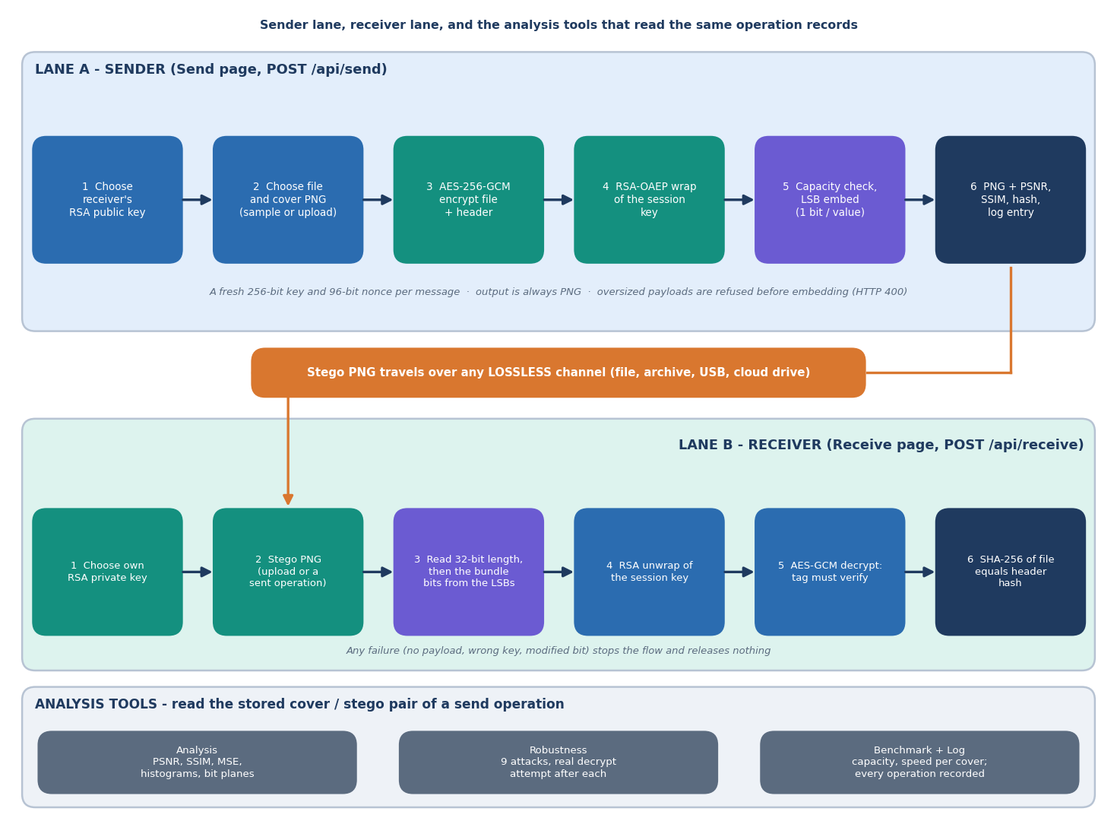
Figure 1: High-level workflow of CipherVeil: key exchange, encrypt, wrap, embed at the sender, and extract, unwrap, decrypt, verify at the receiver.
Out of scope are audio and video carriers, adaptive (edge-aware) or key-driven embedding, error-correcting codes, digital signatures and sender authentication, hardware key storage, the provable-security and homomorphic-computation parts of the base paper, and any formal security proof. Section 1.8 and Chapter 9 return to these.

1.7 Contributions
1. An authenticated bundle format (CVL1). The file name, size and SHA-256 travel inside the AES-GCM layer and the four-byte magic is used as associated data, so a modified bundle, a wrong key or a different file is refused before anything is released.
2. A hybrid pipeline with a fresh key per message. A new AES-256-GCM key and nonce are generated for every message and wrapped with RSA-OAEP-SHA256. The pipeline is byte-exact in 22 of 22 evaluation runs and tamper-evident in 240 of 240 single-bit flips.
3. A capacity-aware 1-bit LSB embedder with a closed-form quality model. Capacity is 3.0 bits per pixel; the closed-form PSNR for the number of embedded bits matches the measurement within 0.053 dB over 6 covers, 7 fill levels and 5 payload seeds, and the PSNR never falls below 51.1 dB at any fill.
4. An honest evaluation. Of 18 attacks tried, 5 leave the payload intact (lossless re-encodings and a crop of the bottom rows); every lossy or geometric change destroys it. A chi-square test flags the embedded region in 30 of 30 cases and a weighted-stego estimate follows the fill ratio, so hidden from the eye is not hidden from statistics.
5. A full-stack tool. A FastAPI and React application with key management, send, receive, analysis, robustness and benchmark views and an operation log that never records secrets, checked by 39 pytest tests and 21 smoke checks.
The novelty is integration and evaluation, not new primitives: AES-GCM, RSA-OAEP and LSB substitution are standard. What is new here is the combination in one authenticated format, the closed-form quality model checked against measurement, and a candid account of what the scheme does and does not survive.
The headline measurements are these. In the core evaluation (6 covers, payloads of 1 to 128 KiB, RSA-3072) 22 runs fit and 8 are blocked by the capacity check. PSNR is 52.5 dB at the minimum and 61.7 dB on average, SSIM 0.9958 at the minimum. Median times are 0.15 ms to encrypt, 0.25 ms to embed, 0.05 ms to extract and 86.37 ms to unwrap the key and decrypt: the cost of the scheme is the RSA private-key operation, not the hiding. These figures are examined in Chapter 8.
Against the base paper [1] the contribution is a different and complementary one. ProSt gives a theoretical security argument for computing on hidden bits; CipherVeil gives a measured, working file-transfer pipeline. The two cannot be compared on speed or security: ProSt reports 8.38 seconds for a 17-gate circuit on a 128 x 128 x 3 image, a different task from moving a file, and no PSNR, SSIM or capacity.

1.8 Limitations and Assumptions
• LSB data survives only lossless handling. One JPEG pass (even at quality 100), noise, resizing, rotation, flipping or colour reduction destroys the payload; there is no error correction. The stego image must travel as a PNG file.
• The hiding is detectable by statistics. Embedding is sequential from the first pixel and independent of any key; chi-square analysis flags 30 of 30 test cases and weighted-stego analysis estimates the embedded fraction. Low fill ratios are safer, not safe.
• Private keys are stored unencrypted in the local SQLite database; the JWT signing secret ships as a placeholder; there is no login rate limit.
• No sender authentication. Anyone who has the public key can send; the receiver cannot tell who. There is no signature, certificate or identity check.
• Only image carriers (PNG, RGB, alpha dropped), a 25 MB upload cap, and six committed cover images with four small synthetic payloads; no camera photographs and no large corpus.
• One machine. Everything was measured on an Intel Core i5-12500 with 15.7 GB of RAM and no GPU; absolute milliseconds vary by roughly 10 to 30 % between runs.
• Assumed: the receiver's private key is kept secret and the receiver's public key is obtained over a channel the sender trusts; the stego image is delivered as an unmodified PNG file; the attacker has not been given the private key.

1.9 Organisation of the Report
Chapter 2 surveys the literature, analyses the base paper in depth and states the research gap. Chapter 3 studies the technical, economic, operational and schedule feasibility. Chapter 4 sets out the existing and proposed systems and the requirements. Chapter 5 presents the design: architecture, workflow, data-flow diagrams, UML, the data model, modules and screens. Chapter 6 describes the methodology and implementation, including the algorithms, the equations, the API and installation. Chapter 7 reports the testing. Chapter 8 presents the results and output screens, the comparison with the base paper and the objectives against outcomes. Chapter 9 concludes and Chapter 10 gives the future scope. The references and three appendices (important code, installation and user guide, additional screens) follow.

CHAPTER 2: LITERATURE SURVEY

2.1 Overview
The survey has four purposes: to understand the base paper in depth, to place it among the work on steganography, steganalysis and hybrid encryption-plus-hiding schemes, to identify the algorithms and measures worth reusing, and to find the gap CipherVeil fills. The base paper was read in full from the PDF kept in the batch folder, together with its reference list. Two further papers archived with the batch were read from their PDFs: SCReedSolo [3], a symmetric-cipher, Reed-Solomon and LSB framework, and a study of memristive lightweight ciphers used for image steganography [2]. The batch literature survey names four more papers ([4], [5], [6], [7]); only their titles, years and sources are known, so they are described from their titles and nothing is claimed for them beyond that. The standards and classic papers cited for the cryptographic and steganalytic background are the usual primary sources.

2.2 Base Paper Analysis
Title. ProSt: Provably Secure Homomorphic Steganography. Authors and venue. S. Ahmad and S. Rass - IEEE Access, vol. 14, 2026, pp. 14393-14409 (received October 2025, accepted January 2026), doi 10.1109/ACCESS.2026.3656995 [1]. The authors work in the Secure and Correct Systems Laboratory of Johannes Kepler University Linz.

2.2.1 Aim and approach
The paper starts from the cloud-outsourcing problem: a client wants an untrusted provider to compute on sensitive data. Fully homomorphic encryption allows this but at a high computational cost [28], and trusted execution environments depend on particular hardware and are exposed to side-channel attacks [29]. The authors propose a third route, provably secure homomorphic steganography (ProSt). The client hides secret bits in the least significant bits of cover images and sends the images to a provider that knows it is processing hidden data but not where the secret bits are. Steganography is therefore used not to hide that a message exists, which the scheme deliberately gives up, but to hide the location and meaning of the secret bits among a large number of decoy bits.

2.2.2 Construction
ProSt is a tuple of four algorithms. LocGen draws a secret position (row, column, colour channel) uniformly at random from the h x w x 3 possibilities; the position acts as a symmetric key shared by the sender and the intended recipient. Emb writes a secret bit into the LSB of the pixel value at that position and leaves every other LSB as an independent random decoy. Comp lets the provider evaluate a Boolean circuit built only from Fredkin gates pixel by pixel over all positions, so the secret and the decoys receive the same operation. Ext reads the result bit at the known position. The Fredkin gate F(c, x, y) swaps x and y when the control bit c is 1; it is reversible and universal, and it keeps the number of ones unchanged (the paper's Lemma 1), which preserves the statistics of the LSB plane through any number of gates. A small domain-specific language lets circuits be written with AND, OR and NOT and compiled to Fredkin gates.

2.2.3 Threat model and security result
The adversary is an honest-but-curious, computationally unbounded provider. It knows the cover images, the circuit, the prior distribution of the secret and the embedding method, but not the secret positions; active attacks and several stego images of the same secret are excluded. Theorem 1 shows that a secret bit hidden at a uniformly random position among n LSBs gives the adversary an advantage of order 1/n over its prior knowledge, and Corollary 1 shows that this is preserved over any number of Fredkin gates. The authors are careful about what "negligible" means here: 1/n is statistically small but not cryptographically negligible, so they recommend n of at least 2^20 (about one million) for an advantage below 10^-6; a single 1024 x 1024 x 3 image gives n of about 3.1 million and four such images about 12.6 million. Hiding of the circuit's logic is heuristic only, and the paper states that no formal circuit privacy is proved.

2.2.4 Implementation and reported performance
The implementation is a Python and NumPy program. On a 128 x 128 x 3 image (49,152 values) with a circuit of 17 gates and 61 wires, run on an HP EliteBook with an Intel Core i5-1135G7 and 16 GB of RAM, the provider's total gate-execution time was 8.38 seconds. The authors extrapolate about 16.5 seconds for 34 gates and about 33 seconds for a 256 x 256 x 3 image, and suggest GPU acceleration as a way to reach 1 to 2 seconds. Their comparison with other steganography and homomorphic-encryption works uses runtimes that they adjusted or estimated from published complexity; the paper reports no PSNR, SSIM, MSE or embedding-capacity figures, because its security goal is the location of the secret and not statistical undetectability.
Table 3: The base paper and CipherVeil side by side
Aspect | ProSt (base paper) | CipherVeil (this project)
Goal | Compute on hidden bits in an untrusted cloud | Move a confidential file from a sender to a receiver
What is hidden | A few secret bits among n random decoy LSBs | A whole encrypted bundle, written sequentially from the first pixel
Role of encryption | None (the paper's footnote assumes steganography is not combined with encryption) | AES-256-GCM for the data; RSA-OAEP wraps a fresh key per message
Key | Secret position (r, c, k), shared out of band | Receiver's RSA keypair; only the public half is shared
Security statement | Adversary advantage of order 1/n (Theorem 1); heuristic circuit privacy | Confidentiality and integrity from AES-GCM and RSA-OAEP; no proof of undetectability
Quality measures | Not reported | PSNR, SSIM, MSE, histograms, bit planes for every operation
Reported cost | 8.38 s for 17 gates on 128 x 128 x 3 | Median encrypt 0.15 ms, embed 0.25 ms, RSA-3072 unwrap and decrypt 86 ms
Implementation | Python and NumPy demonstration | FastAPI and React application, 39 tests

2.2.5 Limitations stated by the authors and observed here
• Circuit privacy is heuristic: the topology is known to the provider and statistical analysis of gate frequencies could leak information.
• The advantage 1/n is statistically negligible only for very large n; small images give weak security.
• Storage and transfer overhead is high because the demonstration allocates one image per wire; runtime scales with the number of gates and the image area.
• Only passive (honest-but-curious) adversaries and a single-shot model are covered; active attacks are future work.
• No imperceptibility or capacity evaluation is given, so a reader cannot judge visual quality or payload size from the paper.

2.2.6 What CipherVeil adopts and what it changes
CipherVeil adopts the paper's carrier (the LSB plane of an RGB image), its idea that decoy-like random bits are what makes the LSB plane safe to write, and its use of a key to be shared with the recipient. One observation links the two works: the paper needs the surrounding bits to look like independent random decoys, and an AES-GCM ciphertext is exactly that kind of bit stream. In our measurement the embedded stream has a fraction of ones between 0.49 and 0.51 for encrypted bundles, against 0.42 to 0.46 for the plain files. CipherVeil does not use secret positions, Fredkin gates or any computation on hidden data, and it makes no claim of provable security. Its numbers therefore cannot be set beside the paper's runtime or its advantage bound; where conditions differ, Chapter 8 says so.

2.2.7 Critical assessment
The paper's strength is a clear security model and an argument that is easy to check: with n equally likely positions, the best the adversary can do is guess. Its weaknesses are the ones the authors list, plus two: the argument rests on the decoy bits being independent random values, which a natural image's LSB plane usually is not (in our chi-square tests the untouched LSB plane of most covers differs clearly from random), and the demonstration is a small proof of concept with no quality or capacity evaluation. These are not faults of the paper's aim, which is secure outsourcing, but they define the room left for a practical, measured hiding pipeline.

2.3 Related Work by Theme
The related work is grouped by the capability it supplies, mirroring the modules of CipherVeil: hiding data in images, detecting hidden data, the cryptographic building blocks, and schemes that combine encryption with hiding.

2.3.1 Hiding data in images
Fridrich's monograph [8] and the textbook of Cox et al. [9] set out the principles: capacity, distortion and detectability pull against one another. Provos and Honeyman [10] give an accessible introduction to the methods and to their detection. Chan and Cheng [11] study simple LSB substitution and add a pixel-adjustment step that lowers the embedding error; Mielikainen [12] revisits LSB matching, which changes pixel values by plus or minus one so that fewer values change than in plain replacement. Filler, Judas and Fridrich [13] embed with syndrome-trellis codes that minimise a distortion cost, the basis of modern adaptive schemes. Cachin [14] gives the information-theoretic definition of a secure steganographic system, in which the stego and cover distributions differ by a small relative entropy. CipherVeil sits at the simple end of this range: sequential substitution of one bit per colour value, chosen for its capacity (3 bits per pixel) and its transparency.

2.3.2 Detecting hidden data
Westfeld and Pfitzmann [15] showed that replacing least significant bits with random-looking bits equalises the frequencies of the value pairs (2k, 2k+1), which a chi-square test detects. Fridrich, Goljan and Du [16] introduced RS analysis for colour and grayscale images, and Dumitrescu, Wu and Wang [17] sample pair analysis; both estimate the length of the hidden message. Fridrich and Goljan [18] derived a weighted-stego estimator, which Ker and Bohme [19] refined with better weights. These methods are why a PSNR above 50 dB is not a security statement. CipherVeil applies the chi-square test and an unweighted weighted-stego estimate to its own output (Chapter 8): the chi-square statistic flags the embedded region in 30 of 30 cases.

2.3.3 Cryptographic building blocks
AES is specified in FIPS 197 [20] and the Galois/Counter Mode in NIST SP 800-38D [21], which recommends a 96-bit nonce and produces an authentication tag together with the ciphertext. RSA [22] is used for key transport with OAEP padding, specified in PKCS #1 version 2.2 [23] and introduced by Bellare and Rogaway [24]. Katz and Lindell [25] give the security definitions behind the hybrid construction: an authenticated symmetric cipher for the bulk data and a public-key scheme for its key. CipherVeil uses these standard primitives as implemented in a widely reviewed library and designs none of its own.

2.3.4 Schemes that combine encryption with hiding
SCReedSolo [3] is the closest companion work. It shuffles the message randomly, encrypts it with the Fernet symmetric cipher, adds Reed-Solomon error-correction codes and hides the result by LSB substitution at 3 bits per pixel. It reports a PSNR of 51.774 dB and an SSIM of 0.996 for the complete works of Shakespeare (5,458,195 characters) hidden in a 14589 x 8423 x 3 telescope image, 57.653 dB and 0.936 for audio in a 21188 x 30328 x 3 image, and 52.888 dB and 0.996 for a 100 x 100 x 3 image hidden in a 512 x 512 test image. The error-correcting codes let it survive noise that alters no more than half of the correction bits, and the authors report that it is not flagged by the passive steganalysis tools they tried. Its limitation for a file-transfer setting is that the key is symmetric and must be shared beforehand. The study of Fatemieh, Alizadeh and Zarezadeh [2] implements the stream ciphers Trivium and Grain-128a on memristive in-memory logic and reports up to 42 % and 44 % lower energy; it tests the circuits in an LSB application on five 256 x 256 grayscale images and quotes the usual rule that a PSNR above 30 dB is indistinguishable to the eye. It is hardware-level work and offers no file-transfer pipeline.
The batch survey lists four further papers [4], [5], [6], [7]. Their titles indicate, in order, a triple-layer data-hiding scheme using visual cryptography, a general paper on hiding data using an image object, a hybrid of chaotic encryption and a convolutional network for robust hiding, and AES encryption with a hybrid DWT-DCT transform. They show that the field mixes spatial-domain and transform-domain hiding with several encryption layers, but their authors, datasets and results could not be verified and are not quoted.

2.3.5 Measuring the result
PSNR, defined from the mean squared error between cover and stego image, is the standard imperceptibility measure; Huynh-Thu and Ghanbari [27] discuss the scope within which it is valid. SSIM [26] compares local luminance, contrast and structure and tracks perceived quality more closely. CipherVeil reports both, with the MSE, the largest change of any value, and the fraction of values changed.

2.3.6 Synthesis
Three observations follow. First, the field's tools are mature and standard: AES-GCM, RSA-OAEP, LSB substitution and the PSNR and SSIM measures. Second, the published combinations either share a symmetric key in advance (SCReedSolo) or address a different problem (ProSt computes on hidden bits; the memristive work is hardware), so a key-wrapped file pipeline measured end to end is a distinct and modest contribution. Third, hiding and detecting are studied by different papers; a hiding paper rarely reports how its own output fares under chi-square or weighted-stego analysis, which is the test CipherVeil adds.
Table 4: Related work compared
Work | Year | Approach | Finding / limitation
Ahmad, Rass [1] (base paper) | 2026 | LSB secret bit at a secret position among random decoy LSBs; Fredkin-gate circuits evaluated on all pixels by an untrusted cloud | Advantage of order 1/n; 8.38 s for 17 gates on 128x128x3; no PSNR, SSIM or capacity reported
Raiyan, Kabir (SCReedSolo) [3] | 2025 | Random shuffle + Fernet + Reed-Solomon codes + LSB, 3 bits per pixel | PSNR 51.77-57.65 dB on very large covers; error correction helps against noise; text, audio and image payloads
Fatemieh et al. [2] | 2026 | Trivium and Grain-128a stream ciphers on memristive IMPLY logic, tested in an LSB application | Up to 42 % and 44 % lower energy; hardware-level, no file-transfer pipeline
Fridrich [8]; Cox et al. [9] | 2008-09 | Textbooks on steganography, watermarking and steganalysis | Foundations: capacity, distortion, detectability
Chan, Cheng [11]; Mielikainen [12] | 2004-06 | Simple LSB substitution with a pixel-adjustment step; LSB matching (+/-1) | Lower distortion than plain replacement; payload not encrypted
Filler et al. [13] | 2011 | Syndrome-trellis codes: embedding that minimises a distortion cost | Adaptive embedding; more complex than sequential LSB
Westfeld, Pfitzmann [15] | 2000 | Chi-square attack on pairs of values after LSB replacement | Detects sequential replacement of random-looking bits
Fridrich et al. [16]; Dumitrescu et al. [17] | 2001-03 | RS analysis; sample pair analysis (message-length estimates) | Detects LSB replacement at low embedding rates
Fridrich, Goljan [18]; Ker, Bohme [19] | 2004-08 | Weighted-stego estimator and its refinement | Blind estimate of the embedded fraction
Batch survey items [4]-[7] | 2024-25 | Triple-layer visual cryptography; image-object hiding; chaotic encryption with a CNN; AES with hybrid DWT-DCT (titles only) | Authors, data and results not verified; not quoted for numbers

2.4 Datasets and Algorithms Used

2.4.1 Data
CipherVeil does not train a model and needs no dataset. Its test material is six cover images and four payload files, all committed to the repository and regenerated by a seeded script. Five covers come from the scikit-image sample data (a NASA astronaut photograph in the public domain, a cat photograph, a coffee-cup photograph and a small crop of it, and a rocket photograph; the cat and coffee images are CC0) and one is a procedurally generated landscape. The payloads are a CSV file of 2,774 bytes, a 21,517-byte memo in PDF form, a 169-byte text file and a 99-byte JSON file, all synthetic and generated for the project. Any image or file uploaded at run time can be used instead, up to 25 MB.

2.4.2 Algorithms
• AES-256-GCM [20], [21]: authenticated encryption of the file with a fresh 256-bit key and a 96-bit random nonce; the magic bytes are bound as associated data.
• RSA-OAEP with SHA-256 [22], [23]: wraps the 32-byte session key for the receiver; key sizes of 2048, 3072 (default) and 4096 bits.
• LSB substitution [10], [11]: one bit per colour value, row by row, preceded by a 32-bit length field; PNG output so that no lossy coding follows.
• SHA-256: a hash of the original file travels inside the encrypted header and is compared with the hash of the restored file.
• Chi-square and weighted-stego analysis [15], [18]: used in the evaluation to measure detectability, not in the product's embedding path.

2.4.3 Evaluation measures
PSNR is 10 log10(255^2 / MSE) over all RGB values; SSIM is computed per colour channel and averaged; capacity is (width x height x 3 - 32) / 8 bytes, that is 3.0 bits per pixel; fill ratio is the share of capacity used. Robustness is a binary outcome per attack: after the attack, extraction and decryption are attempted with the real private key and the recovered file's SHA-256 is compared with the original; the LSB error rate is the share of the first bundle-length bits that differ. Tamper evidence counts single-bit flips that were refused. Chapter 6 gives the formulas.

2.5 Strengths and Limitations of Existing Work
Table 5: Strengths and limitations of the main approaches
Approach | Strengths | Limitations
Encryption only | Strong confidentiality and integrity with AES-GCM and RSA-OAEP | Ciphertext reveals that a secret exists
Plain LSB hiding | Simple, 3 bits per pixel, invisible to the eye | Payload readable once found; flagged by chi-square and weighted-stego tests; lost on any lossy change
Shared-key encryption + Reed-Solomon + LSB (SCReedSolo) | Large payloads; survives some noise; high PSNR on large covers | Symmetric key must be shared; more complex payload coding
Provably secure homomorphic steganography (ProSt) | Formal advantage bound; computation on hidden bits; hardware-independent | Not a file-transfer tool; heuristic circuit privacy; no quality or capacity figures; slow in Python
Adaptive embedding (syndrome-trellis codes) | Lower detectability for the same payload | Coding complexity; not evaluated here
Transform-domain and learned hiding (survey titles) | Possibly more robust to compression | Details not verified

2.6 Research Gap
The surveyed work advances steganography and encryption independently, including provably secure constructions. The gap is a practical hybrid AES-RSA plus LSB pipeline evaluated end to end on capacity, imperceptibility and speed. Beyond that headline gap, four narrower gaps follow from the survey:
1. Imperceptibility is usually reported for a few payloads; the dependence of PSNR on the fill ratio, and its closed-form floor, is seldom shown against measurement
2. Capacity, processing time and the cost of the key-wrapping step are rarely reported together with the quality measures
3. Robustness is often asserted rather than tested: which handling (JPEG, noise, resize, crop, re-encoding) destroys the payload is seldom listed
4. Statistical detectability of the finished stego image is seldom measured on the same pipeline that is advertised as concealment
CipherVeil addresses the headline gap by building and testing the pipeline; the first narrow gap by measuring PSNR against the fill ratio for six covers and seven fill levels and comparing it with the closed-form floor; the second by reporting capacity, per-stage times and the cost of three RSA key sizes; the third by listing eighteen attacks and their outcomes; and the fourth by running two steganalysis tests against its own stego images and reporting the result even though it is unfavourable.

2.7 Summary
The base paper supplies the carrier idea, the role of random decoy bits and a formal way to think about hiding the location of a secret. The companion papers supply the combination of a cipher with LSB hiding and the habit of reporting PSNR and SSIM. The classical steganalysis papers supply the tests that show where plain LSB replacement is weak. What is missing, and what CipherVeil attempts, is one working pipeline in which a file is encrypted, wrapped for a receiver, hidden, recovered and verified, with every claim measured and every limit stated.

CHAPTER 3: FEASIBILITY STUDY

3.1 Introduction
This chapter asks whether CipherVeil can be built, run and maintained with the resources available to the team. The question is answered partly by argument and partly by evidence, because the system was built and measured on one ordinary desktop PC with no graphics card and no paid software.

3.2 Technical Feasibility
Hardware. Every measurement in this report was taken on an Intel Core i5-12500 (6 cores, 12 threads) with 15.7 GB of memory, running Windows 11 Pro. No GPU was used or needed: the cryptography and the pixel arithmetic run on the CPU in milliseconds. Machines of lower specification were not tested.
Software. The stack is mature open-source software: Python 3.11.9 with FastAPI 0.115.6, SQLAlchemy 2.0.36, cryptography 44.0.0, Pillow 11.0.0, NumPy 2.1.3 and scikit-image 0.24.0 on the server, and React 18.3.1 with Vite 6.0.3 and Tailwind CSS 4 in the browser. The standard algorithms are not re-implemented: AES-GCM and RSA-OAEP come from a maintained library, which is the usual rule of applied cryptography [25], and the algorithms themselves are public standards [20], [21], [23].
Data. No dataset is needed. The system is deterministic and does not learn anything, so there is no training set, no labelling and no data-quality risk. The cover images are six small pictures (four from scikit-image, one crop of one of them, one generated procedurally with a fixed seed) and the payloads are four synthetic files. The corresponding risk is one of validity rather than feasibility: six covers do not represent every kind of photograph.
Technical risks and the measurements that retired them. Each risk below was tested on the running system rather than assumed away.
Table 6: Technical risks and the measurements that addressed them
Risk | Measurement | Verdict
Encryption and embedding too slow for interactive use | Median encrypt 0.15 ms, embed 0.25 ms, extract 0.05 ms; RSA unwrap and decrypt 86.37 ms (RSA-3072) | Feasible
A whole send call too slow for a web console | Median 0.44 s on a 512x512 cover and 1.87 s on 1280x720, mostly PSNR/SSIM and PNG encoding | Feasible
RSA key generation too slow | Median 32 ms (2048), 191 ms (3072), 354 ms (4096), with large run-to-run variation | Feasible
The cover is too small for realistic files | Capacity is 3.0 bits per pixel: 14.6 KiB (200x200) to 337.5 KiB (1280x720); oversize files are blocked by a capacity check | Feasible for documents and small files; not for large files
Embedding visibly damages the picture | PSNR 52.479-74.6 dB and SSIM at least 0.995806 on 22 runs; at least 51.1 dB even at 100 % fill | Feasible
The payload does not survive a normal image channel | Lossless re-save survives; JPEG at quality 100, noise, resizing and recolouring do not | A real limit, accepted and documented

Defect found during documentation. The Send page of the console fails for an account that has no keys, because one icon component is used but not imported (KeyRound is not defined, reproduced with a fresh account). It does not affect the flow with a key; it is recorded in Chapter 8 and was left unfixed in the product code.

3.3 Economic Feasibility
No prices are quoted, because none were measured. All software is free and open source (Python, FastAPI, cryptography, Pillow, NumPy, scikit-image, React, Vite). Development, testing and the measurements used one existing desktop PC. The six cover images are public-domain or CC0 pictures from scikit-image or are generated in-house, and the payloads are synthetic. Deployment of the demonstration needs a machine that can run Python and Node, and nothing else. A production service would add costs not studied here: managed key storage, monitoring, a certificate for transport security, and an independent security review.
The benefit is also qualitative. A team that must send a confidential file over a channel it does not control gets a concrete tool and, more importantly, a measured account of what that tool protects and what it does not; the cost of reproducing and extending the work is small because every experiment is a script that regenerates its own result file.

3.4 Operational Feasibility
• Operators. One role, a signed-in user, can generate keys, send, receive, analyse and read the log through a browser console without using a command line.
• Installation. setup.bat creates the virtual environment, installs the packages and runs npm install; run.bat starts the backend on port 8315 and the frontend on port 5315. A demonstration account (demo) is created automatically.
• Maintenance. The backend is about 1,040 lines in 16 small modules; the 39 automated tests and the 21-check smoke test catch regressions in the cryptography, the embedding, the API and the log.
• Training. The workflow is three steps (generate a key, send, receive). The one real operating rule, that the stego image must travel as a PNG file and must not be re-encoded by a chat app, is shown on the Robustness page and in the landing text.
• Risk of misuse. The tool can hide data in a picture; it is intended for protecting confidential files. It makes no claim of resisting a determined steganalyst (Chapter 8).

3.5 Schedule Feasibility
The work was planned in six phases over twelve weeks. The table is the plan used by the team, not a log of measured effort.
Table 7: Planned schedule (weeks)
Phase | Weeks | Work | Output
1 | 1-2 | Literature survey, base paper and problem statement | Survey table, objectives, gap
2 | 3-4 | Design: bundle format, key handling, database, API | Design notes, diagrams
3 | 5-7 | Backend: crypto, LSB, metrics, robustness, API | backend/app/, smoke test
4 | 8-9 | Frontend: keys, send, receive, analysis, robustness, log | frontend/src/
5 | 10-11 | Evaluation, tests, extra experiments | ml/eval.py, tests/, experiments/
6 | 12 | Documentation, decks, report and paper | Review decks, report, IEEE paper

The schedule is feasible because the largest risks (cryptographic correctness and a defensible evaluation) are small in code and large in checking; the plan therefore reserves more time for testing and measurement than for the console.

3.6 Advantages and Constraints
Table 8: Advantages and constraints of the chosen approach
Advantages | Constraints
Standard primitives (AES-256-GCM, RSA-OAEP-SHA256) from a maintained library | LSB data lives only in lossless images; the stego file must stay a PNG
Authenticated encryption: a flipped bit or a wrong key releases nothing (240 of 240 flips rejected) | Embedding is sequential and key-independent, so statistical tests detect medium and high fill
Imperceptible change: PSNR at least 51.1 dB at any fill, SSIM at least 0.9929 | No error correction, no sender authentication, RSA only
Runs offline on one PC with no GPU and no paid software | Private keys are stored unencrypted in the local database; the JWT secret ships as a placeholder; no login rate limit
Every number is regenerated by a script (ml/eval.py, scripts/run_experiments.py) | Six covers and four small payloads; no camera photographs or large corpus

CHAPTER 4: SYSTEM REQUIREMENTS AND ANALYSIS

4.1 Introduction
This chapter describes the situation the system replaces, the system that was built, and the requirements it was built to meet. The requirements are stated so that Chapter 7 can test them and Chapter 8 can report whether they were met.

4.2 Existing System and Its Limitations
To protect a confidential file in transit, people today use one of three approaches, each with a known weakness.
Table 9: Existing approaches and their limitations
Approach | What it gives | Limitation
Encryption alone (an encrypted archive or message) | Confidentiality of the content | The ciphertext announces that something secret is moving, which invites interception or pressure; with a shared key, key exchange is the weak point
Steganography alone (a plain LSB tool) | The existence of the message is not obvious | Nothing protects the data once the payload is found; naive embedding changes the picture and is detectable [10], [15], [16]
Hybrid encryption without hiding | Fast bulk encryption with a safely exchanged key | Same visibility problem as encryption alone
Advanced steganography (adaptive, deep-learning or provably secure schemes) | Better undetectability or formal guarantees [13], [14], [1] | Complex, research-grade, and not packaged as an end-to-end tool measured on capacity, imperceptibility and speed

The base paper [1] is an example of the last row: it studies how secret bits can be hidden among random decoy bits and processed by an untrusted cloud, with a security argument about the adversary's advantage. It is not a file-transfer tool and reports no PSNR, SSIM or capacity. The batch literature survey (Chapter 2) found the same gap: encryption and steganography are advanced separately, and a practical AES-RSA plus LSB pipeline evaluated end to end on capacity, imperceptibility and speed is missing.

4.3 Proposed System and Its Advantages
CipherVeil protects a file twice. The sender chooses a receiver's public key, a file and a cover image. The system builds a fresh 256-bit AES session key and a 96-bit nonce, encrypts the file and a small header (name, size, SHA-256) with AES-256-GCM, wraps the session key with the receiver's RSA public key using OAEP, assembles a bundle, checks that it fits in the cover, and writes it into the lowest bit of every red, green and blue value of the cover as a PNG. The receiver reverses the steps with the private key, and the tag and the hash prove that the restored file is exactly the sent one.
• Two independent layers. The content stays confidential even if the hiding is discovered, and the transfer looks like an ordinary picture.
• No shared secret. The AES key is fresh for every message and travels only under the receiver's RSA public key.
• Integrity built in. The GCM tag and the stored SHA-256 reject any modification (0 of 240 single-bit flips accepted).
• Measured, not claimed. PSNR, SSIM, capacity, timings and a robustness report are computed for every message and logged.
• Usable. A six-page console and an API allow the whole flow without a command line.

4.4 Functional Requirements
The seven features of the product (F1 to F7) were derived from the six project objectives; F8 is the sign-in that scopes everything to an account. Each requirement below is testable.
Table 10: Functional requirements
ID | Requirement | Objective | Where
F1 | Generate, import and export RSA keypairs of 2048, 3072 or 4096 bits; keep public-only entries for recipients; a fresh AES key for every message | 2 | Keys page, /api/keys
F2 | Encrypt a file, wrap the key, check capacity before embedding and download the stego PNG | 1, 3 | Send page, /api/send
F3 | Extract, unwrap, verify the GCM tag and restore the file; show input and output SHA-256 side by side | 4 | Receive page, /api/receive
F4 | Compute PSNR, SSIM, MSE, histograms and bit planes against the original cover | 5 | Analysis page, /api/analysis
F5 | Report capacity per cover and timings of encrypt, embed, extract and decrypt | 6 | Robustness page, /api/benchmark
F6 | Attack the stego image (JPEG, noise, resize, crop) and state honestly what survives | 6 | Robustness page, /api/robustness
F7 | Log every operation with sizes, timings and metrics, never secrets | 6 | Log page, /api/log
F8 | Register and sign in; every key and operation belongs to its owner | - | Login page, /api/auth

4.5 Non-Functional Requirements
Table 11: Non-functional requirements and how they were checked
Quality | Requirement | Check
Confidentiality | AES-256-GCM with a fresh key and nonce per message; RSA at least 2048 bits | Unit tests; 50 encryptions gave 50 distinct nonces and wrapped keys
Integrity | Any modification is rejected before data is released | 240 of 240 tamper trials rejected
Imperceptibility | PSNR above 50 dB | Minimum 52.479 dB on the evaluation; 51.1 dB at 100 % fill
Correctness | Byte-exact round trip | 22 of 22 evaluation runs exact
Performance | Interactive response for small files | Send 0.44 s, receive 0.20 s (median)
Security of the service | Authentication, ownership checks, upload cap, no secrets in the log | API tests; 25 MB cap; log scanned for key material
Usability | Errors say what failed and what to do | Capacity, wrong-key and no-payload messages (Chapter 8)
Portability | Windows with Python 3.11 and Node; no GPU | Measured on one PC only
Maintainability | Small modules; automated tests | 39 pytest tests, 21 smoke checks

4.6 Hardware Requirements
Table 12: Hardware used for development and measurement
Item | Specification
Processor | Intel Core i5-12500, 6 cores, 12 threads
Memory | 15.7 GB
Graphics | None required; CPU only
Storage | A few hundred MB for the environment and the node packages; each stego image is a PNG of a few hundred KB
Network | None for operation; the browser and the server run on the same machine

The minimum machine was not determined; the figures above are what was used.

4.7 Software Requirements
Table 13: Software used
Layer | Software and version
Operating system | Windows 11 Pro
Language and runtime | Python 3.11.9; Node.js v24.19.0 with npm 11.17.0
Server | FastAPI 0.115.6, Uvicorn 0.34.0, SQLAlchemy 2.0.36 on SQLite, PyJWT 2.10.1, bcrypt 4.2.1, python-multipart 0.0.20
Cryptography and imaging | cryptography 44.0.0, Pillow 11.0.0, NumPy 2.1.3, scikit-image 0.24.0, matplotlib 3.9.3
Frontend | React 18.3.1, Vite 6.0.3, Tailwind CSS 4, React Router 6, Axios, Recharts 3, three.js for the landing backdrop
Testing | pytest 9.1.1 with httpx; Playwright with Chrome for the screen captures

4.8 User Roles and Constraints
There is one role, the signed-in user. A user can be a sender, a receiver or both: keys, operations and logs are scoped to the account, and one user cannot read another's keys or messages (the API returns "not found"). A visitor sees only the public landing page. The developer or evaluator runs the scripts and tests but has no special rights in the application.
The constraints that shape the design are: the stego file must be a PNG and stay lossless; the cover must be large enough (capacity is (width x height x 3 - 32) / 8 bytes); uploads are capped at 25 MB; the RSA key must be at least 2048 bits; and the user must keep the private key, because there is no recovery path.

4.9 Requirements Traceability
Each project objective from the batch file maps to requirements, to the code that implements them and to the test that checks them, so that nothing in Chapter 8 is claimed without a requirement behind it.
Table 14: Objectives, requirements and verification
Objective | Requirements | Verification
1. AES for the payload, RSA for the AES key | F2; confidentiality, integrity | tests/test_crypto.py (13 tests); tamper study (240 flips); 50 distinct nonces
2. Key generation and exchange | F1; F8 | tests/test_api.py key lifecycle; fingerprints; PEM import and export
3. Embed by LSB | F2; imperceptibility | tests/test_lsb.py (9 tests); PSNR model within 0.053 dB of measurement
4. Extraction and decryption | F3; correctness | 22 of 22 byte-exact round trips; end-to-end API test; smoke test
5. PSNR and SSIM against the cover | F4 | tests/test_metrics_pipeline.py (7 tests); evaluation tables
6. Capacity, time and robustness | F5, F6, F7; performance | Benchmark, nine attacks over six covers, extra attacks, API latency, steganalysis

The table also shows what is not covered: there is no requirement, and therefore no test, for sender authentication, resistance to a professional steganalyst, or recovery of a lost key. They appear as limitations and future work.

4.10 Summary
The existing options each protect one thing; the proposed system protects the content and the fact of the transfer together, measures what it costs, and states what it cannot do. Chapter 5 shows the design that meets these requirements.

CHAPTER 5: SYSTEM DESIGN
This chapter describes the architecture, the workflow, the data flow, the UML and data design, the modules, the interface design and the security design of CipherVeil. The diagrams were drawn from the code in backend/app/ and frontend/src/; the complete set, with longer explanations, is also in the Block Diagrams document.

5.1 Design Goals and Architecture
Five goals shaped the design. Two independent layers: the content must stay confidential even if the hiding is found, and the transfer must look like a picture. Standard primitives only: AES-256-GCM and RSA-OAEP-SHA256 from a maintained library [20], [21], [23], with no home-made cipher. Measurable behaviour: every message records PSNR, SSIM, capacity and timings. Honest limits: the interface must say what fails (a JPEG pass, a wrong key, an oversize file) and why. Small and testable: about 1,040 lines of backend code in 16 modules, each testable on its own.
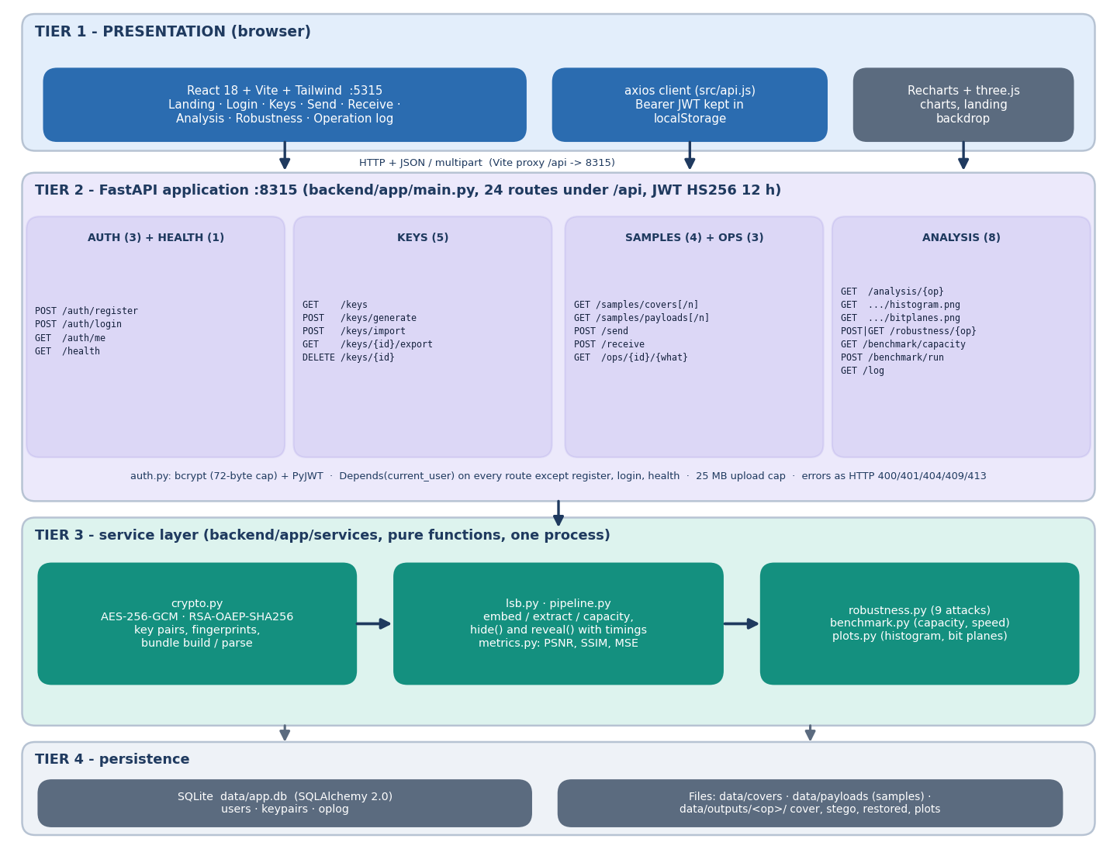
Figure 2: System architecture of CipherVeil: React console, FastAPI application with 24 endpoints, service layer, and the SQLite database and output files.
The React console on port 5315 calls the FastAPI application on 127.0.0.1:8315 through a Vite proxy that forwards /api. The application layer (backend/app/routes/) validates input, checks the bearer token and the ownership of every key and operation, and delegates to the service layer (backend/app/services/). The services hold the actual work: crypto (keys, AES-GCM, RSA-OAEP, bundle), lsb (capacity, embed, extract, PNG encoding), metrics (PSNR, SSIM), pipeline (the send and receive sequences, shared by the API, the benchmark and ml/eval.py), plots, robustness and benchmark. State is kept in a SQLite file (data/app.db, three tables) and in data/outputs/<op>/, where each send operation keeps its cover, its stego PNG and later its histogram and bit-plane images.

5.2 High-Level Workflow and Core Algorithm
Figure 3: High-level workflow: the sender's path (encrypt, wrap, check capacity, embed, measure) and the receiver's path (extract, unwrap, verify).
Send. The sender selects the receiver's public key, a file and a cover. The service builds a header {name, size, sha256}, encrypts header_len | header | file with a fresh 256-bit AES key and a fresh 96-bit nonce (additional data: the magic CVL1), wraps the session key with the receiver's RSA public key, and assembles the bundle. If the bundle is longer than the cover capacity (width x height x 3 - 32) / 8 bytes the request is refused before anything is embedded. Otherwise the 32-bit length and the bundle are written, bit by bit, into the lowest bit of each red, green and blue value from the top-left pixel onwards, and the result is saved as a PNG. PSNR, SSIM and timings are then computed against the untouched cover.
Receive. The receiver extracts the length and the bundle from the lowest bits, rejects an image without a plausible header, checks the magic and the wrapped-key length, unwraps the session key with the private key, and decrypts. A wrong key, a flipped bit or a truncated bundle fails the GCM tag check and nothing is released. Finally the SHA-256 stored inside the encrypted header is compared with the hash of the restored file.
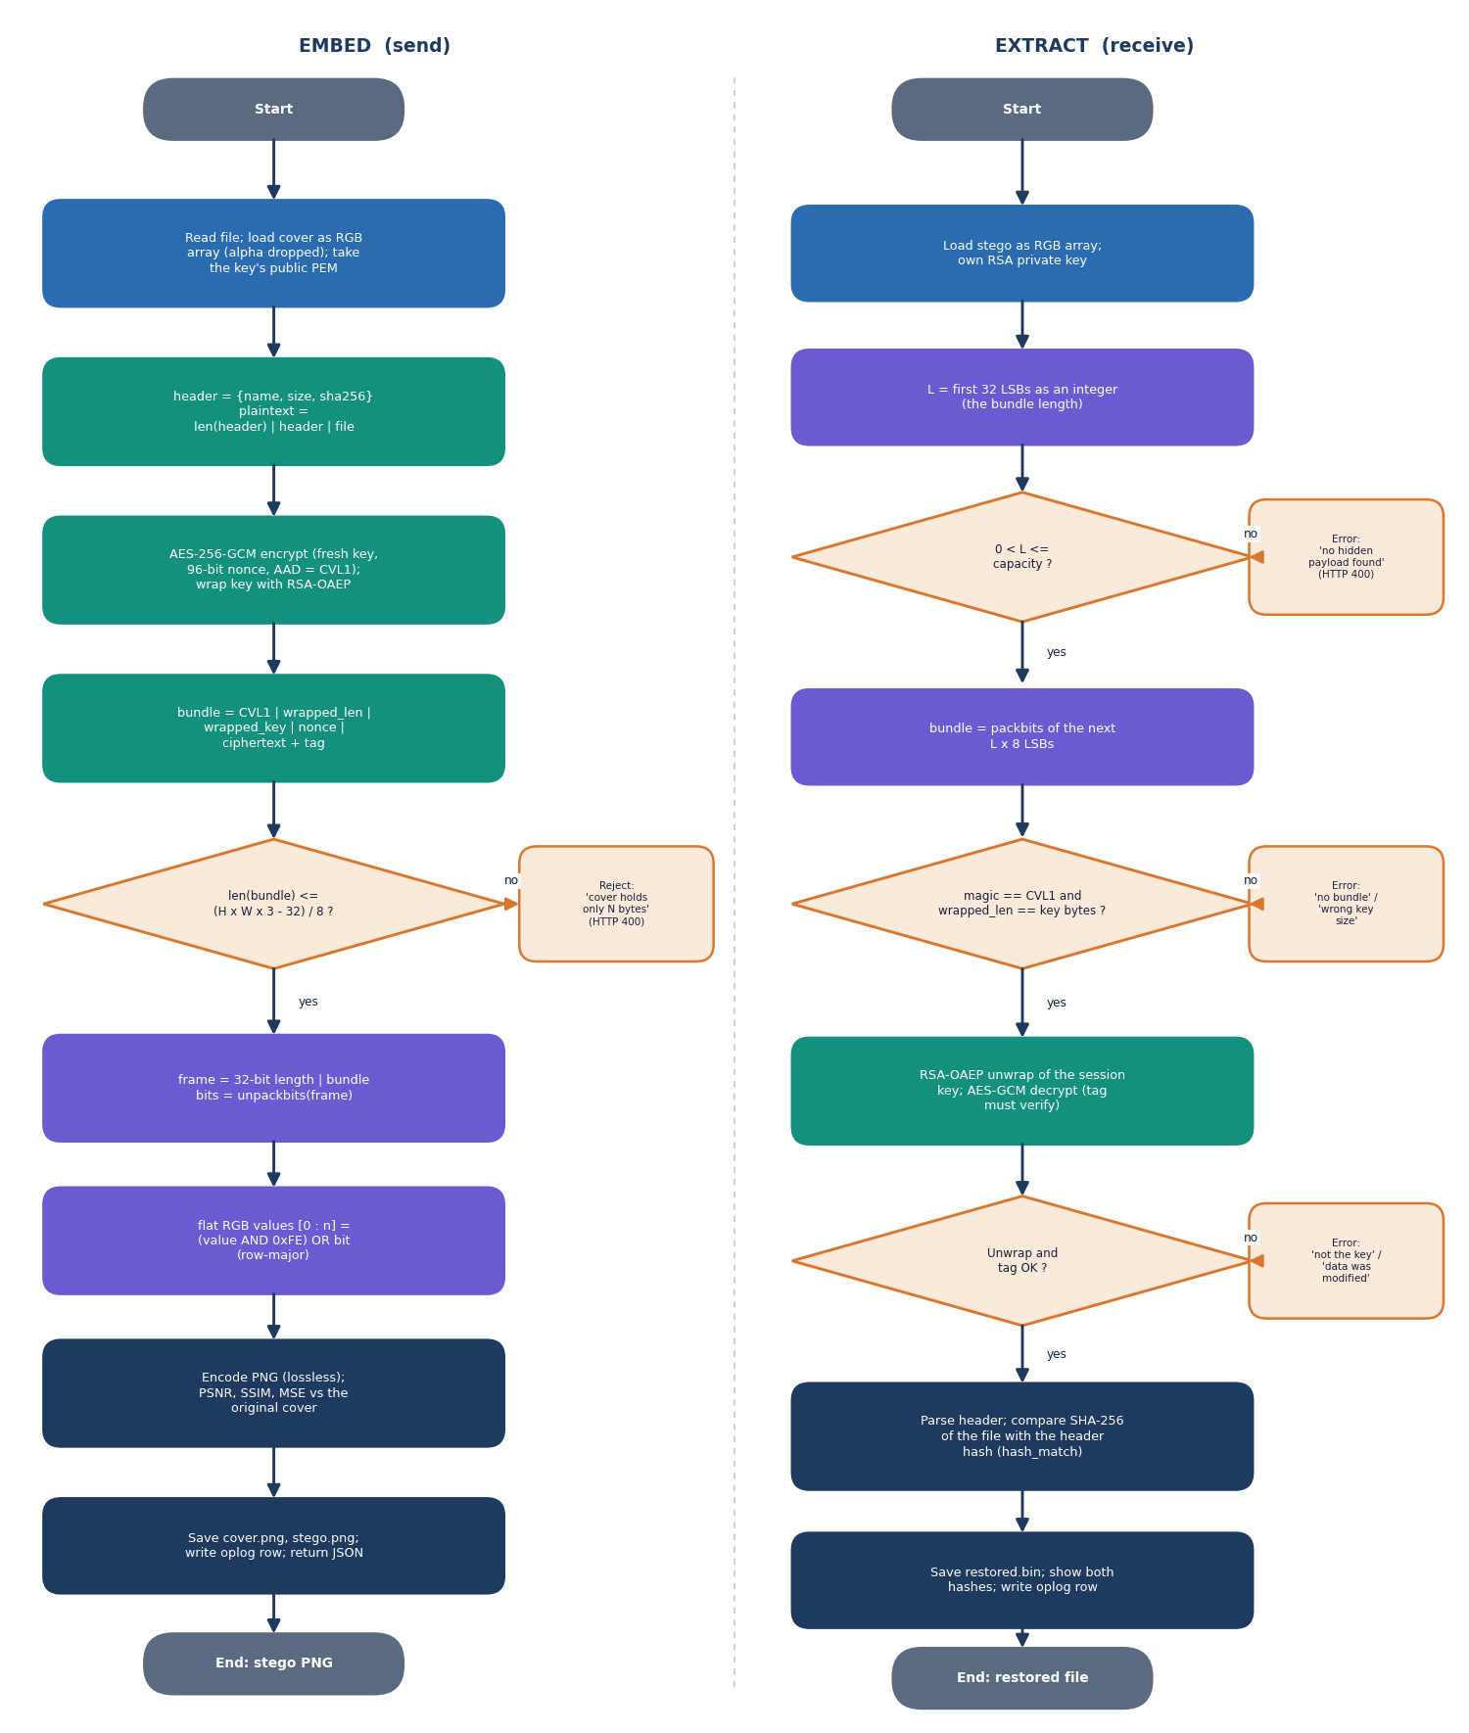
Figure 4: Flowchart of the core algorithm: encrypt and embed, extract and decrypt, with the refusal branches.
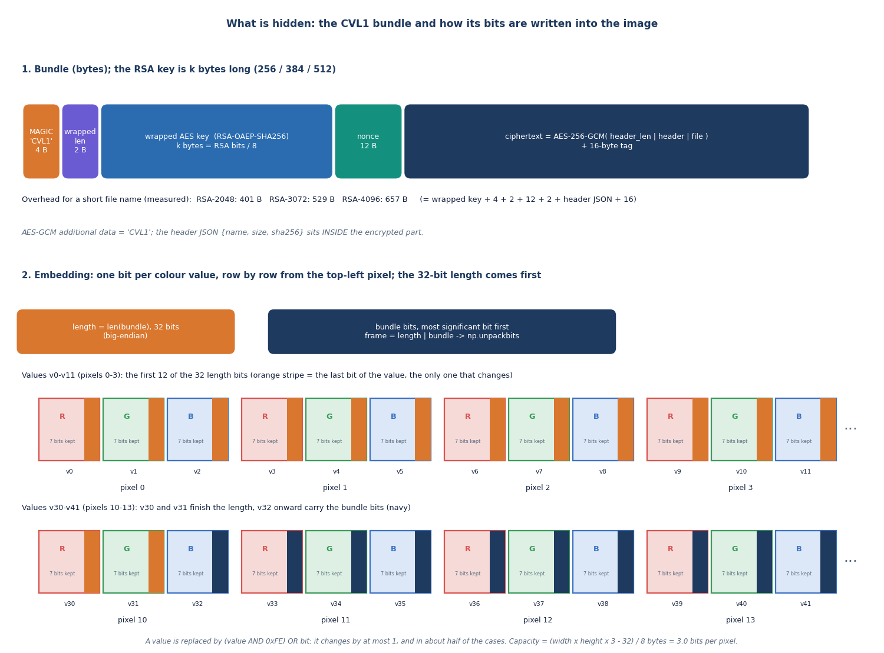
Figure 5: Layout of the CVL1 bundle that is hidden in the image, and its position in the LSB stream.
The bundle carries everything the receiver needs and nothing secret in the clear: the magic and the length of the wrapped key (6 bytes), the RSA-wrapped session key (256, 384 or 512 bytes for RSA-2048, 3072 or 4096), the nonce (12 bytes) and the ciphertext with its 16-byte tag. The fixed overhead is 401, 529 and 657 bytes for the three key sizes with a short file name.

5.3 Data Flow Diagrams

5.3.1 Level 0: context
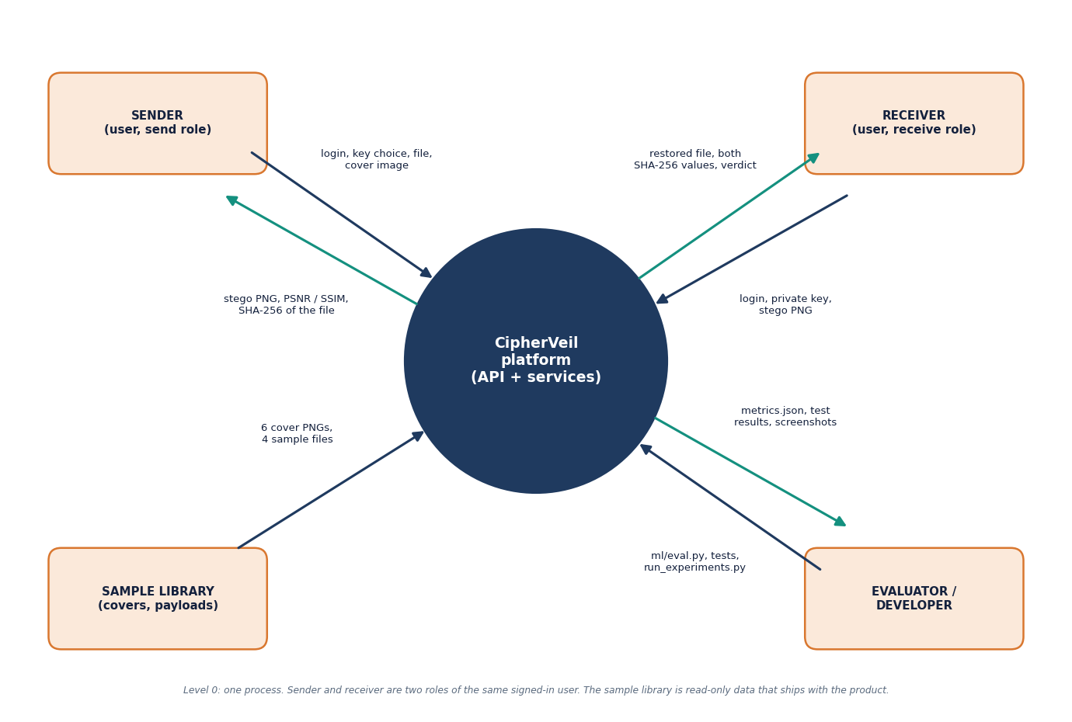
Figure 6: Data flow diagram, level 0: the user, the cover and payload files and the receiver exchange data with the CipherVeil platform.
At level 0 the platform is one process. The user sends credentials, key requests, a payload file, a cover image and a stego image to receive, and gets back keys, the stego PNG, the restored file, the two hashes, quality metrics and the log. The receiver is outside the platform in the sense that the public key goes to the sender and the stego PNG travels between them over a channel CipherVeil does not control. The evaluator runs the scripts and reads the result files.

5.3.2 Level 1: main processes
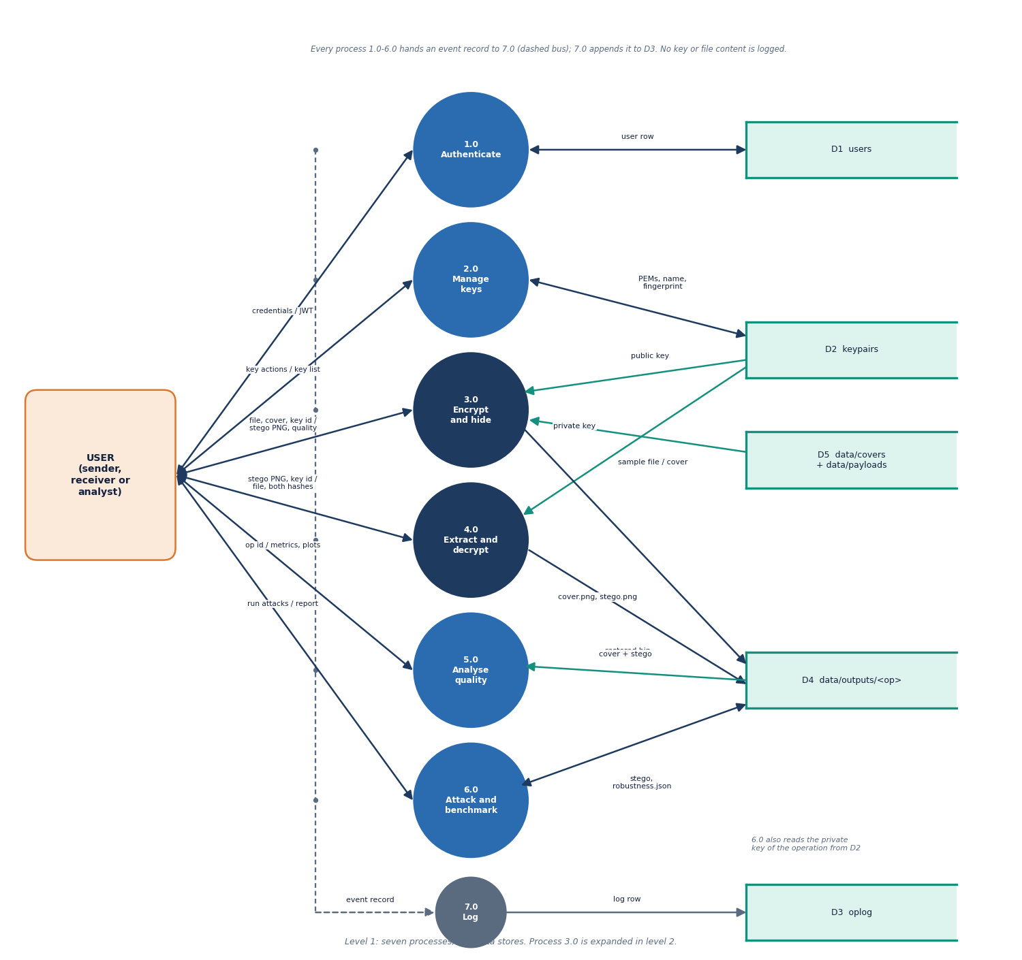
Figure 7: Data flow diagram, level 1: authenticate, manage keys, encrypt and embed, extract and decrypt, analyse, attack and benchmark, and log.
Level 1 splits the platform into processes for authentication (1.0), key management (2.0), encrypt and embed (3.0), extract and decrypt (4.0), analysis of imperceptibility (5.0), robustness and benchmark (6.0) and logging (7.0). The data stores are the user table, the key table (with the private half only for the owner's own keypairs), the operation log, and the output folder of cover, stego and restored files. The log never receives keys, passwords or file contents.

5.3.3 Level 2: encrypt and embed
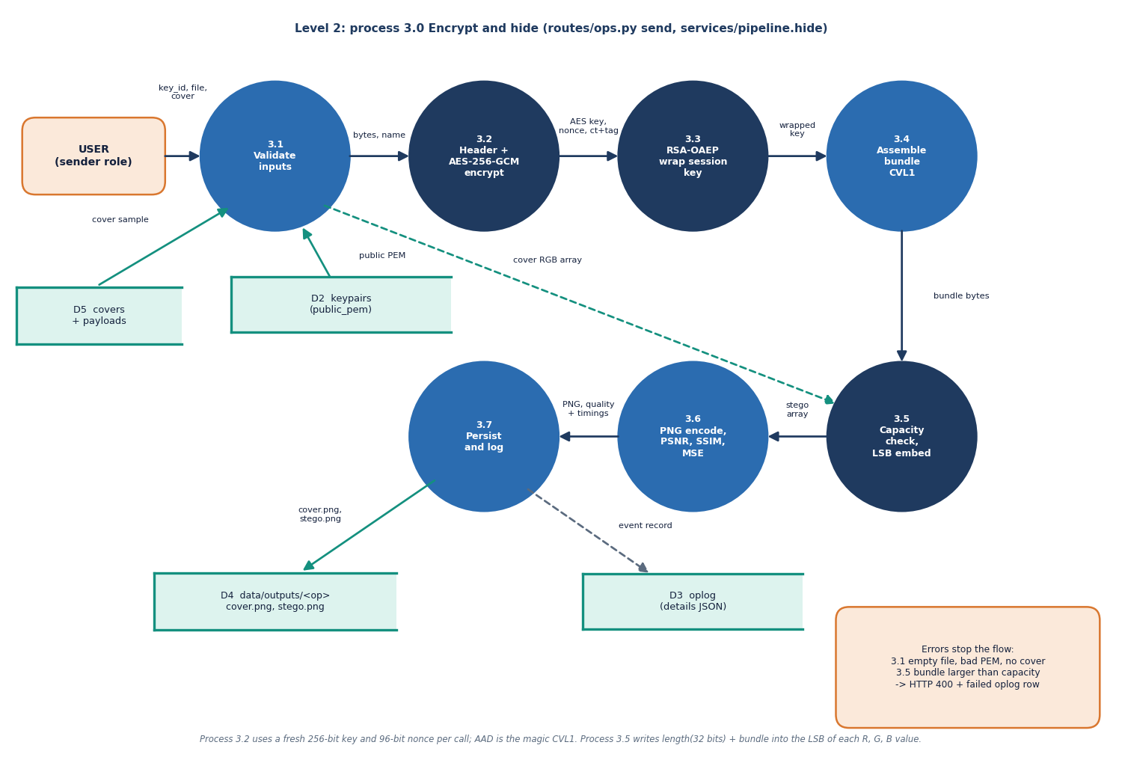
Figure 8: Data flow diagram, level 2: process 3.0 expanded into header, AES-GCM, key wrap, capacity check, embedding and metrics.
Process 3.0 expands into building the header and hashing the file, encrypting with AES-256-GCM, wrapping the session key with RSA-OAEP, assembling the bundle, checking capacity, embedding the bits, encoding the PNG and measuring PSNR and SSIM. The same sequence is used by the API, by the benchmark and by ml/eval.py, so the evaluation measures the code the user runs.

5.4 UML Design

5.4.1 Class diagram
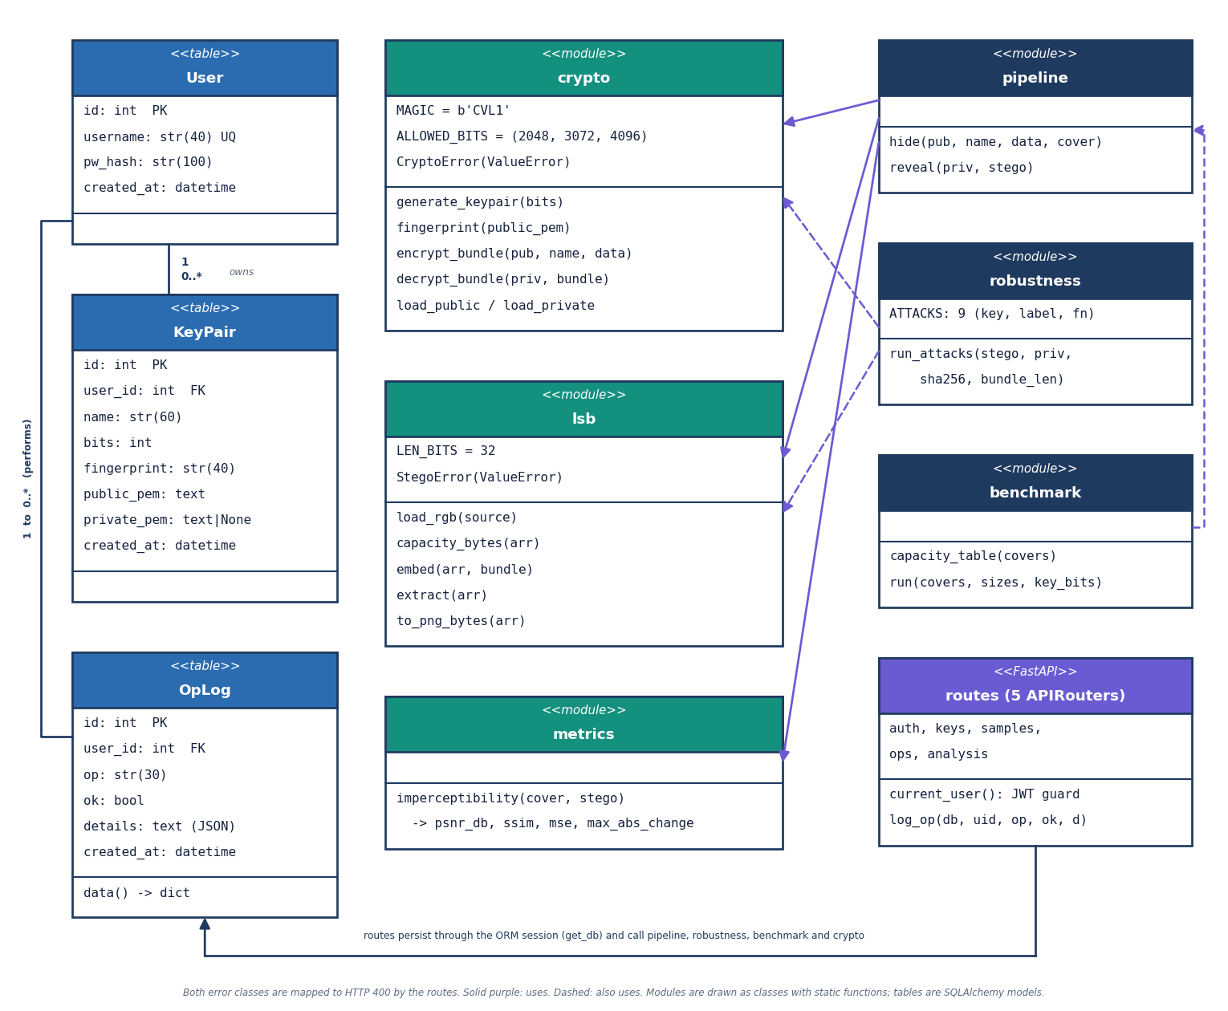
Figure 9: UML class diagram: the ORM classes, the service modules, the two error classes and the FastAPI routers.
Table 15: Principal classes and modules
Element | File | Role
User, KeyPair, OpLog | backend/app/db.py | The three database tables as SQLAlchemy classes
CryptoError | services/crypto.py | Raised for a bad key, wrong key, tag failure or foreign bundle
StegoError | services/lsb.py | Raised for an unreadable image, oversize payload or missing header
crypto | services/crypto.py | Key generation and loading, fingerprint, encrypt_bundle, decrypt_bundle
lsb | services/lsb.py | capacity_bytes, embed, extract, to_png_bytes, load_rgb
pipeline | services/pipeline.py | hide and reveal: the whole send and receive sequences with timings
robustness, benchmark, plots, metrics | services/ | Attacks and verdicts, capacity and speed tables, charts, PSNR and SSIM

The service layer is written as plain functions rather than a class hierarchy because the operations are pure transformations of bytes and arrays; only the database entities and the two error types are classes. This keeps the cryptography and the embedding free of web code and makes them directly testable.

5.4.2 Sequence diagram
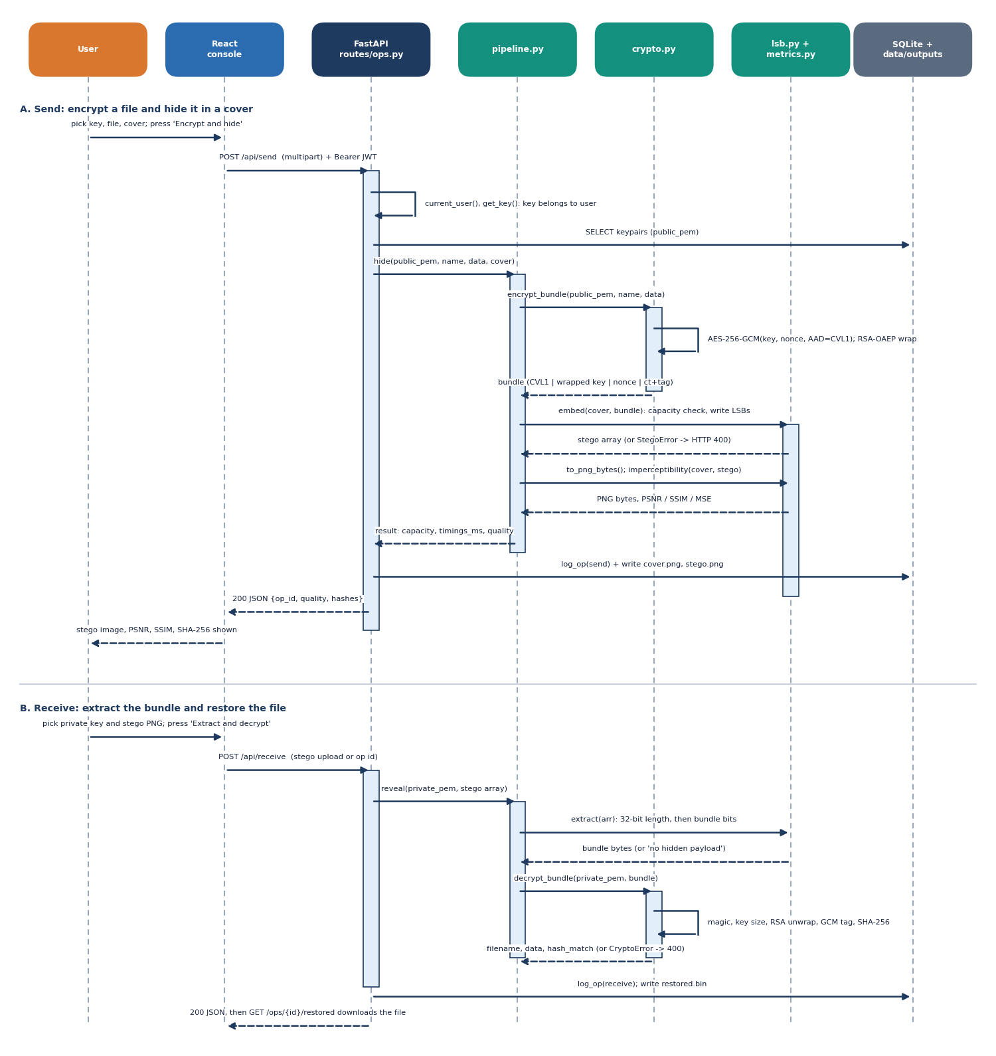
Figure 10: Sequence diagram of the main flow: the sender sends a file, the receiver extracts and decrypts it.
In the send scenario the console posts a multipart request to POST /api/send with the bearer token. current_user verifies the HS256 signature and expiry; the route loads the key (an ownership check), reads the payload and the cover, and calls pipeline.hide; on success it writes a row to oplog, stores the cover and the stego PNG under the operation number, and returns the metrics. In the receive scenario POST /api/receive loads the private key, calls pipeline.reveal, and returns the filename, the two hashes and gcm_verified; any CryptoError or StegoError becomes a 400 response with a message and a failed row in the log.

5.4.3 Use-case diagram
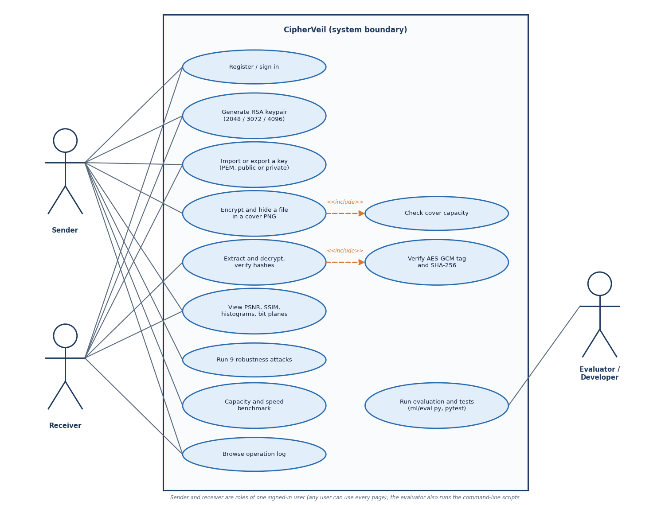
Figure 11: Use-case diagram with the sender, the receiver and the evaluator.
The sender imports or receives a public key, sends a file, reads the analysis and runs the robustness tests. The receiver generates a keypair, exports the public key, and extracts and decrypts. Both are the same application role (a signed-in user); the diagram separates them because they perform different use cases. The evaluator runs the benchmark and the scripts and reads the log.

5.5 Data Design
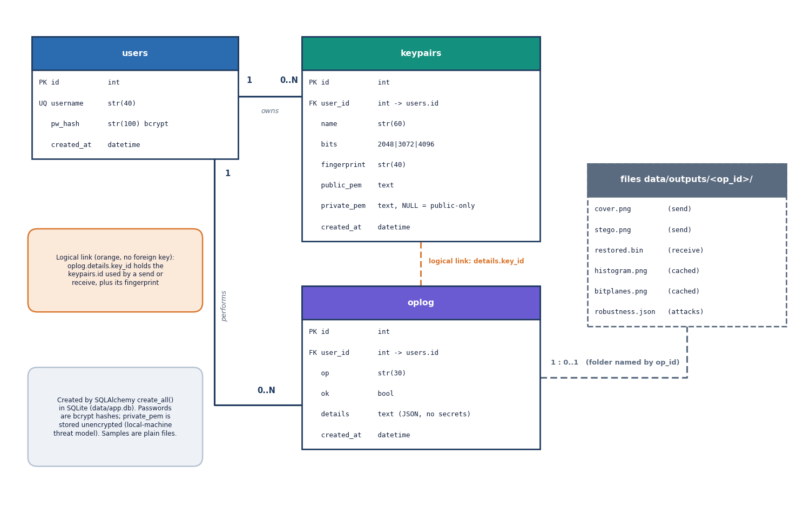
Figure 12: Entity-relationship diagram of the SQLite database: users, keypairs and the operation log.
The database has three tables. One user owns many keypairs and many log rows (1 : n each). A keypairs row stores the public PEM, a SHA-256 fingerprint of the public key (shown as twelve hex pairs) and, only for the owner's own keypairs, the private PEM; an imported recipient key has private_pem empty. The oplog row stores the operation, a success flag and a JSON text of sizes, timings and metrics.
Table 16: Database schema
Table | Columns | Notes
users | id, username (unique, 3-40 characters), pw_hash, created_at | Passwords stored as bcrypt hashes (72-byte limit)
keypairs | id, user_id (FK), name, bits, fingerprint, public_pem, private_pem (nullable), created_at | private_pem is stored unencrypted: a known gap
oplog | id, user_id (FK), op, ok, details (JSON text), created_at | No keys, passwords or file contents are ever passed to the logger

Files are kept beside the database: data/covers/ and data/payloads/ hold the six sample covers and four sample payloads; data/outputs/<operation id>/ holds cover.png, stego.png, the cached histogram and bit-plane images, restored.bin and robustness.json. The database and the outputs are not committed to the repository.

5.6 Module Design
Table 17: Backend modules
Module | Lines | Responsibility
services/crypto.py | 128 | RSA keypairs (2048, 3072, 4096), PEM loading with a 2048-bit floor, fingerprint, bundle encrypt and decrypt
services/lsb.py | 59 | Capacity, embedding and extraction with a 32-bit length prefix, PNG encoding
services/metrics.py | 21 | PSNR, SSIM, MSE, largest change, share of values changed
services/pipeline.py | 55 | hide and reveal with per-stage timings
services/robustness.py | 106 | Nine attacks, bit-error rate, a real decrypt attempt and a verdict per attack
services/benchmark.py, plots.py | 51 + 50 | Capacity and speed tables; histograms and bit-plane charts
routes/ (auth, keys, ops, analysis, samples) | 399 | 24 endpoints with validation, ownership checks and error mapping
auth.py, db.py, config.py, main.py | 171 | bcrypt and JWT, tables, settings from .env, application start-up and the demo account

The frontend has eight pages: Landing, Login, Keys, Send, Receive, Analysis, Robustness and Log, built from a small component set (controls, cards, tables, charts, feedback). A single Axios client adds the token, logs method, path and status to an in-browser activity log, and sends a signed-out user back to the login page on a 401.

5.7 API Design
Table 18: The 24 endpoints (all under /api; JWT required except health and auth)
Group | Endpoints
Health and auth (4) | GET /health; POST /auth/register, /auth/login; GET /auth/me
Keys (5) | GET /keys; POST /keys/generate, /keys/import; GET /keys/{id}/export?part=public|private; DELETE /keys/{id}
Samples (4) | GET /samples/covers, /samples/payloads, /samples/covers/{name}, /samples/payloads/{name}
Operations (3) | POST /send; POST /receive; GET /ops/{id}/cover|stego|restored
Analysis (8) | GET /analysis/{op}, /analysis/{op}/histogram.png, /analysis/{op}/bitplanes.png; POST and GET /robustness/{op}; GET /benchmark/capacity; POST /benchmark/run; GET /log

Errors follow one pattern: a 400 with a plain-language detail for a user mistake (oversize file, wrong key, unreadable image), 401 for a missing or expired token, 404 for something that does not exist or belongs to another user, 409 for a taken username, 413 for an upload above 25 MB and 422 for failed validation.

5.8 Security Design
• Confidentiality. A fresh AES-256 key and 96-bit nonce per message; the key is wrapped under RSA-OAEP with SHA-256 and MGF1-SHA-256; keys below 2048 bits are rejected.
• Integrity. The GCM tag covers the ciphertext and the magic as additional data; the SHA-256 in the header is checked after decryption.
• Access control. HS256 JWT valid for 12 hours; each key and operation is looked up with its owner and answers 404 to anyone else; sample names are resolved from a directory listing and never joined to a path.
• Input limits. 25 MB per upload; username pattern and password length checks; bcrypt on the first 72 bytes.
• Logging. The log records fingerprints and sizes only; a test scans it for key material.
Three gaps are part of the design and are stated rather than hidden: private keys are stored unencrypted in the local SQLite file, so data/app.db must be treated as sensitive; the repository's .env carries a placeholder JWT secret that must be replaced before any real use; and there is no rate limit on login. In addition, embedding is sequential from the first pixel and does not depend on a key, which is why statistical steganalysis can detect medium and high fill [15], [18] (Chapter 8).

5.9 User Interface Design
The console uses a dark theme with a left navigation (Keys, Send, Receive, Analysis, Robustness, Operation log) and a status panel that names the suite (AES-256-GCM, RSA-OAEP, LSB in PNG). Each action page has the same shape: a form on the left with a step indicator (Key, File, Cover, Hide), and the result on the right with the numbers and the images that matter. Errors appear in a red panel that says what failed and what to try, and the Send page warns before the request if the estimated bundle exceeds the cover capacity.
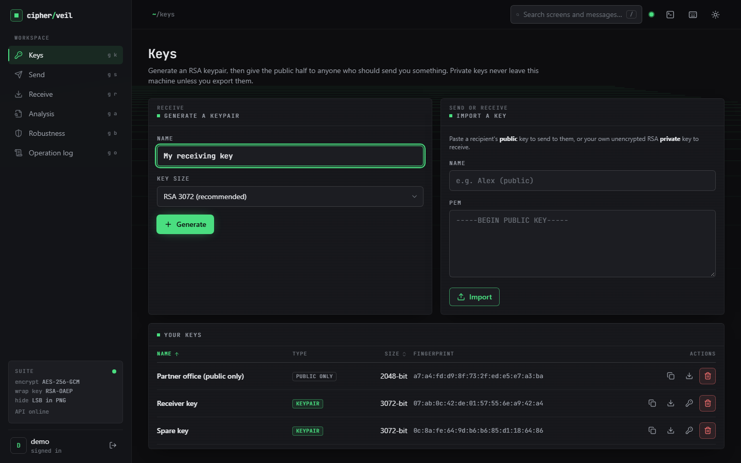  Figure 13: Keys page: two generated RSA-3072 keypairs and one imported public-only RSA-2048 key, with fingerprints. | 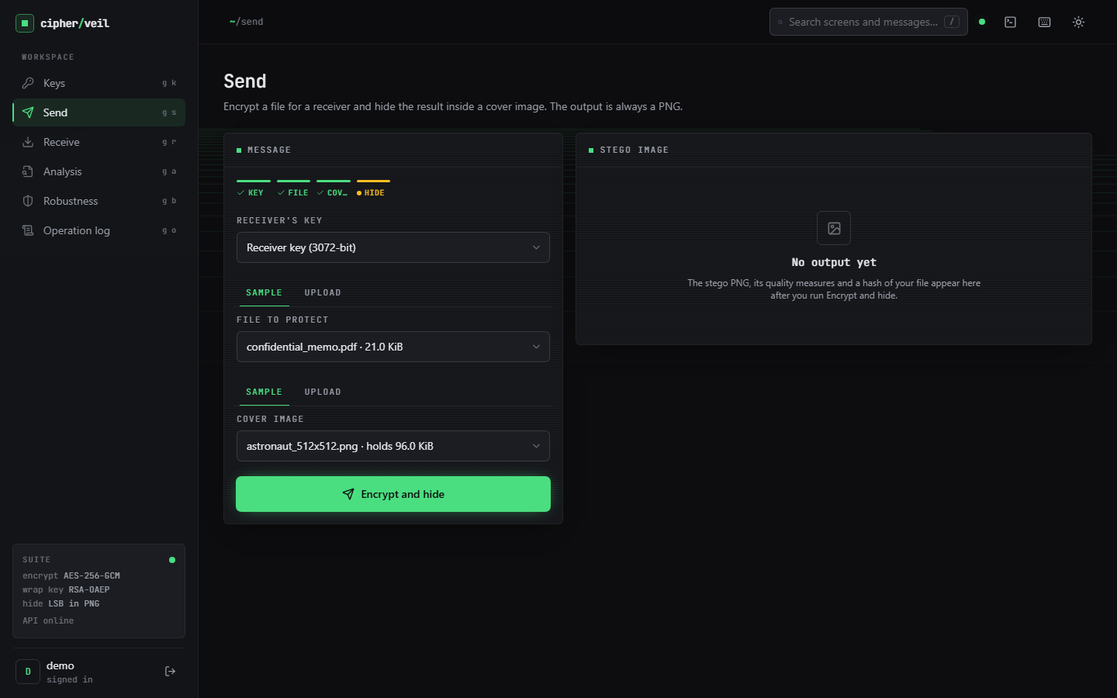  Figure 14: Send page: key, file and cover selected before the request.

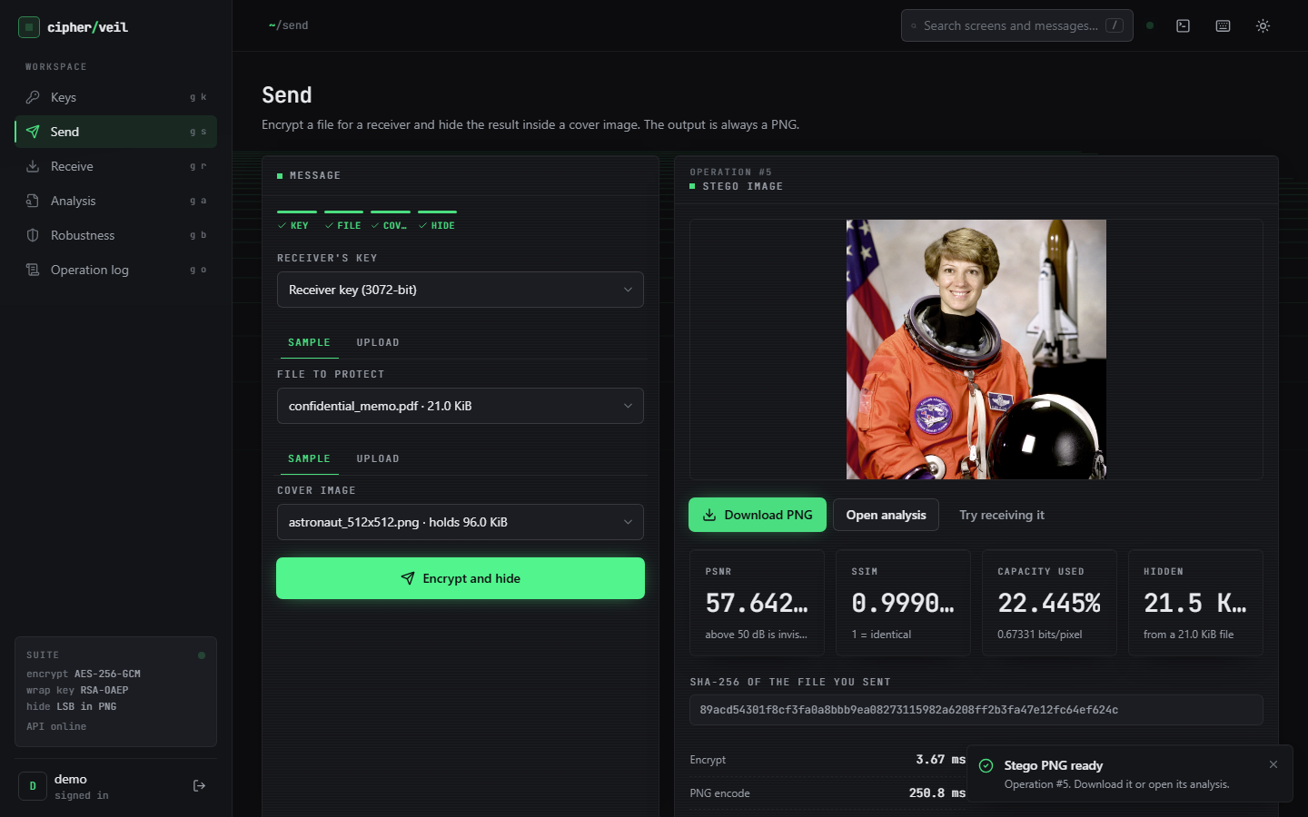  Figure 15: Send result: stego PNG, PSNR 57.642 dB, SSIM 0.9991, 22.445 % of capacity, hash of the sent file. | 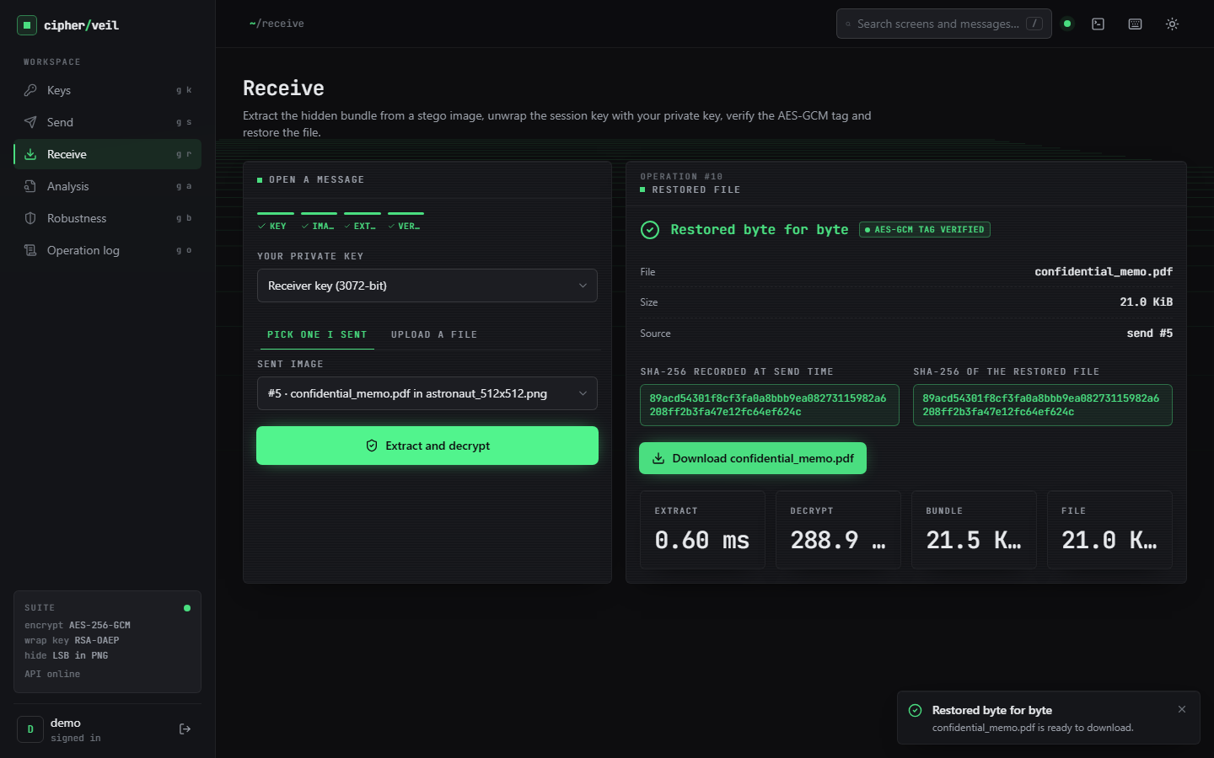  Figure 16: Receive result: tag verified, both SHA-256 values identical, file restored.

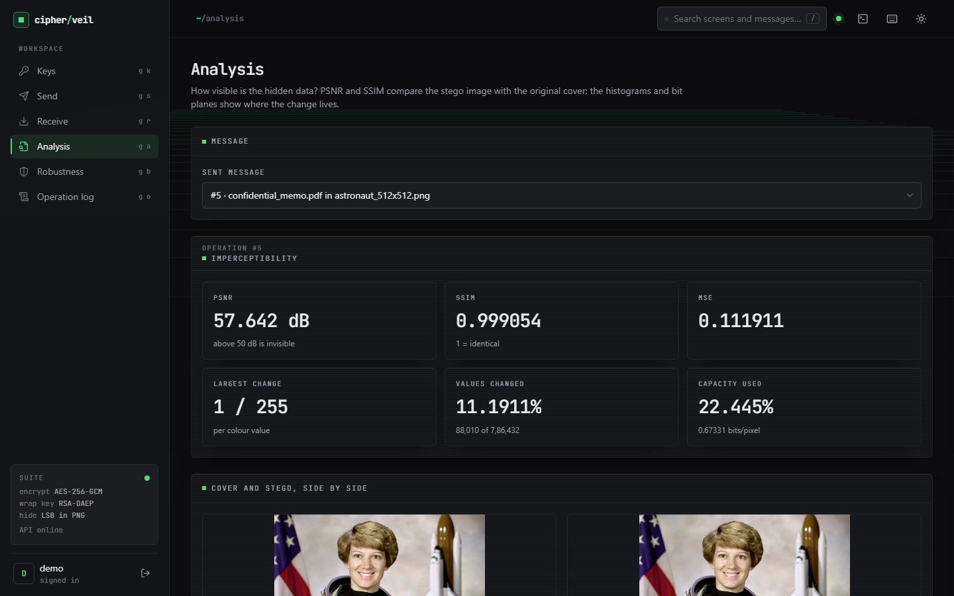
Figure 17: Analysis page: PSNR, SSIM, MSE, largest change, share of values changed and capacity used.
The remaining screens (histograms, bit planes, wrong-key failure, robustness, benchmark and log) are shown with their results in Chapter 8 and in Appendix C.

5.10 Design Decisions and Alternatives
Table 19: Main design decisions
Decision | Chosen | Alternative considered | Reason
Data cipher | AES-256-GCM | AES-CBC with a separate MAC | One authenticated primitive; a flipped bit is rejected before any output
Key transport | RSA-OAEP, SHA-256, 3072-bit default | Raw RSA, PKCS#1 v1.5, ECC | OAEP is the recommended RSA encryption padding [24], [23]; RSA keeps the key-pair story simple for a user
Session key | Fresh per message | One key per receiver | A compromised message key never exposes another message
Embedding | 1 bit per R, G, B value, sequential | Key-driven permutation, LSB matching, adaptive embedding | Simplest scheme with a closed-form PSNR and 3.0 bits per pixel; the stronger schemes [12], [13] are future work
Carrier format | PNG, RGB, alpha dropped | JPEG domain embedding | Lossless carrier keeps spatial LSBs exact; the price is that only lossless handling survives
Length header | 32 bits in the first LSBs | Terminator pattern | Capacity check and extraction need the length; a bad header is detected early
Persistence | SQLite via SQLAlchemy | Files only, or a server database | One file, no service to install; enough for a local tool
Service shape | Plain functions, shared pipeline | Class hierarchy per stage | The API, the benchmark and the evaluation run exactly the same code

Two of these choices carry the main trade-off of the project: a fixed, key-independent embedding order makes the arithmetic exact and the evaluation simple, but also makes the hiding detectable at medium and high fill; and the choice of a lossless carrier makes the extraction exact but limits the usable channels. Both are measured in Chapter 8.

5.11 Summary
The design keeps the cryptography and the embedding in small pure functions, shares one send and receive sequence between the API and the evaluation, scopes every key and operation to its owner, and records measurements instead of secrets. Chapter 6 gives the methodology and the implementation that realise it.

CHAPTER 6: METHODOLOGY AND SOFTWARE IMPLEMENTATION

6.1 Overall methodology
CipherVeil treats data protection as one measurable pipeline with two layers. The first layer is cryptographic: a file is encrypted with a fresh AES-256-GCM key, and that key is wrapped with the receiver's RSA public key. The second layer is steganographic: the resulting byte bundle is written into the least significant bits of a cover image and saved as a PNG. The base paper [1] hides secret bits among random decoy bits so that an untrusted party can compute on them; CipherVeil keeps its choice of the least significant bit as the carrier but pursues a different goal, moving a whole file from a sender to a receiver, and so adds standard authenticated encryption, a capacity check and a measurement of what the hiding costs.
The work was carried out in six steps, each with a check that decides whether the step is finished.
1. Choose the primitives. AES-256-GCM, RSA-OAEP with SHA-256, and one-bit LSB substitution in the three colour channels, all from well-reviewed standards and libraries, with no new cryptography.
2. Fix the bundle format. One self-describing byte string (magic, wrapped key, nonce, ciphertext with tag) so that the receiver needs nothing but the image and a private key.
3. Build the pipeline. crypto.py, lsb.py, metrics.py and pipeline.py as pure functions with no web code, so the same functions serve the API, the benchmark, the evaluation script and the tests.
4. Wrap it in an application. A FastAPI service with login, key storage, send, receive, analysis, robustness and log routes, and a React console for the eight screens.
5. Measure. ml/eval.py (22 round trips, nine attacks) and scripts/run_experiments.py (RSA key size, fill ratio, plain against encrypted bits, steganalysis, tamper study, extra attacks).
6. Test. 39 automated tests, a 21-check smoke script against the running server, and a screen walk with real data.
Figure 18: Methodology as a pipeline: key generation, encryption, wrapping, capacity check, embedding, extraction, decryption and measurement.

6.2 Data
CipherVeil learns nothing from data, so there is no training set, validation set or test split, and none of the results depends on a random split. What the evaluation needs is a set of cover images of different sizes and content and a set of payloads of different sizes. Both are small, are committed to the repository, and are regenerated by the seeded script scripts/make_samples.py. Any image or file uploaded at run time can replace them, up to 25 MB.
Table 20: Cover images used in every experiment.
Cover | Pixels | File size | Source and licence
astronaut_512x512.png | 512 x 512 | 422,355 B | scikit-image data.astronaut(), NASA photograph, public domain
cat_451x300.png | 451 x 300 | 218,916 B | scikit-image data.chelsea(), CC0
coffee_600x400.png | 600 x 400 | 441,801 B | scikit-image data.coffee(), CC0
coffee_small_200x200.png | 200 x 200 | 70,651 B | crop and resize of data.coffee(), CC0
generated_landscape_1280x720.png | 1280 x 720 | 1,234,411 B | procedural, seed 11, generated for this project
rocket_640x427.png | 640 x 427 | 303,107 B | scikit-image data.rocket(), public domain

Table 21: Payloads used in the experiments.
Payload | Size | Nature
accounts.csv | 2,774 B | synthetic table of accounts, generated here; used for the robustness grid
confidential_memo.pdf | 21,517 B | synthetic one-page memo, generated here
meeting_notes.txt | 169 B | synthetic text
settings.json | 99 B | synthetic JSON

The core evaluation crosses the six covers with random payloads of 1, 4, 16, 64 and 128 KiB: 30 combinations, of which 22 fit and 8 are blocked by the capacity check (Section 6.5.1). The fill-ratio study crosses the six covers with seven fill levels from 1 % to 100 % and five random payload seeds, 210 embeddings in all. Three limits of this data are stated here because later chapters depend on them: the covers are six images, none taken by a camera; the payloads are small and synthetic; and the photographs are natural-image samples shipped with a library, so the statistics seen by the steganalysis experiments are those of these six images only.

6.3 Preprocessing
The only preprocessing is in lsb.load_rgb. Whatever the user uploads is opened with Pillow, fully decoded, converted to three 8-bit channels (RGB) and held as an array of shape height x width x 3. An alpha channel is therefore dropped, a palette or grey-scale image is expanded to RGB, and an input that Pillow cannot read as an image is rejected with a clear message. The payload is not preprocessed at all: it is hashed with SHA-256, given a small JSON header and encrypted as raw bytes, so any file type works and no compression is applied. On the way out the stego array is written as PNG (compression level 6), the only output format, because PNG is lossless and the hidden bits must survive storage. Section 7.6 shows that an RGBA input round-trips and that re-saving as PNG or lossless WebP keeps the payload while JPEG at quality 100 does not.
def load_rgb(source) -> np.ndarray:
"""Accept bytes or a path; return an HxWx3 uint8 array (alpha dropped)."""
try:
img = Image.open(io.BytesIO(source) if isinstance(source, (bytes, bytearray)) else source)
img.load()
except Exception as exc:
raise StegoError("Could not read this file as an image") from exc
return np.array(img.convert("RGB"), dtype=np.uint8)

6.4 Algorithm choice and justification
Each stage uses the standard component for its job. The table gives the choice, the reason, and the alternatives that were considered and left out; every one of the left-out alternatives is worth doing and is listed as future work in Chapter 10, but none was part of the objectives set for this project.
Table 22: Algorithm choices.
Stage | Chosen | Why | Left out
Data encryption | AES-256-GCM [20], [21] | Authenticated: a flipped bit or wrong key fails the tag check and nothing is released; fast; available in cryptography | CBC or CTR plus a separate MAC; stream ciphers
Key transport | RSA-OAEP, SHA-256, MGF1-SHA-256 [22], [23], [24] | Public-key wrap lets the sender encrypt without a shared secret; OAEP is the padding recommended for encryption; 2048 to 4096 bits | Key agreement (ECDH), elliptic-curve keys, post-quantum KEMs
Session key | Fresh 256-bit key and 96-bit nonce per message | One compromised message key never exposes another; no nonce reuse | Key derived from a password
Carrier | PNG, RGB, 8 bits per channel | Lossless; widely supported; 3 values per pixel | JPEG-domain, audio, video carriers
Embedding | 1-bit LSB replacement, row-major from the first pixel [11], [8] | Simplest scheme with the highest capacity (3.0 bits per pixel) and a closed-form cost; easy to verify byte for byte | LSB matching [12], syndrome-trellis codes [13], key-driven permutation, error-correcting codes [3]
Quality measure | PSNR, MSE, SSIM [27], [26] | Standard imperceptibility measures; stated as objective 5 | Perceptual or learned metrics
Detection check | Chi-square [15] and weighted stego [18], [19] | Two classical detectors that are simple enough to implement and verify here | RS [16] and sample-pair [17] analysis, learned detectors

The most consequential choice is plain sequential LSB replacement. It is the only embedding for which the cost of hiding can be written in one line (Section 6.5.5) and for which every claim can be checked byte for byte, and it matches the base paper's carrier. Its price is known and measured in this project rather than hidden: it does not survive any lossy operation, and its sequential, key-independent layout is detected by the chi-square test in 30 of 30 cases and tracked by the weighted-stego estimate (Chapter 8).

6.5 Mathematical formulation

6.5.1 Bundle length and capacity
Let the file have n bytes and the receiver's RSA key have k bits. The header is a JSON object with the file name, the size and the SHA-256 of the file, of h bytes (116 bytes for accounts.csv, 126 for confidential_memo.pdf). The plaintext under AES-GCM is a two-byte header length, the header and the file. The bundle that is hidden has length L, and a cover of W x H pixels holds C bytes:
L = 4 (magic) + 2 + k/8 (wrapped key) + 12 (nonce) + (2 + h + n) + 16 (tag) = n + h + k/8 + 36 (1)
C = ⌊(3 · W · H − 32) / 8⌋, the send is accepted only if L ≤ C, used = L / C (2)
The 32 bits are the length prefix. For RSA-2048 the overhead L − n is 408 bytes for accounts.csv and 418 for the memo; for a short file name it is 401, 529 and 657 bytes at 2048, 3072 and 4096 bits. The capacity is 3.0 bits per pixel on every cover (2.999 for the 200 x 200 image because of the 32-bit prefix): 3.0 bits per pixel, from 14.6 KiB for the smallest cover to 337.5 KiB for the 1280 x 720 landscape.

6.5.2 Authenticated encryption
AES-GCM with key K, nonce ν and additional data A = CVL1 produces a ciphertext and a 128-bit tag T:
(C_t, T) = AES-GCM-Enc(K, ν, A, M), M = header_len ‖ header ‖ file (3)
Decryption recomputes the tag in constant time and releases M only if it matches. Because the magic is bound in as additional data, a bundle with a different magic fails even if the rest is intact. A change of any single ciphertext, nonce or tag bit therefore causes rejection with overwhelming probability; the tamper study in Chapter 7 confirms this for 240 of 240 flips.

6.5.3 Key wrapping
The 32-byte session key K is encrypted with the receiver's RSA public key (n_r, e = 65537) using OAEP with SHA-256 for both the hash and the mask generation function. The output is exactly k/8 bytes, which is why the receiver can check, before any private-key operation, that the wrapped-key length equals the length of its own key and reject a bundle sent to a key of a different size:
W = RSA-OAEP-Enc(pk_r, K), K = RSA-OAEP-Dec(sk_r, W), |W| = k/8 (4)

6.5.4 Imperceptibility measures
Let X be the cover and Y the stego image, with N = 3 · W · H colour values in 0..255. The mean squared error, the PSNR and the structural similarity are:
MSE = (1/N) Σ (X_i − Y_i)², PSNR = 10 · log10(255² / MSE) dB (5)
SSIM = mean over channels c of ((2 μ_X μ_Y + c1)(2 σ_XY + c2)) / ((μ_X² + μ_Y² + c1)(σ_X² + σ_Y² + c2)) (6)
The implementation uses scikit-image with data range 255; PSNR is reported as undefined (infinite) when no value changed, and SSIM is averaged over the three channels. Above 50 dB the difference is conventionally treated as invisible [27]; the application shows that threshold next to every result.

6.5.5 A closed form for the cost of hiding
Replacing the least significant bit of a value changes the value by exactly one when the new bit differs from the old one and not at all otherwise. Encrypted bits are uniformly random, so each embedded bit changes its value with probability one half. If B = 8 (L + 4) bits are embedded, the expected squared error per value is the number of changed values divided by N:
E[MSE] = (0.5 · B) / N, PSNR ≈ 10 · log10(255² · N / (0.5 · B)) (7)
This depends only on the number of embedded bits, not on the image content. Over 210 embeddings the measured mean PSNR agrees with the formula to within 0.053 dB, and the standard deviation across five random payloads is at most 0.0987 dB. Filling the whole cover (B = N) gives the floor 10 · log10(255² / 0.5) = 51.14 dB, which is what the measurements show (51.14 to 51.17 dB at 100 % fill). The table gives the six-cover averages.
Table 23: Measured PSNR and the closed form, averaged over the six covers (five payload seeds each).
Fill of capacity | Capacity used (%) | PSNR measured (dB) | PSNR formula (dB) | SSIM
1 % | 1.8 | 68.93 | 68.94 | 0.99995
5 % | 5.8 | 63.58 | 63.57 | 0.99975
10 % | 10.7 | 60.85 | 60.85 | 0.99952
25 % | 25.5 | 57.07 | 57.07 | 0.99880
50 % | 50.3 | 54.13 | 54.13 | 0.99766
75 % | 75.0 | 52.39 | 52.39 | 0.99639
100 % | 99.9 | 51.15 | 51.15 | 0.99507

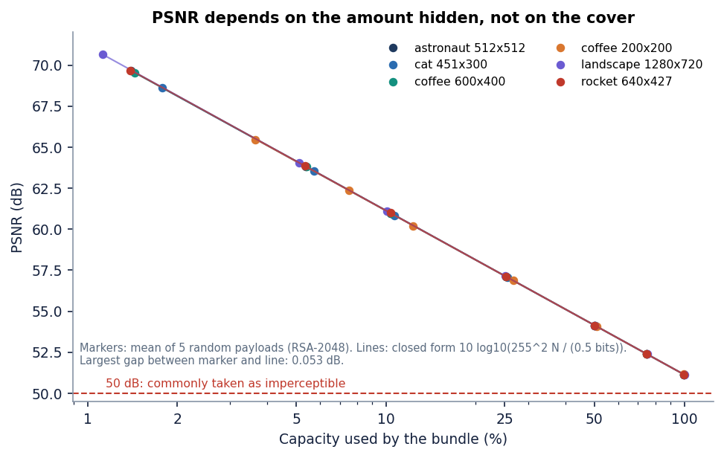
Figure 19: Measured PSNR against the fraction of capacity used for the six covers, with the closed-form curve.

6.5.6 Robustness and detection measures
For each attack the stego image is modified, the whole extract-and-decrypt path is run with the real private key, and the recovered file's SHA-256 is compared with the original. The LSB error rate is the fraction of the first (L + 4) · 8 least significant bits that differ before and after the attack; a value near 0.5 means the bits are as good as random. Two detectors are applied to the cover and the stego image. The Westfeld-Pfitzmann chi-square statistic compares the counts h(2j) and h(2j+1) of each pair of values with their mean e_j = (h(2j) + h(2j+1)) / 2:
χ² = Σ_j (h(2j) − e_j)² / e_j (pairs with e_j ≥ 5), p = 1 − F_χ²(χ²; df = pairs − 1) (8)
Embedding random bits equalises each pair, so p close to 1 on the embedded region signals LSB replacement. The weighted-stego estimate predicts each value from its four neighbours and measures how far the LSB flip moves the value toward that prediction; it returns the embedded fraction of the image. Both are implemented in scripts/run_experiments.py as measurements, not as part of the product.

6.6 Pipeline architecture
The pipeline is two functions in pipeline.py that call small, independently tested services. hide encrypts, checks capacity, embeds, encodes the PNG and computes the quality measures, and times each stage; reveal extracts, unwraps, verifies and hashes. Nothing in these functions knows about HTTP, the database or the screen.
Figure 20: Layout of the CVL1 bundle and its placement in the least significant bits of the cover.
Figure 21: Flowchart of the send and receive algorithm with the points at which a request is rejected.
The embedding and extraction functions are the heart of the system and are short enough to quote in full. Embedding builds the framed bit stream (32-bit length followed by the bundle), unpacks it to bits and overwrites the lowest bit of the first B values; extraction reads the length, refuses an implausible one, and repacks the following bits.
def embed(arr: np.ndarray, bundle: bytes) -> np.ndarray:
cap = capacity_bytes(arr)
if len(bundle) > cap:
raise StegoError(f"Payload needs {len(bundle)} bytes but this cover holds only {cap} bytes. "
"Choose a larger cover or a smaller file.")
framed = len(bundle).to_bytes(4, "big") + bundle
bits = np.unpackbits(np.frombuffer(framed, dtype=np.uint8))
flat = arr.reshape(-1).copy()
flat[:bits.size] = (flat[:bits.size] & 0xFE) | bits
return flat.reshape(arr.shape)

def extract(arr: np.ndarray) -> bytes:
flat = arr.reshape(-1)
if flat.size < LEN_BITS:
raise StegoError("Image is too small to contain a payload")
length = int.from_bytes(np.packbits(flat[:LEN_BITS] & 1).tobytes(), "big")
if length == 0 or length > capacity_bytes(arr):
raise StegoError("No hidden payload found (length header is invalid)")
bits = flat[LEN_BITS:LEN_BITS + length * 8] & 1
return np.packbits(bits).tobytes()

Across the 22 evaluated runs (RSA-3072) the median stage times are 0.15 ms to encrypt and wrap, 0.25 ms to embed, 0.05 ms to extract and 86.37 ms to unwrap and decrypt; the private-key operation is the only cost that is noticeable, and it is paid once per message.

6.7 Application architecture
The application has three tiers. The browser console is a React 18 single-page application built with Vite and styled with Tailwind CSS; it has eight screens (landing, login, keys, send, receive, analysis, robustness and benchmark, operation log) and talks to the backend only through an axios client that adds the bearer token. The backend is a FastAPI application on port 8315 with five routers (auth, keys, samples, operations and analysis), a thin layer of services, and SQLAlchemy models over SQLite. Files that are too large for a row (cover and stego PNGs, restored files, plots) are written to data/outputs/<operation id>/. The Vite development server on port 5315 proxies /api to the backend, so the browser sees one origin.
Table 24: Backend modules and their responsibilities.
Module | Lines | Responsibility
services/crypto.py | 128 | RSA key generation and checks, fingerprint, bundle encryption and decryption
services/lsb.py | 59 | Image loading, capacity, embed, extract, PNG encoding, LSB stream
services/metrics.py | 21 | PSNR, SSIM, MSE, largest change, values changed
services/pipeline.py | 55 | hide and reveal, with per-stage timings
services/plots.py | 50 | Histogram and bit-plane figures
services/robustness.py | 106 | Nine attacks, real decrypt attempt, error rate and explanation
services/benchmark.py | 51 | Capacity table and speed and quality benchmark
routes/ (5 files) | 399 | Request validation, ownership checks, logging, responses
auth.py, db.py, config.py, main.py | 171 | bcrypt and JWT, three tables, settings, application and demo user

The database has three tables. users holds the name and the bcrypt hash; keypairs holds the name, size, fingerprint, public PEM and, for a keypair the user owns, the private PEM (empty for an imported public key); oplog holds one row per operation with a JSON details field. Everything the log records is a size, a time, a metric, a file name or a key fingerprint; keys and file contents are never passed to it, and a test searches the log for key material.
Figure 22: System architecture of CipherVeil: browser console, FastAPI application, services and storage.

6.8 API design
All 24 routes sit under /api. Three are public (register, login and the health probe); the other 21 require a bearer token issued at login. Requests that carry files are multipart forms; the rest are JSON. Every failure returns a JSON body with a detail message that the console shows together with a hint.
Table 25: The 24 API routes.
Group | Method and path | Purpose
Auth | POST /api/auth/register, /login | Create an account or sign in; returns a 12-hour token
Auth | GET /api/auth/me | Current user
Keys | GET /api/keys | List the user's keys with fingerprints (no private PEM)
Keys | POST /api/keys/generate | Generate an RSA keypair of 2048, 3072 or 4096 bits
Keys | POST /api/keys/import | Import a public key (recipient) or an unencrypted private key (keypair)
Keys | GET /api/keys/{id}/export?part=public|private | Download a PEM; private export is logged
Keys | DELETE /api/keys/{id} | Delete a key
Samples | GET /api/samples/covers, /payloads | List sample covers (with capacity) and payloads
Samples | GET /api/samples/covers/{name}, /payloads/{name} | Download one sample
Operations | POST /api/send | Encrypt a file and hide it in a cover; returns metrics, capacity and timings
Operations | POST /api/receive | Extract, decrypt and verify; returns hashes and timings
Operations | GET /api/ops/{id}/cover, /stego, /restored | Download the files of an operation
Analysis | GET /api/analysis/{op} | Metrics of a send
Analysis | GET /api/analysis/{op}/histogram.png, /bitplanes.png | Plots, rendered once and cached
Analysis | POST /api/robustness/{op}; GET /api/robustness/{op} | Run the nine attacks; read the last report
Analysis | GET /api/benchmark/capacity; POST /api/benchmark/run | Capacity table; speed and quality benchmark
Analysis | GET /api/log | The user's operations, newest first, optional filter
System | GET /api/health | Liveness

Two design points are worth noting. First, send and receive return everything the screen needs in one response (metrics, capacity, timings, hashes), so each screen costs one round trip. Second, the sample routes resolve a name by listing the directory and comparing names, never by joining a user string to a path, which removes path traversal by construction.

6.9 Security and error handling
Security measures present in the code are the following. Passwords are stored as bcrypt hashes and limited to 72 bytes, the bcrypt maximum; tokens are HS256 JWTs that expire after 12 hours. Every key and every operation is fetched with a check that it belongs to the requesting user. RSA keys below 2048 bits are rejected on generation and on import. A bundle is rejected before any private-key operation if its magic is wrong or its wrapped-key length does not match the key, and the AES-GCM tag is verified before any plaintext is returned. Uploads are capped at 25 MB. CORS allows only the two local front-end origins.
The weaknesses are equally part of the design and are stated plainly. Private keys are stored unencrypted in the local SQLite file, so data/app.db is as sensitive as the keys. The shipped .env carries a placeholder JWT_SECRET that must be replaced for any shared use. There is no rate limit on login, the token is kept in the browser's local storage, and there is no sender authentication: anyone who holds the receiver's public key can send, and the receiver cannot tell who did.
Table 26: Errors the application detects and what the user sees.
Situation | Detected by | Response
Cover too small for the bundle | lsb.embed capacity check | 400: payload needs L bytes, cover holds only C bytes
Empty file, or file over 25 MB | send route | 400, or 413 "File is larger than 25 MB"
Upload is not an image | lsb.load_rgb | 400: could not read this file as an image
Image carries no payload | lsb.extract length check | 400: no hidden payload found
Bundle is not CipherVeil's | magic check | 400: no CipherVeil bundle found in this image
Wrong key size | wrapped-key length | 400: wrapped for a different key size
Wrong key, same size | RSA-OAEP decryption | 400: RSA unwrap failed - this is not the key the message was sent to
Image changed after sending | AES-GCM tag | 400: tag check failed - the data was modified
Public-only key used to receive | receive route | 400: no private key
Bad credentials, duplicate name, weak input | auth route and schema | 401, 409, 422
Missing or expired token | current_user | 401; the console returns to the login page
Unknown key, operation or sample | ownership and listing checks | 404

A send or receive that fails on a capacity, image or cryptographic error is also written to the log with its message, so the failure is visible afterwards without exposing any secret.

6.10 Installation and execution
CipherVeil runs offline on Windows with Python 3.11 or later and Node.js. It needs no API key, dataset or special hardware. The steps are:
1. Run setup.bat once. It creates the venv folder, installs the pinned Python packages (FastAPI 0.115.6, SQLAlchemy 2.0.36, cryptography 44.0.0, Pillow 11.0.0, NumPy 2.1.3, scikit-image 0.24.0, matplotlib 3.9.3, PyJWT, bcrypt), regenerates the sample covers if they are missing, and runs npm install in frontend.
2. Run run.bat. It opens the backend on port 8315 and the frontend on port 5315 in two windows and opens the browser. The ports are fixed in .env.
3. Sign in with the demo account demo / Demo@12345, which the backend creates at first start, or register a new account.
4. Follow the screens in order: Keys (generate a keypair), Send (choose key, file and cover; encrypt and hide; download the PNG), Analysis, Receive (choose the key and the stego image), Robustness and Log.
5. Check the installation with venv\Scripts\python -m pytest (39 tests), venv\Scripts\python scripts\smoke_test.py against the running backend (21 checks), venv\Scripts\python ml\eval.py (writes experiments/eval/metrics.json), and npm run build in frontend.
If the browser shows a blank page or a 502, the backend window did not start and its output explains why. If a port is busy, change it in .env. If the recipient cannot open an image, it was almost certainly re-encoded by a messaging application; send the PNG as a file or in an archive. Appendix B gives the complete user guide.

CHAPTER 7: SYSTEM TESTING

7.1 Testing strategy
CipherVeil was delivered with a single end-to-end smoke script and an evaluation script. The documentation run added an automated test suite, a tamper study and the measurement scripts. The cryptographic and steganographic services are deterministic functions of their inputs (apart from the random session key and nonce), so they are tested at unit level with exact assertions: a round trip must return the original bytes, a flipped bit must be rejected, and the PSNR of a known change must equal its closed-form value. The API is tested through FastAPI's test client against a scratch database and a scratch output folder, so tests never touch the user's data, and through a smoke script against a running server. The screens were walked with real data and captured by a Playwright script; that walk is evidence that the screens work, not an automated assertion suite.
Table 27: Test levels, tools and results.
Level | Tool and scope | Count | Result
Unit | pytest: tests/test_crypto.py, test_lsb.py, test_metrics_pipeline.py | 29 tests | All passed
API and component | pytest with FastAPI TestClient: tests/test_api.py | 10 tests | All passed
Integration | scripts/smoke_test.py against the running API (127.0.0.1:8315) | 21 checks | 21 of 21 passed
Round-trip evaluation | ml/eval.py: 6 covers x 5 payload sizes | 22 runs (8 blocked by capacity) | 22 of 22 byte-exact
Security | Tamper study: one flipped stego LSB, 6 bundle fields | 240 trials | 240 of 240 rejected
Robustness | Nine attacks x 6 covers, plus nine more channel changes | 54 + 54 attempts | Only lossless handling survives (Chapter 8)
Performance | Median timings of services and of the API | see Section 7.7 | Measured
Screens | Playwright walk of all eight screens, 18 captures | 18 screens | All rendered with real data

All 39 automated tests pass in about 8 to 12 seconds on the measurement machine. Test files and scripts are part of the repository (tests/, scripts/smoke_test.py, scripts/run_experiments.py), so every result in this chapter can be reproduced with one command.

7.2 Unit tests
The 29 unit tests are split by module. The table lists each file and what its tests assert; a parametrised test counts once per parameter.
Table 28: Unit tests by file.
File | Tests | What is asserted
test_crypto.py | 13 | Round trip with path stripped from the stored name; overhead matches the bundle layout; a fresh key and nonce per message (two encryptions of the same data differ); wrong private key rejected; key-size mismatch rejected before any private-key operation; tampered ciphertext, nonce or tag rejected (three positions); tampered wrapped key rejected; truncated, foreign-magic and empty bundles rejected; key sizes below the policy rejected; fingerprint stable; public key derivable from private key
test_lsb.py | 9 | Capacity equals (3WH - 32) / 8; exact round trip for 1 byte, 17, 1,000 bytes and a payload that fills the cover exactly; only the lowest bit plane changes and by at most 1; values after the payload are untouched; oversize payload rejected; a clean cover yields no decryptable bundle; PNG encoding is lossless; alpha channel dropped; a non-image is rejected
test_metrics_pipeline.py | 7 | Identical images give undefined PSNR and SSIM 1; PSNR of exactly 1,000 changed values equals the closed form within 0.01 dB; pipeline round trip with PSNR above 50 dB and largest change 1; a full cover gives 50.9 to 51.5 dB (the theoretical floor); lossless attacks recover and the seven destructive ones do not, with error rates between 0.3 and 0.7; the benchmark marks oversize rows; capacity table gives 3.0 bits per pixel

Two of these tests deserve a remark. The closed-form PSNR test is a check of the specification as well as the code: it fails if the metric is computed over a different set of values or with a different data range. The floor test embeds a random payload that fills the cover and requires a PSNR between 50.9 and 51.5 dB; it would fail if the embedding wrote more than one bit per value or changed values by more than one.

7.3 Integration testing
scripts/smoke_test.py drives a running backend over HTTP using only the standard library, in the order a user would: 21 checks, all of which pass. It logs in as the demo user, generates an RSA-3072 and an RSA-2048 keypair, sends the sample memo into the astronaut cover, reads the metrics (PSNR above 50 dB, SSIM above 0.999, no value moved by more than 1, input hash recorded), fetches the histogram and bit-plane images, downloads the stego PNG and submits it as a fresh upload, and requires the restored file to be byte-identical with equal hashes.
• Rejections: the second keypair is refused as a wrong private key; the original cover is refused as an image with no payload.
• Robustness: a lossless re-save survives; JPEG at quality 95 and 50, noise and the left crop destroy the payload.
• Capacity: the same memo into the 200 x 200 cover is blocked with the capacity message.
• Housekeeping: the capacity table lists six covers; the log contains the key, send, receive and robustness operations and contains no key material.

7.4 Functional testing
Each feature of the application was exercised on the running system with real data. The table maps the seven features to the evidence.
Table 29: Functional test cases.
# | Feature | Action and expected result | Evidence | Result
F1 | Keys | Generate RSA-3072 and RSA-2048 keypairs; import a public-only key; fingerprints shown | test_key_lifecycle; screen 04 | Passed
F2 | Send | Encrypt the memo into the astronaut cover; stego PNG, PSNR 57.642 dB, SSIM 0.9991, 22.445 % used | test_send_receive_end_to_end; screens 05-06 | Passed
F2 | Send (capacity) | A 22,063-byte bundle into a 14,996-byte cover is blocked with the sizes in the message | test_capacity_check_blocks_oversize; screen 07 | Passed
F3 | Receive | Extract and decrypt; both SHA-256 values equal; file downloadable | test_send_receive_end_to_end; screen 11 | Passed
F3 | Receive (wrong key) | A same-size wrong keypair fails with the RSA unwrap message and releases nothing | test_receive_failure_paths; screen 12 | Passed
F4 | Analysis | PSNR, SSIM, MSE, histograms and bit planes of a send | test_analysis_images_and_robustness; screens 08-10 | Passed
F5 | Capacity and timings | Capacity per cover; timings per stage; benchmark rows with blocked rows marked | smoke test; screens 15-16 | Passed
F6 | Robustness | Nine attacks; two survive, seven lose the payload; verdict shown | test_robustness_lossless_survives_lossy_destroys; screens 13-14 | Passed
F7 | Log | Operations with sizes, timings, metrics; failures visible; no secrets | test_log_never_contains_key_material; screens 17-18 | Passed

Registration and login validation (user name length, password length, duplicate user, wrong password) is covered by test_register_login_validation.

7.5 Security testing
The central security claim of the hybrid scheme is that nothing is released unless the key is right and the data is untouched. It was tested directly. The tamper study takes a stego image of the astronaut cover holding a 4 KiB random payload (RSA-2048), flips exactly one least significant bit at a random position inside each of six regions of the embedded bundle, and runs the real extract-and-decrypt path. Forty flips per region, 240 in all: 0 were accepted with wrong data, and every flip was rejected.
Table 30: Tamper study: one flipped LSB in each region of the bundle.
Region of the bundle | Flips | How it was rejected
length header | 40 | bad length header x13; AES-GCM tag check failed x27
magic | 40 | No CipherVeil bundle found in this image x40
wrapped-key length | 40 | This bundle was wrapped for a different key size x40
wrapped key | 40 | RSA unwrap failed x40
nonce | 40 | AES-GCM tag check failed x40
ciphertext and tag | 40 | AES-GCM tag check failed x40

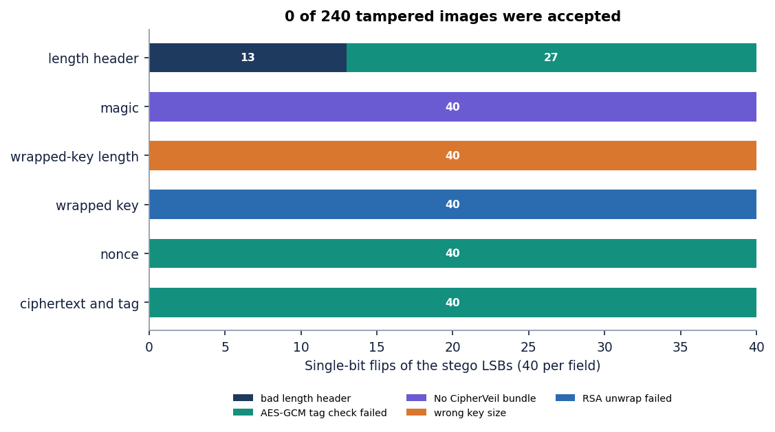
Figure 23: Outcome of the 240 single-bit tamper trials by region of the bundle.
A flip in the length prefix is caught in one of two ways: 13 of the 40 produce an implausible length and are refused at extraction, and the other 27 change the number of bytes read, so the tag check fails. The other checks are:
• Wrong key, same size: RSA-OAEP decryption fails and the message names the key as the cause (test_wrong_private_key_rejected; test_receive_failure_paths).
• Wrong key size: rejected from the wrapped-key length before any RSA operation (test_key_size_mismatch_rejected).
• Truncated, foreign and empty bundles: rejected (test_truncated_and_foreign_bundles).
• Path traversal: requests for ..%2F..%2F.env and ..%5C..%5C.env as sample names return 404 (test_sample_names_cannot_escape_folder).
• Secrets in the log: a search of 500 log entries for BEGIN and PRIVATE finds nothing (test_log_never_contains_key_material).
• Key policy: generating a 1,024-bit key is refused (test_key_lifecycle); a public key imported as recipient cannot export a private part.
• Freshness: 50 encryptions of one file under one key gave 50 distinct nonces and 50 distinct wrapped keys; the mean bit difference between two bundles was 0.4992, as expected for independent random keys.
What was not tested is as important. The ownership checks that stop one user opening another's key or operation are in the code but no test logs in as a second user to try it. The 25 MB upload cap is in the code but no test sends 25 MB. No penetration test, fuzzing campaign or timing-side-channel analysis was done, and the application inherits the properties of the cryptography library rather than proving them.

7.6 Validation and edge cases
Table 31: Edge cases and their outcomes.
Case | Expected | Outcome | Where checked
Payload fills the cover exactly | Embeds and extracts | Byte-exact | test_round_trip_exact
One byte over capacity | Rejected with sizes | Rejected: payload needs N bytes, cover holds only C | test_oversize_rejected
One-byte payload | Works | Byte-exact | test_round_trip_exact
Empty file | Rejected | 400 | test_empty_upload_rejected
Upload that is not an image | Rejected | 400: could not read as an image | test_non_image_rejected
Cover with an alpha channel | Accepted, alpha dropped | Shape (H, W, 3); PNG with alpha also survives re-save | test_alpha_channel_dropped; extra attack grid
Image with no payload | No plausible bundle | Rejected, never decrypts | test_clean_cover_has_no_decryptable_payload
Smallest cover (200 x 200) with the memo | Blocked | Blocked by the capacity check | smoke test; screen 07
PNG re-saved at compression 9, with alpha, or as lossless WebP | Payload survives | 6 of 6 covers each | run_experiments, group G
JPEG quality 100, lossy WebP q90, grayscale, rotate 90, flip, 256-colour palette | Payload lost | 0 of 6 covers each | run_experiments, group G
Crop bottom 10 % / crop left 10 % | Survives / lost | 6 of 6 / 0 of 6 | ml/eval.py

The two rows at the bottom of the table show why robustness results must be read with the embedding layout in mind. A crop of the bottom rows leaves the payload intact because the bits are stored from the top row downwards and the payload ends before the cut; a crop of the left columns changes the row width, so every later bit lands in the wrong place.

7.7 Performance testing
All timings were taken on one machine (Intel Core i5-12500, 6 cores, 15.7 GB, Windows 11, CPU only). Other work ran on the same machine at times, so absolute milliseconds vary by roughly 10 to 30 % between runs (for example, the RSA-3072 unwrap median is 86.37 ms in ml/eval.py and 93.7 ms in the extra experiments); the ordering of the costs does not change.
Service level. Over the 22 evaluated runs the median times are 0.15 ms to encrypt and wrap, 0.25 ms to embed and 0.05 ms to extract; the largest embedding, 131,072 bytes into the 1280 x 720 cover, took 1.674 ms. The only noticeable cost is the RSA private-key operation, median 86.37 ms at 3072 bits.
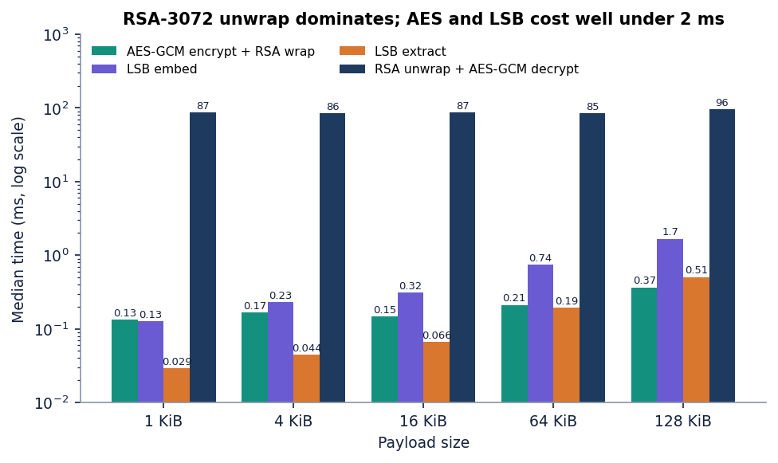
Figure 24: Median time of each stage of the pipeline for the evaluated payload sizes.
Table 32: RSA key size: time and overhead (median of 30 operations on a 4 KiB payload; key generation median of 5, with range).
RSA bits | Key generation (ms) | Encrypt + wrap (ms) | Unwrap + decrypt (ms) | Wrapped key (B) | Overhead (B)
2048 | 32.5 (24.9-101.6) | 0.164 | 31.1 | 256 | 401
3072 | 191.5 (70.8-271.3) | 0.173 | 93.7 | 384 | 529
4096 | 353.9 (97.0-541.0) | 0.236 | 221.1 | 512 | 657

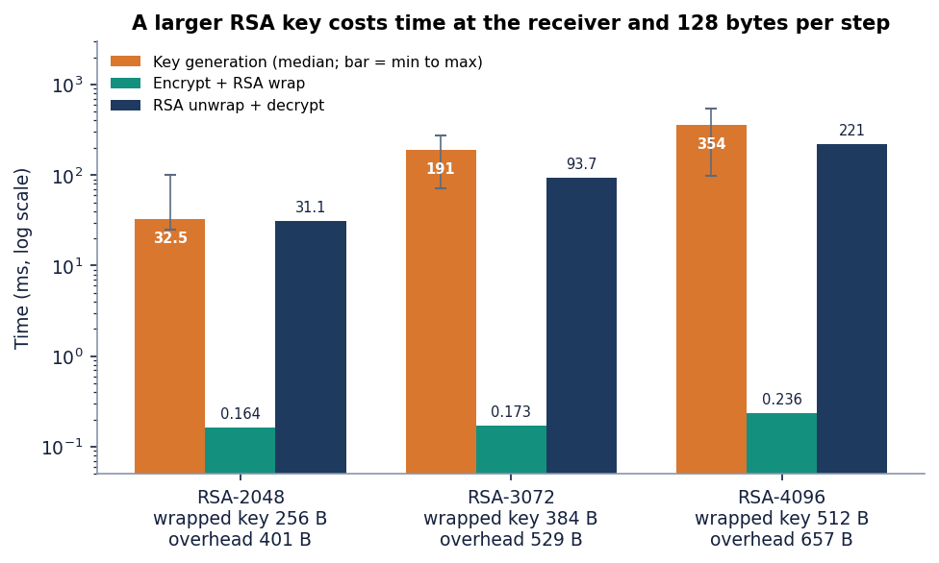
Figure 25: Key generation and private-key operation time at 2048, 3072 and 4096 bits.
Wrapping is cheap at every size because the public exponent is small; unwrapping and key generation grow steeply (roughly seven times from 2048 to 4096 bits for unwrapping). The overhead grows only by 128 bytes per step. Key generation is also highly variable (the 4096-bit range is 97 to 541 ms) because it searches for random primes.
API level. The table gives end-to-end latency through HTTP on 127.0.0.1 with the demo user. A send costs 0.4 s on a 512 x 512 cover and 1.9 s on 1280 x 720, although encryption and embedding together take well under a millisecond: the time goes to PNG encoding (100 to 190 ms in the log) and to the SSIM computation (about 300 ms), both of which are measurements and not part of the protection. Login costs 0.29 s because bcrypt is deliberately slow.
Table 33: API latency (median and 95th percentile or maximum, ms).
Call | Runs | Median | p95 / max
login | 10 | 286.7 | 315.5
keys/generate 2048 | 5 | 42.9 | 152.3
keys/generate 3072 | 5 | 223.4 | 350.6
keys/generate 4096 | 3 | 505.4 | 1,160.8
send (21 KiB memo, 512x512 cover, RSA-3072) | 10 | 437.7 | 534.5
send (21 KiB memo, 1280x720 cover) | 10 | 1,873.4 | 2,154.4
receive (RSA-3072) | 10 | 198.2 | 234.8
analysis metrics | 10 | 5.2 | 6.0
histogram + bit planes, first render | 3 | 942.4 | 1,031.6
robustness (9 attacks) | 5 | 542.6 | 587.7
benchmark run (6 covers x 3 sizes, RSA-2048) | 2 | 14,962.4 | 15,140.5
log (100 rows) | 10 | 12.9 | 30.4
health | 20 | 2.3 | 25.6

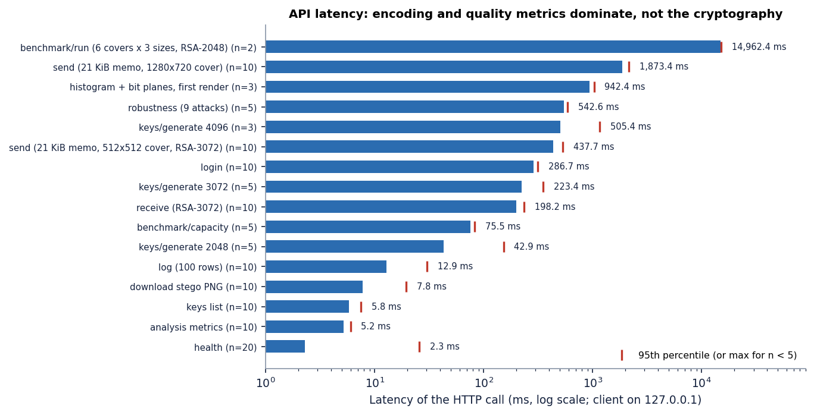
Figure 26: Median API latency of the main calls.
No load or concurrency test was run: every figure is for one user at a time.

7.8 User acceptance
No formal user-acceptance test with outside users was carried out, and this chapter does not claim one. The acceptance evidence is a structured walk of the console by the team on a fresh database: sign in, generate two RSA-3072 keys and import a public key, send four files into four covers, try one send that the capacity check blocks, analyse the first message, receive it with the right key and fail with the wrong one, run the nine attacks, run the benchmark, and read the log. Each step worked as the screen text described, and the 18 screens captured in that session are shown in Chapter 8 and Appendix C.
The walk also found one defect that the unit tests could not: the Send screen refers to an icon it does not import, so an account with no keys sees a crash instead of the empty-state message (KeyRound is not defined, reproduced with a freshly registered account). The Receive screen imports the icon and is not affected. The defect is recorded, not fixed, in the code that was submitted; the one-line fix is to import KeyRound from lucide-react in Send.jsx.

7.9 Limits of the testing done
The results above support the claims made for CipherVeil and no more. The following were not done and should be read as open items.
• No browser test suite. The screens were driven and captured by a script but not asserted, so a visual regression would not be caught automatically.
• No load, concurrency or soak test. Latency is for a single user; a shared database file and a single worker process were not stressed.
• No external security audit, fuzzing or side-channel analysis. The tamper study covers single-bit flips only, not structured attacks on the bundle format.
• No cross-user authorisation test and no 25 MB upload test, although the checks exist in the code.
• Six covers and four small payloads. All covers are the committed library images; no camera photographs, no large files, no images produced by social-media pipelines.
• One machine. All timings come from one Windows PC; other hardware was not tried.
• Statistical detection is assessed with two classical detectors only. The chi-square and weighted-stego tests were implemented here; RS analysis, sample-pair analysis and learned detectors were not run, so the detection results are a lower bound on what an attacker could do.
• No comparison run against the base paper. Its code was not executed; the comparison in Chapter 8 uses its published numbers and says where the conditions differ.

CHAPTER 8: RESULTS AND OUTPUT SCREENS
This chapter reports what was measured. It begins with the set-up, shows every screen of the working product, then gives the core evaluation of imperceptibility, capacity and speed, the fill-ratio study, the key-size and latency measurements, robustness, steganalysis and tamper evidence, the comparison with the base paper, sample inputs and outputs, a success and failure analysis and the objectives against outcomes. Where a result is weaker than the product's screens suggest, the text says so.

8.1 Experimental set-up
All measurements in this chapter were made on one machine: an Intel Core i5-12500 (6 cores, 12 threads) with 15.7 GB of memory, Windows 11 Pro, Python 3.11.9 and Node.js 24.19. No GPU was used. The backend ran FastAPI 0.115.6 with cryptography 44.0.0, Pillow 11.0.0, NumPy 2.1.3 and scikit-image 0.24.0; screens were captured with headless Google Chrome driven by a Playwright script. Other programs shared the machine, so absolute timings vary by about 10-30 % between runs (the median RSA-3072 unwrap and decrypt was 86 ms in ml/eval.py and 94 ms in scripts/run_experiments.py). The embedding and the image-quality numbers do not depend on load. Every table and figure comes from stored JSON written by ml/eval.py, scripts/run_experiments.py and scripts/measure_api.py; nothing was typed in by hand.
CipherVeil learns nothing from data, so there is no training set, validation split or test split. The system is deterministic apart from the random AES key and nonce. Evaluation uses six committed cover images and four committed synthetic payloads, all regenerated by the seeded script scripts/make_samples.py.
Table 34: Data used in the evaluation
Item | Size | Source and licence
astronaut_512x512.png | 512 x 512 | scikit-image astronaut(), NASA photograph, public domain
cat_451x300.png | 451 x 300 | scikit-image chelsea(), CC0
coffee_600x400.png | 600 x 400 | scikit-image coffee(), CC0
coffee_small_200x200.png | 200 x 200 | crop and resize of coffee(), CC0
generated_landscape_1280x720.png | 1280 x 720 | procedural, seed 11, generated for this project
rocket_640x427.png | 640 x 427 | scikit-image rocket(), public domain
accounts.csv, confidential_memo.pdf, meeting_notes.txt, settings.json | 2,774 B, 21,517 B, 169 B, 99 B | synthetic, generated for this project

Evaluation grid: the six covers crossed with payloads of 1, 4, 16, 64 and 128 KiB (30 combinations), each measured three times with an RSA-3072 key; 22 combinations fit and 8 are blocked by the capacity check. Additional experiments (fill-ratio, key-size, steganalysis, tamper and extra-attack studies) are described where they are reported.

8.2 Output screens
The screens below were captured in one working session on a fresh database, driving the real interface: two RSA-3072 keypairs were generated, a partner's public key was imported, five files were sent, one was received, and the robustness test and benchmark were run. Nothing on screen is a mock-up; the numbers in the captions are the numbers the screens show.

8.2.1 Keys
Figure 27: Output screen: Keys. Two generated RSA-3072 keypairs (Receiver key, Spare key) and one imported public-only RSA-2048 partner key, each with its fingerprint and download actions.
The Keys screen holds the cryptographic identities. A keypair can send and receive; a public-only entry can only be sent to. The fingerprint is the first 12 bytes of the SHA-256 of the public key, so two people can compare keys by eye. Private keys never appear in the list; they are exported only on request, and each export is written to the log.

8.2.2 Send
Figure 28: Output screen: Send, before the run. Receiver key, confidential_memo.pdf (21.0 KiB) and the astronaut cover (holds 96.0 KiB) are selected; the capacity estimate is shown before anything is sent.
Figure 29: Output screen: Send result. The stego PNG with PSNR 57.642 dB, SSIM 0.9991, 22.445 % of the cover used (0.67331 bits per pixel), the SHA-256 of the file and the per-stage timings.
The 21,517-byte memo grows to a 22,063-byte bundle (546 bytes of overhead with RSA-3072, of which 384 are the wrapped key) and occupies 22.445 % of the astronaut image. The picture shown is the stego image and is indistinguishable by eye from the cover. Largest change to any colour value is 1 out of 255; the SHA-256 shown is the fingerprint the receiver must reproduce.

8.2.3 Analysis
Figure 30: Output screen: Analysis. PSNR 57.642 dB, SSIM 0.999054, MSE 0.111911, largest change 1 / 255, 11.1911 % of values changed (88,010 of 786,432), cover and stego side by side.
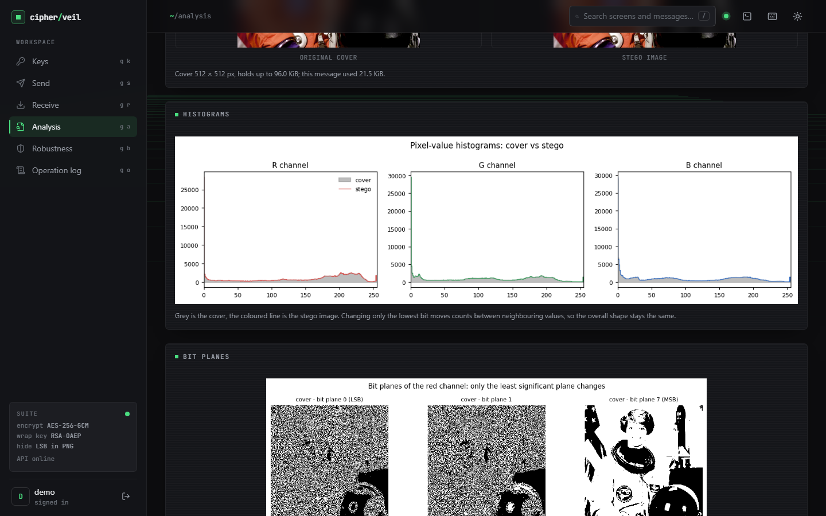  Figure 31: Output screen: Analysis, histograms of cover and stego per colour channel. | 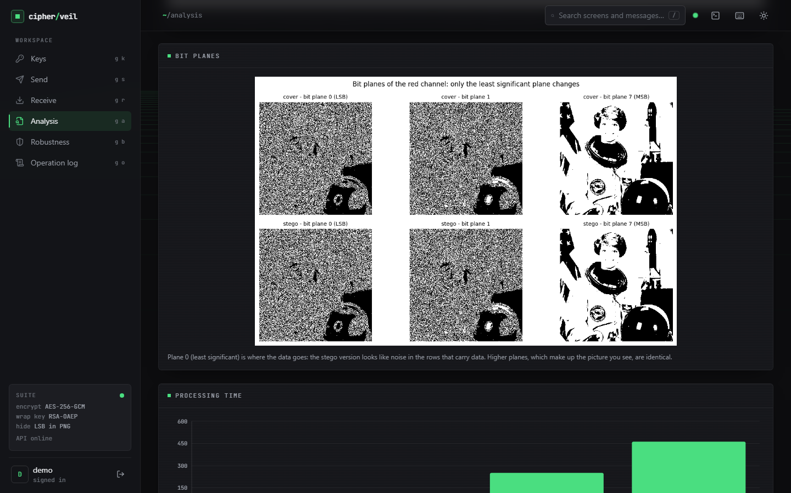  Figure 32: Output screen: Analysis, bit planes 0, 1 and 7 of the red channel, cover and stego.

The histograms overlay almost exactly: replacing the least significant bit moves a count only between two neighbouring values. The bit-plane view shows where the change lives: plane 7 (the picture) is identical, while plane 0 carries noise-like data in the rows used by the bundle. Only the first 22 % of the rows are touched, which is also why the analysis in Section 8.8 can find them.

8.2.4 Receive
Figure 33: Output screen: Receive. The file is restored byte for byte, the AES-GCM tag is verified, and the SHA-256 recorded at send time equals the SHA-256 of the restored file.
Receiving the same image with the Receiver key extracts the bundle in 0.60 ms and decrypts it in 288.9 ms on that run (the machine was busy with the browser and the screen capture; the evaluation median is 86 ms). The two hashes are identical, so the file is the one that was sent. The download button returns confidential_memo.pdf unchanged.

8.2.5 Robustness and benchmark
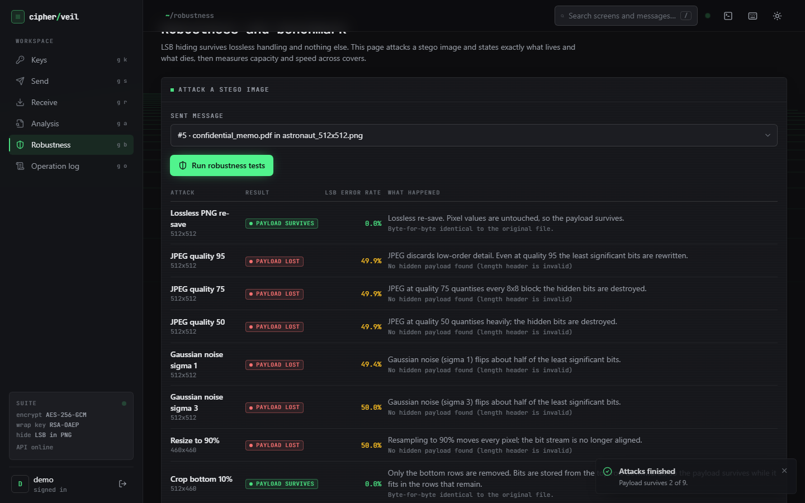  Figure 34: Output screen: Robustness, the nine attacks with their verdict and LSB error rate. | 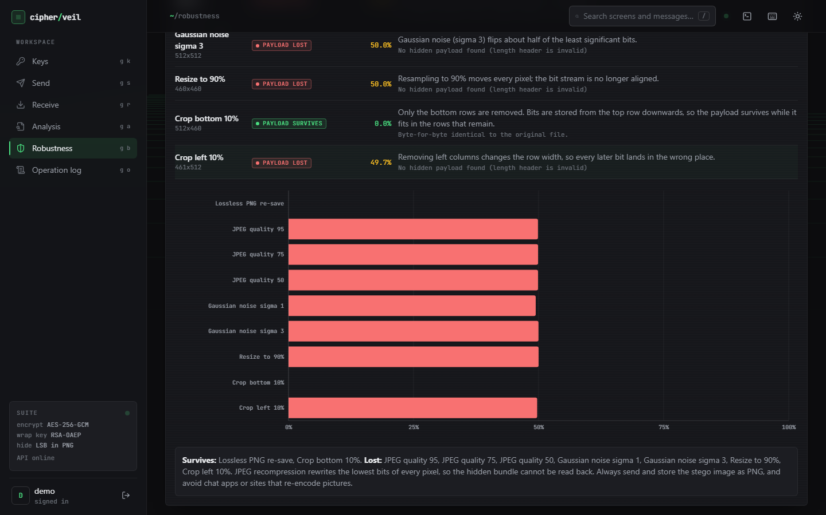  Figure 35: Output screen: Robustness, LSB error-rate chart and the plain-language verdict.

Of the nine attacks only two let the payload through: the lossless PNG re-save (error rate 0.0 %) and the bottom crop of 10 % (0.0 %, because the bundle lies in the top rows). JPEG at quality 95, 75 and 50, Gaussian noise of sigma 1 and 3, resizing to 90 % and the left crop all leave about half of the least significant bits wrong (49.4-50.0 % in the screen) and the payload is lost. The page states the consequence in words: send and store the stego image as a PNG and avoid applications that re-encode pictures.
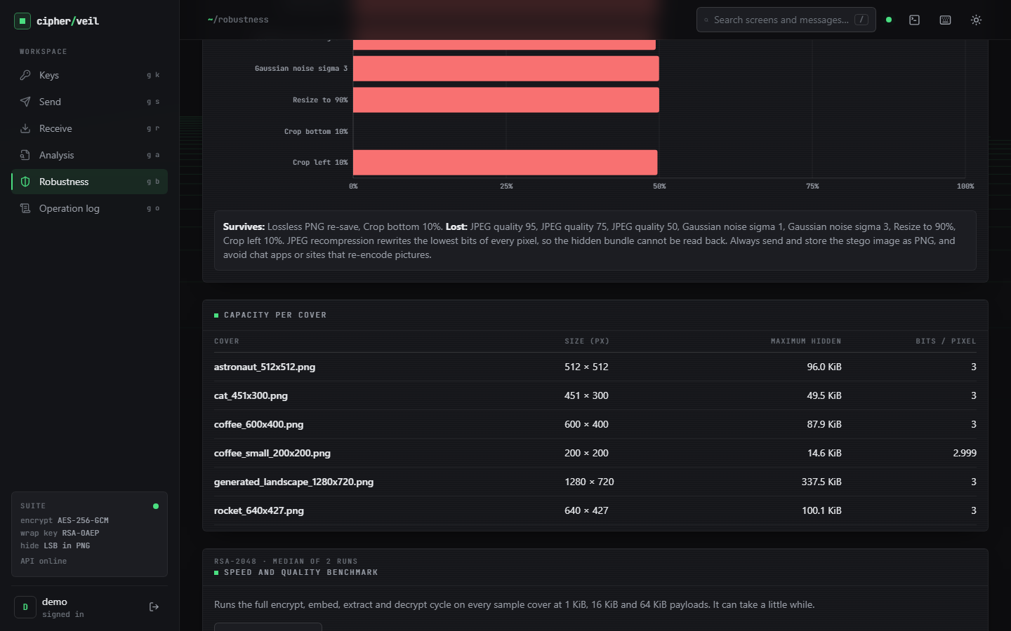  Figure 36: Output screen: capacity per cover, 14.6 KiB (200 x 200) to 337.5 KiB (1280 x 720), 3.0 bits per pixel. | 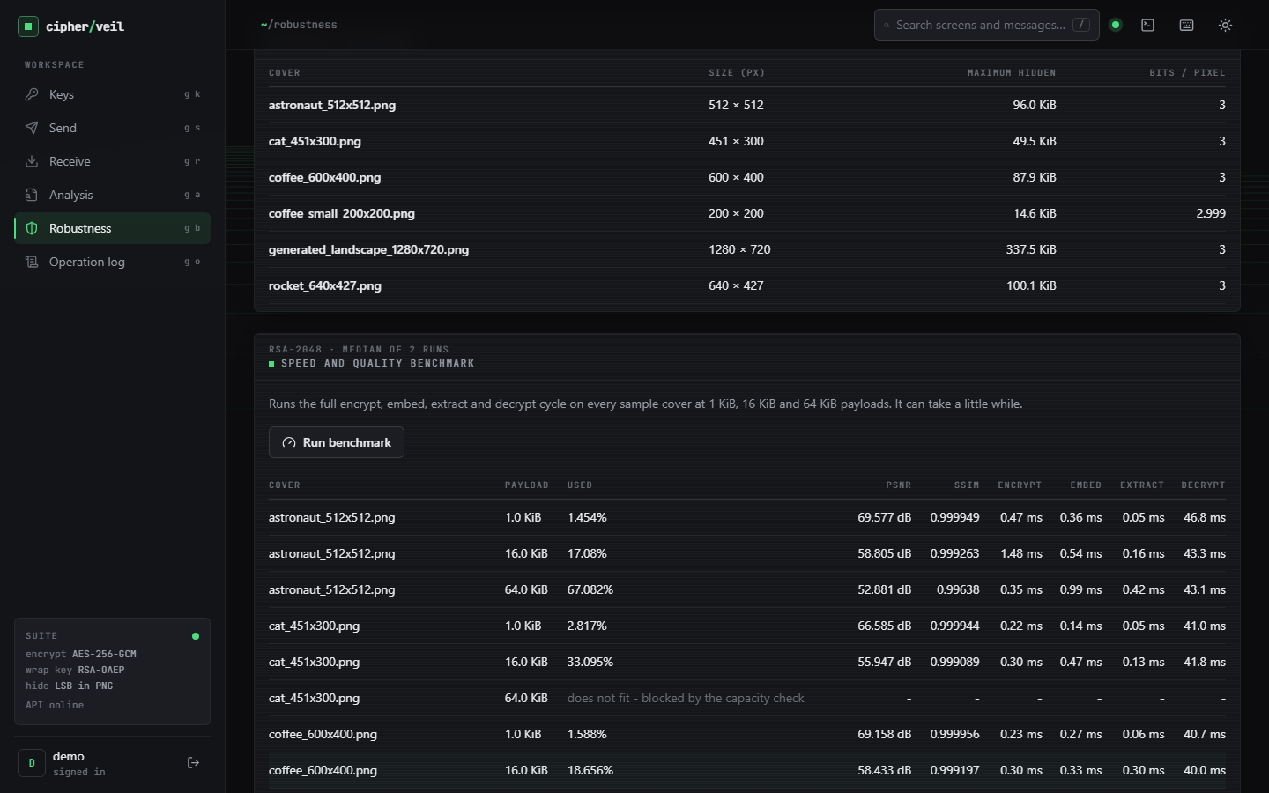  Figure 37: Output screen: speed and quality benchmark rows (RSA-2048), including a row blocked by the capacity check.

The capacity table is a direct consequence of the formula (width x height x 3 - 32) / 8. The benchmark runs the full encrypt, embed, extract and decrypt cycle on every cover at 1, 16 and 64 KiB; a combination that does not fit is shown as blocked instead of failing, for example 64 KiB into the 451 x 300 cat image.

8.2.6 Operation log
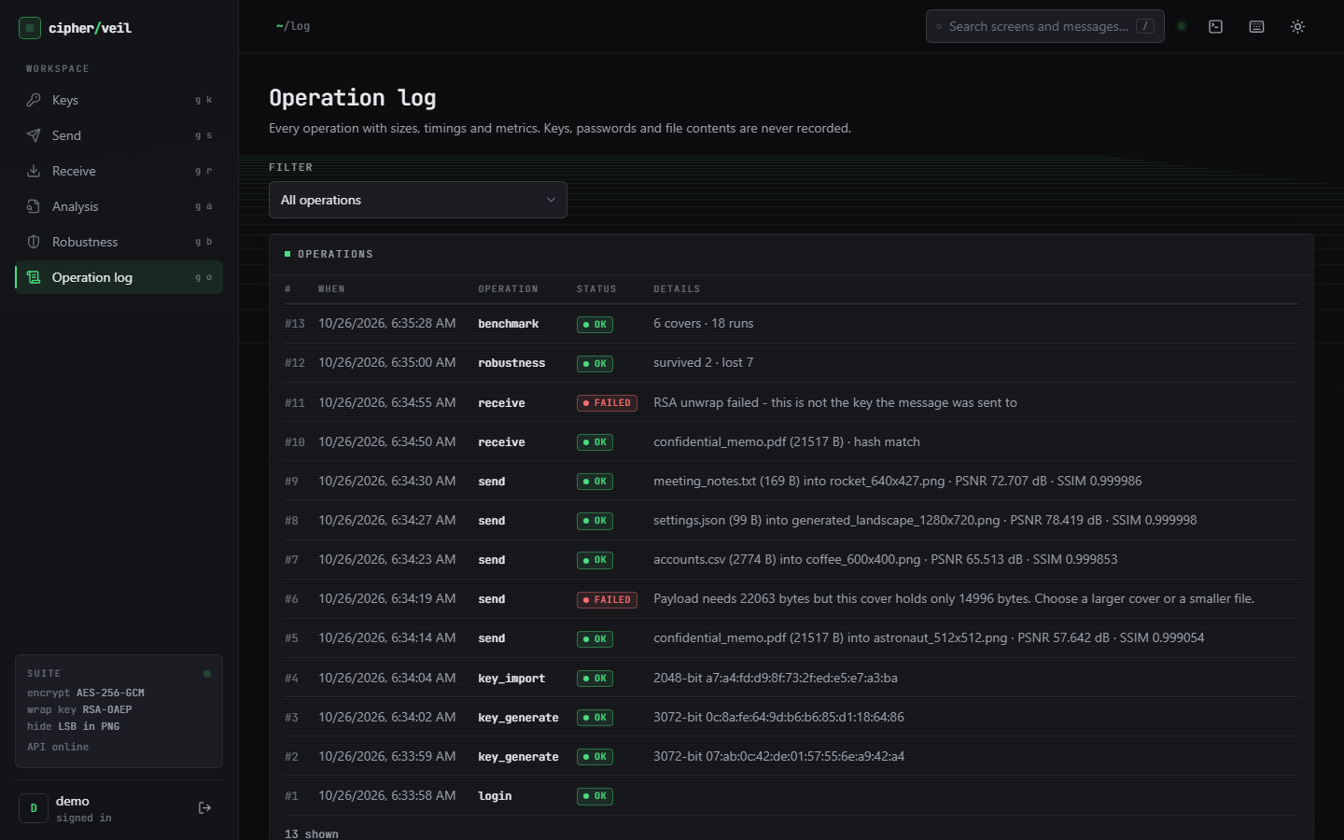  Figure 38: Output screen: operation log of the session (login, key generate and import, sends, receives, robustness, benchmark; failed operations in red). | 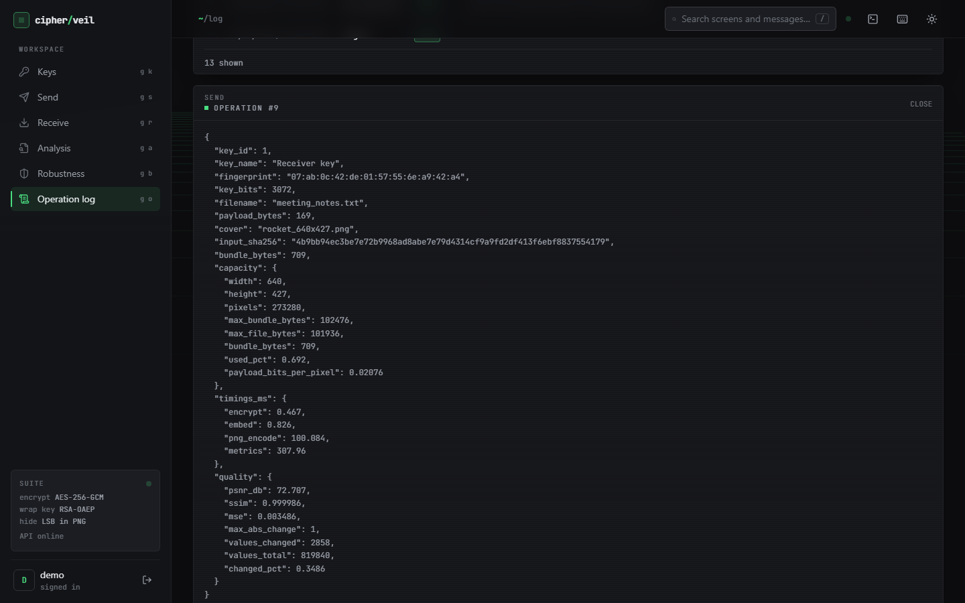  Figure 39: Output screen: log detail of one send, with sizes, timings, quality and key fingerprint but no key material.

The log lists thirteen operations for the session, including the failed send (capacity) and the failed receive (wrong key), each with a plain-language reason. Expanding an entry shows the stored JSON: file name, sizes, hash, capacity, timings and quality. The test suite checks that no private key, PEM text or file content ever reaches this log.

8.3 Core evaluation: imperceptibility, capacity and speed
The core evaluation (ml/eval.py) hides random-length files in the six covers with an RSA-3072 key. Of the 30 combinations, 22 fit and 8 are refused by the capacity check, which is the intended behaviour. All 22 round trips restored the file byte for byte. PSNR was never below 52.479 dB (mean 61.731 dB) and SSIM never below 0.995806 (mean 0.999039). The median times were 0.15 ms to encrypt and wrap, 0.25 ms to embed, 0.05 ms to extract and 86.37 ms to unwrap and decrypt.
Table 35: Capacity of each cover (1 bit per colour value, 32-bit length header)
Cover | Size (px) | Pixels | Max bundle (B) | Max bundle (KiB) | Bits per pixel
astronaut_512x512 | 512 x 512 | 262,144 | 98,300 | 96.0 | 3.0
cat_451x300 | 451 x 300 | 135,300 | 50,733 | 49.5 | 3.0
coffee_600x400 | 600 x 400 | 240,000 | 89,996 | 87.9 | 3.0
coffee_small_200x200 | 200 x 200 | 40,000 | 14,996 | 14.6 | 2.999
generated_landscape_1280x720 | 1280 x 720 | 921,600 | 345,596 | 337.5 | 3.0
rocket_640x427 | 640 x 427 | 273,280 | 102,476 | 100.1 | 3.0

Table 36: Quality and speed of the 22 runs that fit (RSA-3072, median of 3 repeats)
Cover | Payload (B) | Used % | PSNR (dB) | SSIM | Enc (ms) | Embed (ms) | Extr (ms) | Dec (ms)
astronaut_512x512 | 1,024 | 1.584 | 69.171 | 0.999941 | 0.131 | 0.115 | 0.034 | 87.481
astronaut_512x512 | 4,096 | 4.709 | 64.423 | 0.999767 | 0.19 | 0.222 | 0.047 | 86.009
astronaut_512x512 | 16,384 | 17.211 | 58.754 | 0.999256 | 0.154 | 0.183 | 0.091 | 88.198
astronaut_512x512 | 65,536 | 67.213 | 52.865 | 0.996392 | 0.211 | 0.684 | 0.178 | 85.482
cat_451x300 | 1,024 | 3.069 | 66.217 | 0.999934 | 0.12 | 0.102 | 0.028 | 86.946
cat_451x300 | 4,096 | 9.124 | 61.531 | 0.999764 | 0.158 | 0.112 | 0.03 | 84.322
cat_451x300 | 16,384 | 33.347 | 55.898 | 0.999078 | 0.146 | 0.17 | 0.059 | 86.181
coffee_600x400 | 1,024 | 1.73 | 68.74 | 0.999948 | 0.138 | 0.175 | 0.028 | 93.163
coffee_600x400 | 4,096 | 5.144 | 63.993 | 0.999786 | 0.139 | 0.266 | 0.037 | 85.139
coffee_600x400 | 16,384 | 18.799 | 58.409 | 0.999195 | 0.153 | 0.374 | 0.066 | 87.478
coffee_600x400 | 65,536 | 73.414 | 52.479 | 0.997186 | 0.21 | 0.828 | 0.234 | 84.241
coffee_small_200x200 | 1,024 | 10.383 | 61.014 | 0.99977 | 0.129 | 0.095 | 0.022 | 87.388
coffee_small_200x200 | 4,096 | 30.868 | 56.264 | 0.999166 | 0.14 | 0.121 | 0.051 | 89.865
generated_landscape_1280x720 | 1,024 | 0.451 | 74.615 | 0.99999 | 0.135 | 0.55 | 0.03 | 92.94
generated_landscape_1280x720 | 4,096 | 1.339 | 69.876 | 0.999931 | 0.174 | 0.595 | 0.059 | 85.656
generated_landscape_1280x720 | 16,384 | 4.895 | 64.234 | 0.999664 | 0.145 | 0.565 | 0.066 | 87.522
generated_landscape_1280x720 | 65,536 | 19.118 | 58.321 | 0.998598 | 0.212 | 0.796 | 0.208 | 85.791
generated_landscape_1280x720 | 131,072 | 38.081 | 55.333 | 0.99718 | 0.367 | 1.674 | 0.507 | 95.645
rocket_640x427 | 1,024 | 1.519 | 69.365 | 0.999941 | 0.176 | 0.138 | 0.033 | 84.905
rocket_640x427 | 4,096 | 4.517 | 64.581 | 0.999723 | 0.205 | 0.242 | 0.042 | 85.478
rocket_640x427 | 16,384 | 16.509 | 58.955 | 0.998853 | 0.144 | 0.315 | 0.084 | 86.566
rocket_640x427 | 65,536 | 64.474 | 53.049 | 0.995806 | 0.213 | 0.543 | 0.17 | 84.287

The eight refused combinations are 128 KiB into every cover except the landscape, 64 KiB into the 451 x 300 and 200 x 200 covers, and 16 KiB into the 200 x 200 cover. PSNR falls as the share of the cover used grows, from 74.615 dB at 0.45 % (1 KiB into the landscape) to 52.479 dB at 73.4 % (64 KiB into the 600 x 400 coffee image); SSIM stays above 0.9958. RSA unwrap dominates the time of the cryptographic step and is almost independent of payload size, while embedding grows with the payload to 1.674 ms for 128 KiB.
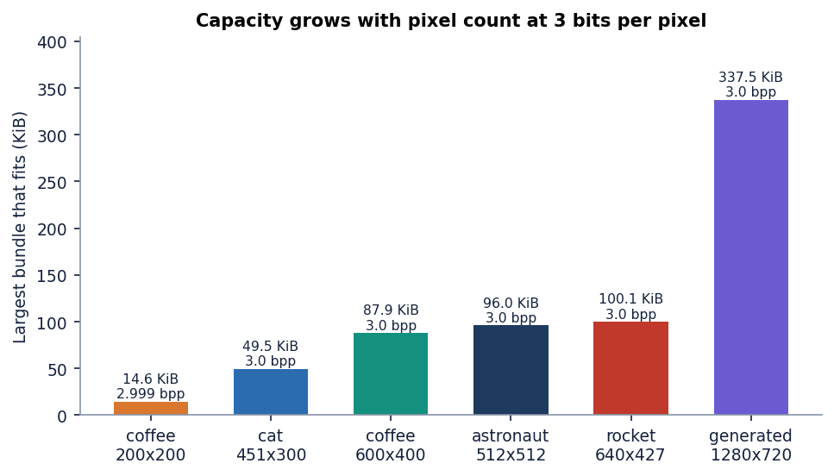
Figure 40: Maximum hidden bundle per cover: capacity is proportional to the pixel count at 3.0 bits per pixel.

8.4 Fill-ratio study and the closed-form PSNR model
The core evaluation uses a few payload sizes. To cover the whole range the fill-ratio study fills each of the six covers to 1, 5, 10, 25, 50, 75 and 100 % of capacity with random payloads of five different seeds (RSA-2048). Because the embedded bits are ciphertext, each bit equals the cover's own least significant bit half of the time, so half of the used values change by exactly one. This gives a closed-form model:
MSE = 0.5 x n_bits / N, PSNR = 10 log10(255^2 / MSE) (N = width x height x 3 colour values, n_bits = 8 x (bundle bytes + 4)) (9)
Measured PSNR matches the model within 0.053 dB over all 42 cover and fill combinations, and the standard deviation across payload seeds never exceeded 0.0987 dB. The model also gives the floor: with every value used, PSNR is 10 log10(255^2 / 0.5) = 51.14 dB, and the measurement at 100 % fill is 51.14-51.17 dB. PSNR is therefore above 50 dB at every fill level on every cover. SSIM depends on the picture as well as the amount of data and is lowest (0.992893) for the smooth procedural landscape at 100 % fill.
Table 37: Imperceptibility against fill ratio (mean over the six covers and five payload seeds)
Fill | Capacity used % | PSNR mean (dB) | PSNR min (dB) | PSNR model (dB) | SSIM mean | SSIM min
1 % | 1.8 | 68.93 | 65.44 | 68.94 | 0.99995 | 0.99993
5 % | 5.8 | 63.58 | 62.36 | 63.57 | 0.99975 | 0.99965
10 % | 10.7 | 60.85 | 60.19 | 60.85 | 0.99952 | 0.99928
25 % | 25.5 | 57.07 | 56.87 | 57.07 | 0.99880 | 0.99815
50 % | 50.3 | 54.13 | 54.08 | 54.13 | 0.99765 | 0.99630
75 % | 75.0 | 52.39 | 52.39 | 52.39 | 0.99639 | 0.99462
100 % | 99.9 | 51.15 | 51.14 | 51.15 | 0.99507 | 0.99289

Figure 41: Measured PSNR against fill ratio for the six covers, with the closed-form model; the 50 dB line marks the usual limit of visibility.
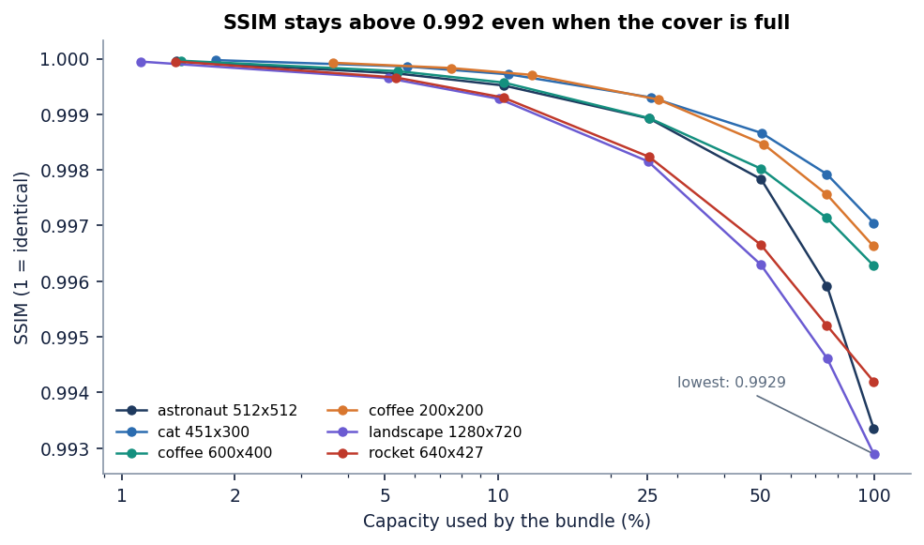
Figure 42: Measured SSIM against fill ratio for the six covers.
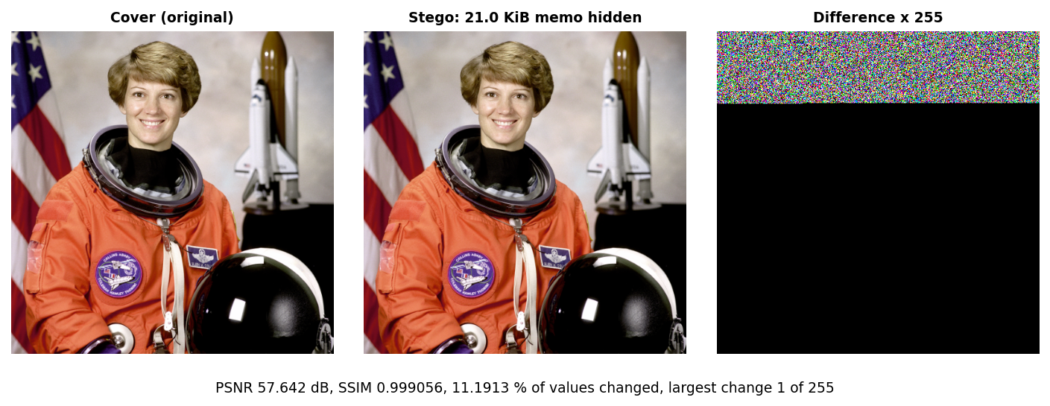
Figure 43: Absolute difference between cover and stego, amplified, for the 22 % fill of the Send screen: the changes are scattered values of 1 in the rows used.

8.5 Key size, stage timings and API latency
Key size changes three things: the time to generate a key, the time to unwrap, and the bundle overhead. Wrapping is cheap (0.16-0.24 ms) because it uses the public exponent 65537; unwrapping uses the private key and grows roughly with the cube of the key size. Key generation varies strongly from run to run because it searches for primes, so the range is shown beside the median.
Table 38: RSA key size study (4 KiB payload; 30 wraps and unwraps, 5 key generations)
RSA bits | Key generation (ms), median (min-max) | Encrypt + wrap (ms) | Unwrap + decrypt (ms) | Wrapped key (B) | Bundle overhead (B)
2048 | 32.497 (24.9-101.6) | 0.164 | 31.054 | 256 | 401
3072 | 191.488 (70.8-271.3) | 0.173 | 93.693 | 384 | 529
4096 | 353.921 (97.0-541.0) | 0.236 | 221.139 | 512 | 657

Figure 44: RSA key size against key-generation time, wrap time and unwrap time (median).
For a 4 KiB message the 3072-bit key costs 94 ms to open and adds 128 bytes more than the 2048-bit key; the 4096-bit key costs 221 ms and 256 bytes more. The overhead is a fixed 401, 529 or 657 bytes (wrapped key, magic, lengths, nonce, header, tag), which matters only for very small covers: it is 3 % of the 14.6 KiB capacity of the 200 x 200 image.
Figure 45: Median time of the four cryptographic and embedding stages for payloads of 1 to 128 KiB (RSA-3072): the unwrap dominates and everything else is below 2 ms.
End to end, through HTTP, the picture changes because the web layer adds the work the library benchmark leaves out: PNG encoding and the image-quality measures. A send of the 21 KiB memo into a 512 x 512 cover takes 437.7 ms at the median, and 1,873.4 ms into a 1280 x 720 cover; the cryptography is about 0.15 ms of that, and the log of the send shows png_encode at 100-190 ms and metrics (PSNR and SSIM) at about 300 ms. Receiving takes 198.2 ms, mostly the RSA unwrap. Login costs 286.7 ms because bcrypt is deliberately slow.
Table 39: API latency on the measurement machine (127.0.0.1, demo user)
Call | Runs | Median (ms) | p95 or max (ms)
login | 10 | 286.7 | 315.5
keys/generate 3072 | 5 | 223.4 | 350.6
send (21 KiB memo, 512x512 cover, RSA-3072) | 10 | 437.7 | 534.5
send (21 KiB memo, 1280x720 cover) | 10 | 1873.4 | 2154.4
receive (RSA-3072) | 10 | 198.2 | 234.8
analysis metrics | 10 | 5.2 | 6.0
histogram + bit planes, first render | 3 | 942.4 | 1031.6
robustness (9 attacks) | 5 | 542.6 | 587.7
benchmark/run (6 covers x 3 sizes, RSA-2048) | 2 | 14962.4 | 15140.5
log (100 rows) | 10 | 12.9 | 30.4

Figure 46: API latency per call (median, with 95th percentile or maximum).

8.6 What encryption adds to the embedded bits
A natural question is whether encryption costs image quality. The experiment hides each sample file twice in the generated_landscape_1280x720 cover, once as plain bytes and once as the encrypted bundle. In both cases about half of the embedded bits change a value (49.1-51.6 %), so PSNR depends on the number of bits and not on their kind: encryption costs nothing in imperceptibility. What changes is the statistics of the stream. Plain files are unbalanced (fraction of 1-bits 0.42-0.46) and have low entropy (4.2-4.4 bits per byte for the text files), so they can be read directly once the carrier bits are found; the encrypted bundle has a fraction of 1-bits of 0.49-0.51 and 7.58-7.99 bits per byte, bounded only by the small sample size.
Table 40: Plain versus encrypted payloads in the same cover
Payload | Kind | Bytes | Fraction of 1-bits | Entropy (bits/byte) | Embedded bits that flip a value (%) | PSNR (dB)
accounts.csv | plain | 2774 | 0.4649 | 4.346 | 49.67 | 72.119
accounts.csv | encrypted | 3182 | 0.4971 | 7.94 | 50.37 | 71.462
confidential_memo.pdf | plain | 21517 | 0.4367 | 6.933 | 49.96 | 63.201
confidential_memo.pdf | encrypted | 21935 | 0.5004 | 7.992 | 50.09 | 63.107
meeting_notes.txt | plain | 169 | 0.4512 | 4.379 | 49.06 | 84.229
meeting_notes.txt | encrypted | 581 | 0.489 | 7.609 | 50.09 | 78.848
settings.json | plain | 99 | 0.4167 | 4.246 | 51.58 | 86.264
settings.json | encrypted | 506 | 0.5091 | 7.577 | 51.3 | 79.34

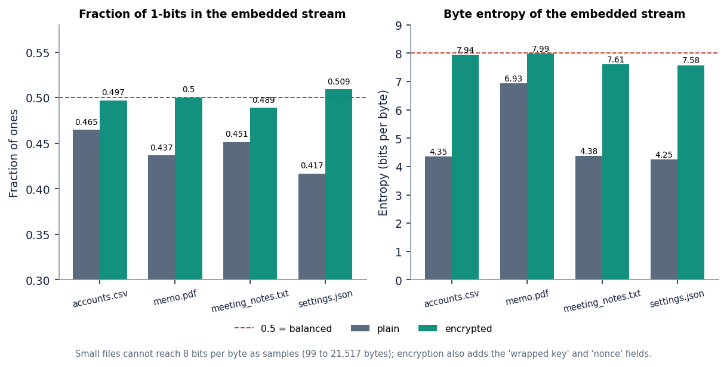
Figure 47: Fraction of 1-bits and byte entropy of plain files and of the encrypted bundles.

8.7 Robustness: what survives
Robustness was tested on all six covers with the 2,774-byte accounts.csv and an RSA-3072 key. Each attack modifies the stego image, then the real extraction and decryption are attempted and the recovered file is hashed. The nine attacks of the application are in the first block of the table; a further nine (re-encodings, a colour reduction and geometric changes) were added in scripts/run_experiments.py on the same six images with RSA-2048.
Table 41: Payload recovery after each attack (6 covers)
Attack | Recovered | Mean LSB error rate
Lossless PNG re-save | 6 / 6 | 0.0
JPEG quality 95 | 0 / 6 | 0.4973
JPEG quality 75 | 0 / 6 | 0.4999
JPEG quality 50 | 0 / 6 | 0.5032
Gaussian noise sigma 1 | 0 / 6 | 0.4935
Gaussian noise sigma 3 | 0 / 6 | 0.4988
Resize to 90% | 0 / 6 | 0.501
Crop bottom 10% | 6 / 6 | 0.0
Crop left 10% | 0 / 6 | 0.4995
PNG re-save, compression 9 | 6 / 6 | -
PNG with alpha channel added | 6 / 6 | -
WebP lossless | 6 / 6 | -
WebP lossy q90 | 0 / 6 | -
JPEG quality 100 | 0 / 6 | -
Grayscale conversion | 0 / 6 | -
Rotate 90 degrees | 0 / 6 | -
Flip horizontally | 0 / 6 | -
256-colour palette | 0 / 6 | -

The pattern is exact. Anything that preserves pixel values keeps the payload: PNG re-save, PNG at compression 9, PNG with an alpha channel added, lossless WebP, and a crop that removes only rows below the payload. Anything that changes pixel values or their order loses it: JPEG even at quality 100, lossy WebP, Gaussian noise of sigma 1, resizing, grayscale conversion, a 256-colour palette, rotation, flipping and cropping columns. The error rate of the lossy attacks is 49-50 %, which is what a coin toss gives, so there is nothing left for an error-correcting code to repair; the batch objective of measuring robustness is met, and the answer is that the scheme is robust to lossless handling only. The 5 attacks of 18 that were survived are lossless or leave the payload rows untouched.
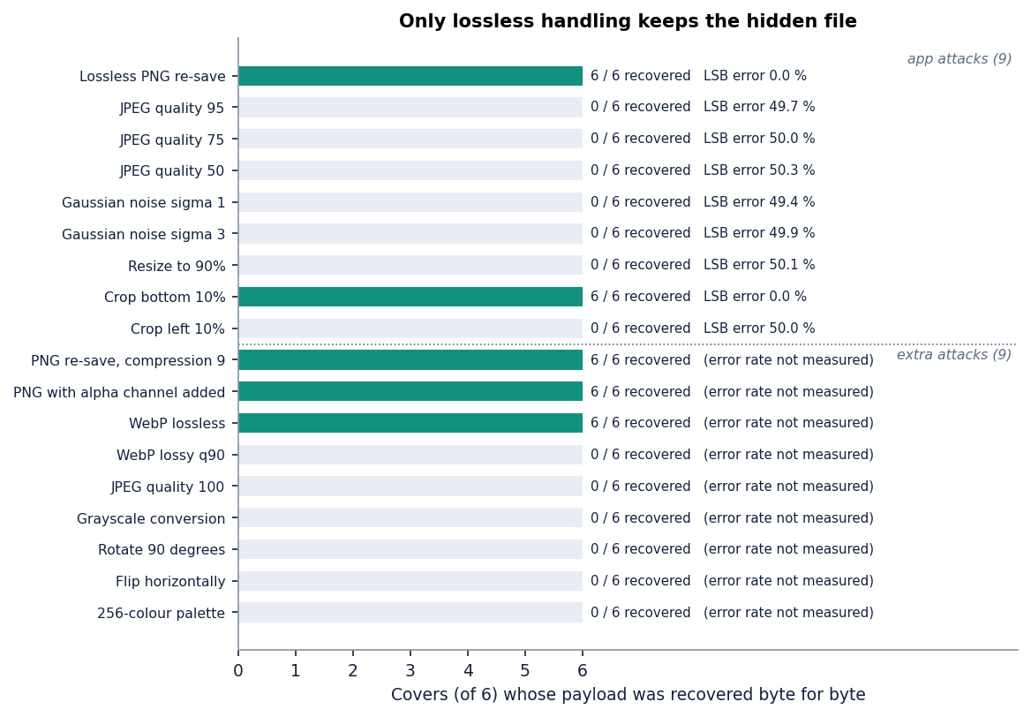
Figure 48: Payload recovery and LSB error rate for the 18 attacks over the six covers.

8.8 Steganalysis and tamper evidence
Imperceptible does not mean undetectable, so the stego images were attacked with two classical detectors. The chi-square test of Westfeld and Pfitzmann [15] checks whether the counts of the value pairs (2k, 2k+1) have been equalised; a p-value near 1 means the least significant bit plane has been overwritten with random-looking bits. It was applied to the embedded prefix, which is an oracle because it assumes the length of the payload is known. The stego prefix gave p between 0.97 and 1.00 in all 30 cases (six covers, five fill levels); the clean cover gave p below 0.5 in 27 of them. In three cases (the cat image at 10 and 25 % and the small coffee image at 10 %) the clean image's prefix was already near-equalised, so the test could not separate cover from stego there.
The weighted-stego estimator [18], [19] is blind: it estimates the fraction of overwritten samples from the whole image. Its estimate tracks the true fill (about 0.10, 0.50 and 1.00 for the three levels shown, within 0.30 at the low end), with a natural-image bias of 0.08-0.18 on four of the six covers and about 0 on the other two. A steganalyst with such a tool can therefore tell that these images carry data when the fill is medium or high. Because the embedding starts at the first pixel and does not depend on a key, the location of the payload is also known to anyone who knows the algorithm; the secrecy rests on the encryption, not on the hiding.
Table 42: Steganalysis of the stego images (selected fill levels; full 30 cases in the experiment file)
Cover | Fill | Chi-square p, cover | Chi-square p, stego | Weighted-stego, cover | Weighted-stego, stego
astronaut_512x512 | 10 % | 0.0 | 1.0 | 0.0828 | 0.182
astronaut_512x512 | 50 % | 0.0 | 1.0 | 0.0828 | 0.5696
astronaut_512x512 | 100 % | 0.0 | 0.9999 | 0.0828 | 0.9944
cat_451x300 | 10 % | 0.9988 | 1.0 | 0.0037 | 0.102
cat_451x300 | 50 % | 0.3416 | 0.9991 | 0.0037 | 0.5218
cat_451x300 | 100 % | 0.0135 | 1.0 | 0.0037 | 1.0044
coffee_600x400 | 10 % | 0.0 | 1.0 | 0.0868 | 0.1915
coffee_600x400 | 50 % | 0.0 | 0.9999 | 0.0868 | 0.5434
coffee_600x400 | 100 % | 0.0 | 1.0 | 0.0868 | 1.0104
coffee_small_200x200 | 10 % | 0.5819 | 1.0 | 0.1804 | 0.3008
coffee_small_200x200 | 50 % | 0.0 | 1.0 | 0.1804 | 0.6205
coffee_small_200x200 | 100 % | 0.0 | 0.9993 | 0.1804 | 0.9865
generated_landscape_1280x720 | 10 % | 0.0 | 0.9982 | -0.005 | 0.0956
generated_landscape_1280x720 | 50 % | 0.0 | 1.0 | -0.005 | 0.4933
generated_landscape_1280x720 | 100 % | 0.0 | 1.0 | -0.005 | 0.9972
rocket_640x427 | 10 % | 0.0 | 0.9935 | 0.1082 | 0.2026
rocket_640x427 | 50 % | 0.0 | 0.9999 | 0.1082 | 0.5659
rocket_640x427 | 100 % | 0.0 | 1.0 | 0.1082 | 1.0311

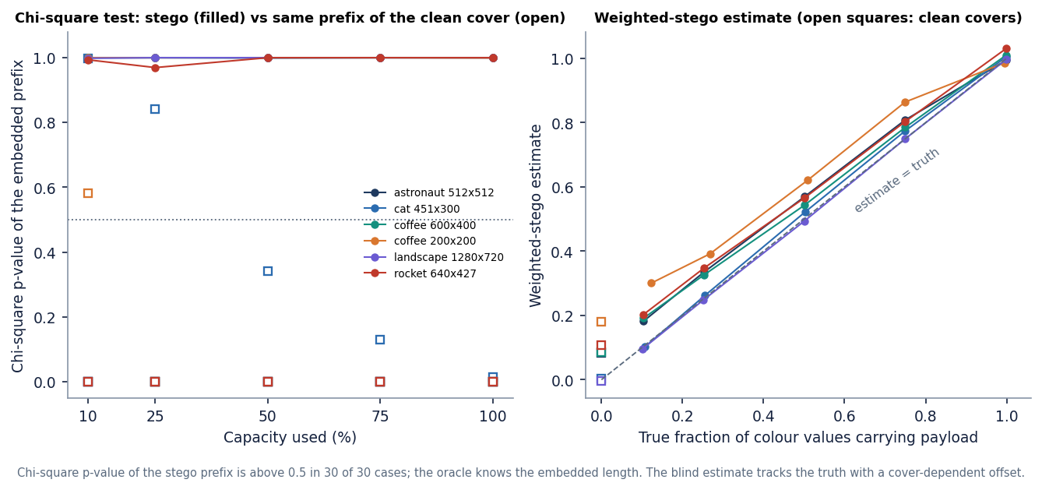
Figure 49: Chi-square p-value and weighted-stego estimate against the true fill, for cover and stego images.
Tamper evidence is the opposite case: the receiver must notice any change. One stego LSB was flipped at a random position inside each field of the bundle, 40 times per field, 240 flips in all (astronaut cover, RSA-2048, 4 KiB payload). All 240 were rejected and 0 produced a wrong file. Flips in the magic, the key-length field and the wrapped key are caught by the format checks and the RSA unwrap; flips in the nonce, the ciphertext and the tag fail the AES-GCM tag check; flips in the 32-bit length header either give an invalid length (13 cases) or shift the bundle and fail the tag (27 cases).
Table 43: Outcome of single-bit tampering by field
Field | Flips | Outcome
length header | 40 | rejected: bad length header x13; rejected: AES-GCM tag check failed x27
magic | 40 | rejected: No CipherVeil bundle found in this image x40
wrapped-key length | 40 | rejected: This bundle was wrapped for a different key size x40
wrapped key | 40 | rejected: RSA unwrap failed x40
nonce | 40 | rejected: AES-GCM tag check failed x40
ciphertext and tag | 40 | rejected: AES-GCM tag check failed x40

Figure 50: Outcome of 240 single-bit flips by bundle field: every flip is rejected.
A further check shows that encrypting the same file 50 times under one key gives 50 different nonces and 50 different wrapped keys, and two bundles differ in 49.9 % of their bits on average, so an observer cannot tell that two images carry the same file.

8.9 Comparison with the base paper and the supporting papers
The base paper [1] and CipherVeil solve different problems, and the comparison below is therefore qualitative. ProSt hides single secret bits at a secret position among random decoy bits so that an untrusted cloud can compute on them with Fredkin gates; it proves that the adversary's advantage is of order 1/n in the number n of positions and recommends n of at least 2^20 (about 10^6). It reports no PSNR, SSIM or capacity, because its goal is private computation, not transmitting a file. Its reported runtime of 8.38 s is for a 17-gate circuit on a 128 x 128 x 3 image on an Intel Core i5-1135G7 and cannot be compared with the milliseconds of CipherVeil, which does no gate evaluation.
Table 44: Qualitative comparison (different goals, covers and payloads)
Aspect | ProSt (base paper) [1] | SCReedSolo [3] | Memristive ciphers [2] | CipherVeil (this project)
Goal | Compute on hidden bits in an untrusted cloud | Robust hiding of text, audio or image | Lightweight ciphers in memory hardware | Send a file with two layers of protection
Embedding | Secret bit among random decoy LSBs | Shuffled, encrypted and RS-coded LSB, 3 bpp | LSB hiding of cipher output (demonstration) | Sequential 1-bit LSB in RGB, 3.0 bpp
Encryption | None on the payload; location secrecy | Fernet (symmetric) | Trivium, Grain-128a on IMPLY logic | AES-256-GCM + RSA-OAEP-SHA256
Reported quality | Not reported | PSNR 51.774, 57.653, 52.888 dB; SSIM 0.996, 0.936, 0.996 | PSNR table for 256 x 256 gray images | PSNR 52.479-74.615 dB up to 73 % fill; 51.14 dB at 100 %; SSIM 0.9929-0.99999
Robustness | Not applicable | Reed-Solomon against bit corruption | Not studied | Lossless only; no error correction
Security argument | Provable, advantage of order 1/n | Empirical steganalysis tools | Hardware energy and steps | Standard primitives; detectable by chi-square and weighted-stego
Speed | 8.38 s (17 gates, 128 x 128 x 3) | Not given in comparable form | Energy reductions up to 42 % and 44 % | 0.15 ms encrypt, 0.25 ms embed, 86 ms unwrap (median)

SCReedSolo [3] reports PSNR 51.774 dB and SSIM 0.996 for 5.46 million characters of text in a 14589 x 8423 x 3 image, 57.653 dB and 0.936 for audio in a 21188 x 30328 x 3 image, and 52.888 dB and 0.996 for a 100 x 100 x 3 image in the 512 x 512 Lenna image. These use very different covers and payloads, so the numbers are of the same order as CipherVeil's 52.5-74.6 dB up to 73 % fill, not better or worse. SCReedSolo adds shuffling and error correction, which CipherVeil does not have; CipherVeil adds public-key key transport and authenticated encryption, which SCReedSolo does not have. The memristive paper concerns hardware (energy and step reductions of up to 42 % and 44 %) and offers no software result to compare.
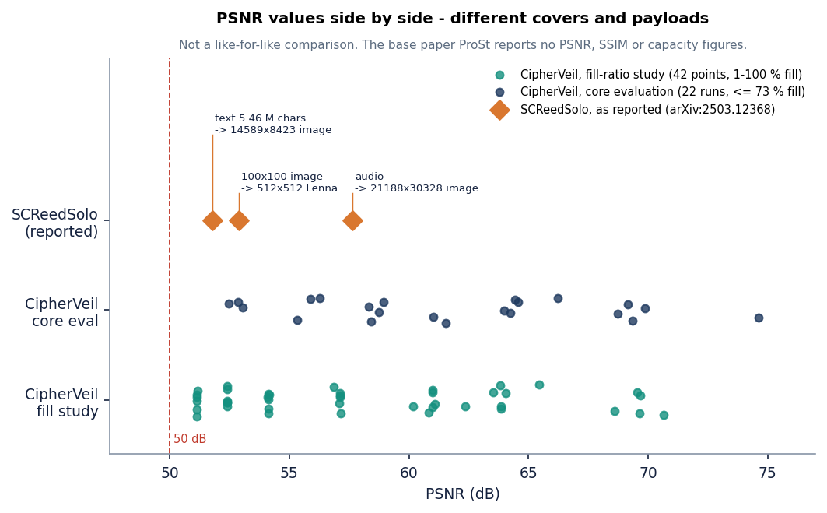
Figure 51: PSNR range reported for SCReedSolo and measured for CipherVeil. Covers and payloads differ, so the bars indicate order of magnitude only.
What CipherVeil adopts from the base paper is the LSB carrier and the idea of exchanging a secret between sender and receiver by standard cryptography. What it does not implement is homomorphic computation on hidden bits, decoy-bit location hiding and a provable-security argument; Chapter 10 lists how a key-dependent pixel selection could move towards the base paper's location secrecy.

8.10 Sample inputs and outputs
Table 45: The five messages of the demonstration session
Op | Input file (bytes) | Cover | PSNR (dB) | Result
5 | confidential_memo.pdf (21,517) | astronaut_512x512 | 57.642 | bundle 22,063 B, 22.445 % of the cover; received byte for byte (op 10)
6 | confidential_memo.pdf (21,517) | coffee_small_200x200 | - | blocked: needs 22,063 B, cover holds 14,996 B
7 | accounts.csv (2,774) | coffee_600x400 | 65.513 | bundle 3,310 B, 3.678 % of the cover; stego PNG produced
8 | settings.json (99) | generated_landscape_1280x720 | 78.419 | bundle 634 B, 0.183 % of the cover; stego PNG produced
9 | meeting_notes.txt (169) | rocket_640x427 | 72.707 | bundle 709 B, 0.692 % of the cover; SSIM 0.999986

The input is any file up to 25 MB and the output is a PNG. The same hash is shown at both ends: for the memo the SHA-256 begins 89acd543 before sending and after receiving. A second output of the receive step, the failed one, is shown below. The smaller the payload relative to the cover, the higher the PSNR, as the closed-form model predicts: 99 bytes in the landscape gives 78.419 dB, 21,517 bytes in the astronaut image gives 57.642 dB.

8.11 Success and failure analysis
Where the system succeeds. Every file that fits is restored byte for byte (22 of 22 in the core evaluation, plus the 240 tamper trials and 50 repeated encryptions that all decrypted correctly). The stego image is visually identical to the cover (largest change 1 of 255, PSNR above 51.14 dB at every fill level). Any modification of the bundle is detected before anything is released. A wrong key, an image without a payload and a file that is not an image are each refused with a specific message.
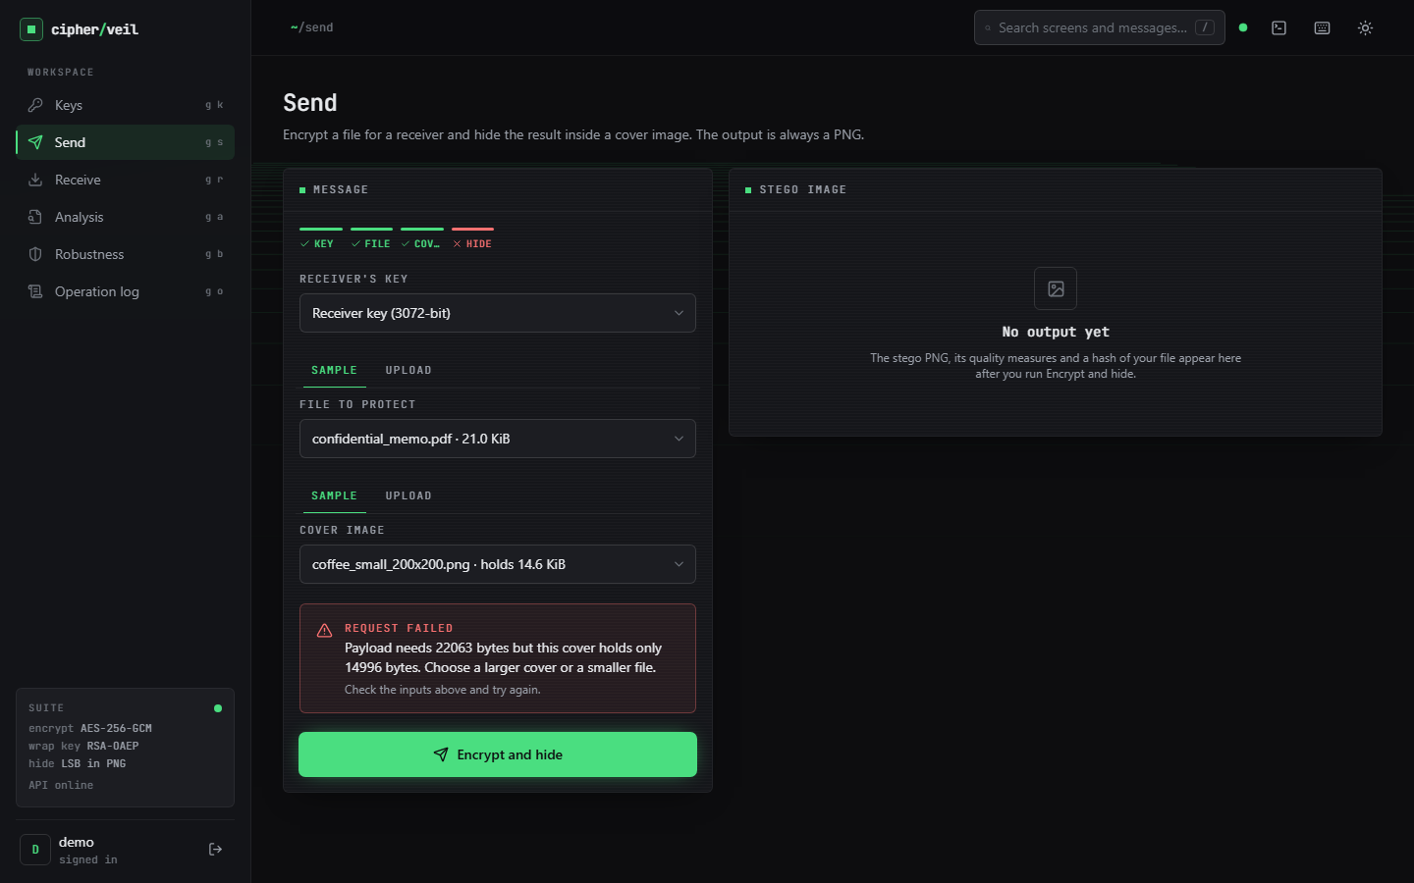  Figure 52: Failure case: a 22,063-byte bundle does not fit the 14,996-byte 200 x 200 cover; the send is refused with the exact numbers. | 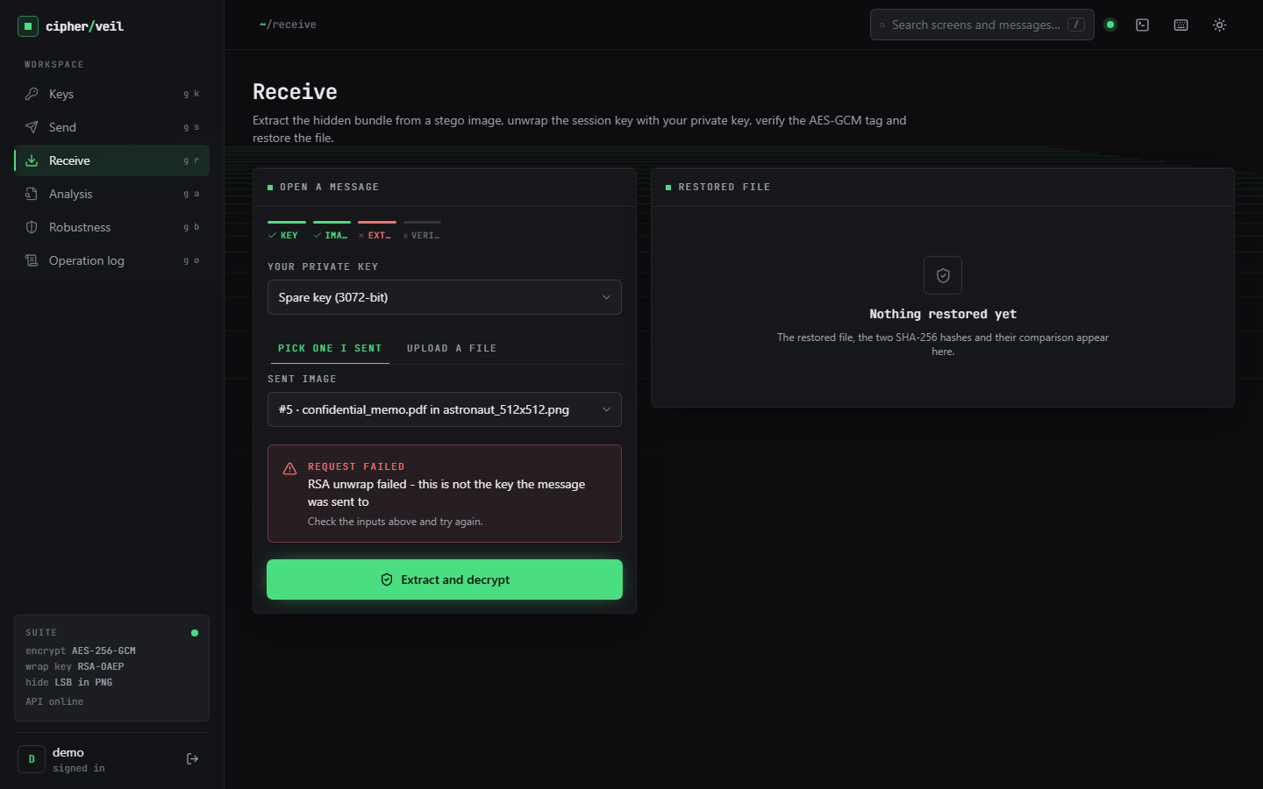  Figure 53: Failure case: receiving with the Spare keypair; the RSA unwrap fails and no data is released.

Where it fails, by design. The two screens above show refusals that protect the user. The failures that cost data are different: JPEG, noise, resizing, rotation, grayscale and palette conversion destroy the payload (Section 8.7), and the receiver is told only that no payload was found, because after such an attack the length header is garbage. The image cannot be repaired, only resent. A chat application or a social site that recompresses the picture will make a sent message unreadable.
Where it is weaker than it looks. The imperceptibility numbers are excellent, but the chi-square test flags the images and the weighted-stego estimate recovers the fill (Section 8.8). A user who reads PSNR above 50 dB as safe from detection draws the wrong conclusion. Low fill is the best defence: a 169-byte note in a 640 x 427 image changes 0.35 % of the values.

8.12 Limitations of these results
• Six covers, all committed test images or a procedural landscape; no camera photographs, no images that were already JPEG-compressed before conversion, and no large corpus.
• Four small synthetic payloads and random payloads; no real confidential documents were used.
• One machine and one operating condition; timings vary by 10-30 % with load. Only the embedding, PSNR and SSIM numbers are load-independent.
• Steganalysis used only two classical detectors, and the chi-square test was applied with the payload length known. Sample-pair, RS and deep-learning detectors were not run, so the detectability reported is a lower bound.
• Robustness was measured with a single payload (accounts.csv) and a single noise seed; the bottom-crop result holds only while the bundle lies in the retained rows.
• The comparison with the base paper is qualitative; its provable-security claim was not reproduced and was not in scope.
• The web interface was driven by a script to capture screens, not tested with an assertion-based browser suite, and no usability study with real users was done.

8.13 Objectives against outcomes
Table 46: The six objectives of the project and what was measured
# | Objective (from the objectives document) | Outcome
1 | AES for the payload and RSA for the AES key | Met: AES-256-GCM with RSA-OAEP-SHA256; 22 of 22 round trips and 240 of 240 tampered images rejected
2 | Key generation and exchange between sender and receiver | Met for RSA 2048, 3072 and 4096 keypairs with PEM import and export and fingerprints; no key-agreement protocol, certificate or identity check
3 | Embed the encrypted payload by LSB | Met: 1 bit per colour value, 3.0 bits per pixel, capacity check before embedding
4 | Extraction and decryption path | Met: byte-exact restoration with tag and SHA-256 verification
5 | PSNR and SSIM against the cover | Met: PSNR 52.479-74.615 dB up to 73 % fill and 51.14 dB at full fill; SSIM 0.9929-0.99999
6 | Capacity, time and robustness | Measured: 14.6-337.5 KiB capacity, sub-millisecond embedding, 86 ms unwrap; robust to lossless handling only; detectable by statistics

All six objectives are met in the sense that each was implemented and measured, but objective 6 was answered with a limit rather than a strength: the combined scheme is fast and has high capacity, and it is fragile and statistically visible. The project is supported by 39 passing unit and API tests (13 cryptography, 9 embedding, 7 metrics and pipeline, 10 API) and 21 smoke checks against the running backend.

CHAPTER 9: CONCLUSION

9.1 Summary of the work
CipherVeil was built to show a two-layer protection for a confidential file: encryption that survives discovery of the payload, and hiding that does not announce that a secret is moving. A file is encrypted with a fresh AES-256-GCM key, the key is wrapped with the receiver's RSA public key, and the resulting bundle is written into the least significant bits of a PNG. The receiver extracts the bundle, unwraps the key, verifies the tag and the file hash, and obtains the original file. The work is grounded in the base paper [1], whose LSB carrier and key-exchange framing it adopts, and not its homomorphic computation.
The system was evaluated and not only demonstrated. Over 22 runs on six covers the file was restored byte for byte every time, PSNR was at least 52.479 dB (mean 61.731 dB), SSIM at least 0.995806, and capacity was 3.0 bits per pixel. A closed-form model reproduced measured PSNR within 0.053 dB, and the same measurement at full capacity gave 51.14-51.17 dB.

9.2 Objectives achieved
Table 47: The six objectives and their status
Objective | Status | Headline evidence
AES for the payload, RSA for the AES key | Achieved | AES-256-GCM + RSA-OAEP-SHA256; 240 of 240 tamper trials rejected
Key generation and exchange | Achieved for the keypair workflow | 2048, 3072, 4096-bit keys, PEM import and export; no identity check
Embed by LSB | Achieved | 1 bit per colour value, 3.0 bits per pixel, capacity check
Extraction and decryption | Achieved | 22 of 22 byte-exact restorations
PSNR and SSIM | Achieved | PSNR 52.479-74.615 dB up to 73 % fill, 51.14 dB at 100 %; SSIM at least 0.9929
Capacity, time and robustness | Measured | 86 ms median unwrap; lossless handling only survives; detectable at medium and high fill

9.3 Key findings
1. Encryption costs nothing in image quality. Plain and encrypted payloads flip about 50 % of the embedded bits either way, so PSNR depends only on how many bits are embedded; encryption makes the stream balanced and unreadable.
2. Imperceptibility is predictable. PSNR follows 10 log10(255^2 / (0.5 n / N)) within 0.053 dB, and never falls below 51.1 dB even at full capacity.
3. The scheme is robust to lossless handling only. Of 18 attacks, 5 were survived; JPEG at quality 100 already loses the payload, and the error rate of 49-50 % leaves nothing for a correcting code to repair.
4. Hidden is not undetectable. The chi-square test flagged all 30 embedded prefixes and the weighted-stego estimate followed the fill, because embedding is sequential and key-independent.
5. The cryptographic layer is cheap and strict. AES-GCM takes 0.15 ms; the RSA unwrap (94 ms at 3072 bits) dominates; any single-bit change is rejected before data is released.

9.4 Practical applications
• Sending a small confidential file (a few kilobytes to a few hundred kilobytes) as an ordinary-looking PNG over a channel that does not recompress images.
• A teaching tool that shows PSNR, SSIM, histograms and bit planes for real data, and what lossy processing does to a hidden payload.

9.5 Known limitations
The payload is lost to any lossy change and the images can be flagged statistically; the private keys are unencrypted at rest; there is no sender authentication; the evaluation uses six covers and four small synthetic payloads on one machine. These are listed with their evidence in Chapters 8 and 10.

9.6 Lessons learned
• A closed-form model is worth deriving: it turned PSNR from a result into a check.
• Perceptual quality is the wrong proxy for security; the chi-square test found the data in images with PSNR above 57 dB.
• Measure the whole request: the cryptography took 0.15 ms and a send took 438 ms because of PNG encoding and SSIM.

9.7 Concluding remarks
CipherVeil delivers a working, tested, double-layer protection tool whose strengths and weaknesses are both measured. The honest reading is a sound hybrid encryption layer with a simple hiding layer on top: the content is protected by standard cryptography, the concealment is good to the eye and weak to statistics, and the image must stay a PNG.

CHAPTER 10: FUTURE SCOPE

10.1 Improvements to the existing system
1. Key-dependent pixel selection. Derive a pseudo-random permutation of the embedding positions from a shared secret (or from the session key) so that the payload is no longer in raster order; this moves towards the location secrecy of the base paper and defeats the oracle chi-square test on the prefix.
2. LSB matching and adaptive embedding. Replace LSB replacement by +/-1 matching [12] and by cost-based embedding with syndrome-trellis codes [13], which change fewer values and avoid the pair-equalisation signature of replacement.
3. Error correction. Add Reed-Solomon coding, as in SCReedSolo [3], so that mild bit corruption can be repaired; JPEG itself would still need transform-domain embedding.
4. Sender signatures. Sign the bundle with Ed25519 or RSA-PSS so that the receiver learns who sent it and a message cannot be forged by anyone who holds the public key.
5. An encrypted key store. Protect private keys at rest with a passphrase-derived key (scrypt or Argon2) or an operating-system store, and add rate limiting and a generated JWT_SECRET.

10.2 Additional features
• Compression before encryption to increase the effective capacity, and a choice of fill levels with a warning when the estimated detectability is high.
• Post-quantum key transport: a KEM such as ML-KEM next to or instead of RSA-OAEP.
• More carriers: audio (WAV) and video frames, and JPEG-domain embedding for channels that recompress.
• Multiple recipients: wrap the same session key for several public keys in one bundle.
• Fix the empty-key crash on the Send page and add an assertion-based browser test suite.

10.3 Scalability and deployment
• Move the quality measures (SSIM, PNG encoding) off the request path, since they cost about 300 ms of each send and cryptography costs 0.15 ms.
• Replace SQLite by a server database with row-level ownership, store the stego images in object storage and add a job queue for large covers.
• Package the backend and the console as containers and serve both behind TLS; the demonstration runs as two local processes.

10.4 Further research
• Evaluate against stronger steganalysis (sample-pair, RS, rich-model and deep detectors) at several fill levels, and report detection error against fill as the base paper's security view would require.
• Bring the base paper's secret-position idea into the pipeline: hide the payload bits among decoys with a keyed location generator and measure the capacity cost of the added security.
• Run a formal usability study with real senders and receivers, including how they move PNG files through ordinary channels.
• Measure on a larger corpus of camera photographs, including previously compressed images.

REFERENCES
[1] S. Ahmad and S. Rass, "ProSt: Provably secure homomorphic steganography," IEEE Access, vol. 14, pp. 14393-14409, 2026, doi: 10.1109/ACCESS.2026.3656995.
[2] S. E. Fatemieh, R. Shahdi Alizadeh, and E. Zarezadeh, "Design of memristive lightweight encryption for in-memory image steganography," arXiv:2605.03494, May 2026.
[3] S. R. Raiyan and M. H. Kabir, "SCReedSolo: A secure and robust LSB image steganography framework with randomized symmetric encryption and Reed-Solomon coding," arXiv:2503.12368, 2025 (ACPR 2025).
[4] B. Kukreja and S. Malik, "An steganography-based triple layered image data hiding using visual cryptography," 2024 (authors as listed on the Authorea preprint page; venue and year of formal publication not confirmed).
[5] "Steganography - data hiding using image object," Gurukul International Multidisciplinary Research Journal, 2024.
[6] "Hybrid steganography: Leveraging chaotic encryption and CNN for robust image hiding," in Proc. 7th Int. Conf. Mechatronics, Robotics and Automation (ICMRA), 2024.
[7] "Enhanced image steganography with AES encryption and hybrid DWT-DCT transform for secure data hiding," International Journal of Advanced Research, 2025.
[8] J. Fridrich, Steganography in Digital Media: Principles, Algorithms, and Applications. Cambridge, U.K.: Cambridge Univ. Press, 2009.
[9] I. J. Cox, M. L. Miller, J. A. Bloom, J. Fridrich, and T. Kalker, Digital Watermarking and Steganography, 2nd ed. Burlington, MA, USA: Morgan Kaufmann, 2008.
[10] N. Provos and P. Honeyman, "Hide and seek: An introduction to steganography," IEEE Security & Privacy, vol. 1, no. 3, pp. 32-44, May/Jun. 2003.
[11] C.-K. Chan and L. M. Cheng, "Hiding data in images by simple LSB substitution," Pattern Recognition, vol. 37, no. 3, pp. 469-474, Mar. 2004.
[12] J. Mielikainen, "LSB matching revisited," IEEE Signal Processing Letters, vol. 13, no. 5, pp. 285-287, May 2006.
[13] T. Filler, J. Judas, and J. Fridrich, "Minimizing additive distortion in steganography using syndrome-trellis codes," IEEE Trans. Information Forensics and Security, vol. 6, no. 3, pp. 920-935, Sep. 2011.
[14] C. Cachin, "An information-theoretic model for steganography," in Information Hiding (IH 1998), Lecture Notes in Computer Science, vol. 1525. Berlin, Germany: Springer, 1998, pp. 306-318.
[15] A. Westfeld and A. Pfitzmann, "Attacks on steganographic systems," in Information Hiding (IH 1999), Lecture Notes in Computer Science, vol. 1768. Berlin, Germany: Springer, 2000, pp. 61-76.
[16] J. Fridrich, M. Goljan, and R. Du, "Detecting LSB steganography in color and gray-scale images," IEEE MultiMedia, vol. 8, no. 4, pp. 22-28, Oct.-Dec. 2001.
[17] S. Dumitrescu, X. Wu, and Z. Wang, "Detection of LSB steganography via sample pair analysis," IEEE Trans. Signal Processing, vol. 51, no. 7, pp. 1995-2007, Jul. 2003.
[18] J. Fridrich and M. Goljan, "On estimation of secret message length in LSB steganography in spatial domain," in Proc. SPIE, vol. 5306, Security, Steganography, and Watermarking of Multimedia Contents VI, 2004, pp. 23-34.
[19] A. D. Ker and R. Bohme, "Revisiting weighted stego-image steganalysis," in Proc. SPIE, vol. 6819, Security, Forensics, Steganography, and Watermarking of Multimedia Contents X, 2008, Art. no. 681905.
[20] Advanced Encryption Standard (AES), Federal Information Processing Standards Publication 197, NIST, Nov. 2001.
[21] M. Dworkin, "Recommendation for block cipher modes of operation: Galois/Counter Mode (GCM) and GMAC," NIST Special Publication 800-38D, Nov. 2007.
[22] R. L. Rivest, A. Shamir, and L. Adleman, "A method for obtaining digital signatures and public-key cryptosystems," Communications of the ACM, vol. 21, no. 2, pp. 120-126, Feb. 1978.
[23] K. Moriarty, B. Kaliski, J. Jonsson, and A. Rusch, "PKCS #1: RSA cryptography specifications version 2.2," IETF RFC 8017, Nov. 2016.
[24] M. Bellare and P. Rogaway, "Optimal asymmetric encryption," in Advances in Cryptology - EUROCRYPT '94, Lecture Notes in Computer Science, vol. 950. Berlin, Germany: Springer, 1995, pp. 92-111.
[25] J. Katz and Y. Lindell, Introduction to Modern Cryptography, 2nd ed. Boca Raton, FL, USA: Chapman & Hall/CRC, 2014.
[26] Z. Wang, A. C. Bovik, H. R. Sheikh, and E. P. Simoncelli, "Image quality assessment: From error visibility to structural similarity," IEEE Trans. Image Processing, vol. 13, no. 4, pp. 600-612, Apr. 2004.
[27] Q. Huynh-Thu and M. Ghanbari, "Scope of validity of PSNR in image/video quality assessment," Electronics Letters, vol. 44, no. 13, pp. 800-801, Jun. 2008.
[28] C. Gentry, "Fully homomorphic encryption using ideal lattices," in Proc. 41st ACM Symp. Theory of Computing (STOC), 2009, pp. 169-178.
[29] V. Costan and S. Devadas, "Intel SGX explained," IACR Cryptology ePrint Archive, Report 2016/086, 2016.

APPENDIX A: IMPORTANT CODE
The key functions are copied from 8.ProjectCode in the state in which the results were measured (whole statements; the full files are in the repository). Chapter 6 explains the design; Chapter 5 gives the database and API.

A.1 Hybrid encryption: building and opening the bundle (`crypto.py`)
def encrypt_bundle(public_pem: str, filename: str, data: bytes) -> tuple[bytes, dict]:
"""Return (bundle, info). A fresh AES session key and nonce are used for every call."""
pub = load_public(public_pem)
header = json.dumps({"name": os.path.basename(filename) or "payload.bin", "size": len(data),
"sha256": sha256_hex(data)}).encode()
plaintext = struct.pack(">H", len(header)) + header + data

session_key = AESGCM.generate_key(bit_length=256)
nonce = os.urandom(NONCE_LEN)
ciphertext = AESGCM(session_key).encrypt(nonce, plaintext, MAGIC)
wrapped = pub.encrypt(session_key, _OAEP)

bundle = MAGIC + struct.pack(">H", len(wrapped)) + wrapped + nonce + ciphertext
return bundle, {"input_sha256": sha256_hex(data), "wrapped_key_bytes": len(wrapped),
"bundle_bytes": len(bundle), "overhead_bytes": len(bundle) - len(data)}

def decrypt_bundle(private_pem: str, bundle: bytes) -> tuple[str, bytes, dict]:
"""Return (filename, data, info). Raises CryptoError when the key or the tag is wrong."""
if len(bundle) < 6 + NONCE_LEN + 16 or bundle[:4] != MAGIC:
raise CryptoError("No CipherVeil bundle found in this image")
priv = load_private(private_pem)
(wlen,) = struct.unpack(">H", bundle[4:6])
if wlen != priv.key_size // 8:
raise CryptoError("This bundle was wrapped for a different key size - wrong private key")
wrapped = bundle[6:6 + wlen]
nonce = bundle[6 + wlen:6 + wlen + NONCE_LEN]
ciphertext = bundle[6 + wlen + NONCE_LEN:]
try:
session_key = priv.decrypt(wrapped, _OAEP)
except Exception as exc:
raise CryptoError("RSA unwrap failed - this is not the key the message was sent to") from exc
try:
plaintext = AESGCM(session_key).decrypt(nonce, ciphertext, MAGIC)
except InvalidTag as exc:
raise CryptoError("AES-GCM tag check failed - the data was modified") from exc

(hlen,) = struct.unpack(">H", plaintext[:2])
header = json.loads(plaintext[2:2 + hlen])
data = plaintext[2 + hlen:]
return header["name"], data, {"embedded_sha256": header["sha256"], "output_sha256": sha256_hex(data),
"match": header["sha256"] == sha256_hex(data), "size": len(data)}

A.2 LSB embedding and extraction (`lsb.py`)
def to_png_bytes(arr: np.ndarray) -> bytes:
buf = io.BytesIO()
Image.fromarray(arr, "RGB").save(buf, format="PNG", compress_level=6)
return buf.getvalue()

def capacity_bytes(arr: np.ndarray) -> int:
"""Largest bundle (bytes) that fits in this image."""
return max(0, (arr.size - LEN_BITS) // 8)

def embed(arr: np.ndarray, bundle: bytes) -> np.ndarray:
cap = capacity_bytes(arr)
if len(bundle) > cap:
raise StegoError(f"Payload needs {len(bundle)} bytes but this cover holds only {cap} bytes. "
"Choose a larger cover or a smaller file.")
framed = len(bundle).to_bytes(4, "big") + bundle
bits = np.unpackbits(np.frombuffer(framed, dtype=np.uint8))
flat = arr.reshape(-1).copy()
flat[:bits.size] = (flat[:bits.size] & 0xFE) | bits
return flat.reshape(arr.shape)

def extract(arr: np.ndarray) -> bytes:
flat = arr.reshape(-1)
if flat.size < LEN_BITS:
raise StegoError("Image is too small to contain a payload")
length = int.from_bytes(np.packbits(flat[:LEN_BITS] & 1).tobytes(), "big")
if length == 0 or length > capacity_bytes(arr):
raise StegoError("No hidden payload found (length header is invalid)")
bits = flat[LEN_BITS:LEN_BITS + length * 8] & 1
return np.packbits(bits).tobytes()

A.3 Send and receive pipeline (`pipeline.py`)
def hide(public_pem: str, filename: str, data: bytes, cover: np.ndarray) -> dict:
t = time.perf_counter()
bundle, enc_info = crypto.encrypt_bundle(public_pem, filename, data)
encrypt_ms = _ms(t)

cap = lsb.capacity_bytes(cover)
t = time.perf_counter()
stego = lsb.embed(cover, bundle) # raises StegoError when it does not fit
embed_ms = _ms(t)

t = time.perf_counter()
png = lsb.to_png_bytes(stego)
encode_ms = _ms(t)

t = time.perf_counter()
quality = metrics.imperceptibility(cover, stego)
metrics_ms = _ms(t)

...
def reveal(private_pem: str, stego: np.ndarray) -> dict:
t = time.perf_counter()
bundle = lsb.extract(stego)
extract_ms = _ms(t)
t = time.perf_counter()
name, data, info = crypto.decrypt_bundle(private_pem, bundle)
decrypt_ms = _ms(t)
return {"filename": name, "data": data, "info": info, "bundle_len": len(bundle),
"timings_ms": {"extract": extract_ms, "decrypt": decrypt_ms}}

A.4 Imperceptibility measures (`metrics.py`)
def imperceptibility(cover: np.ndarray, stego: np.ndarray) -> dict:
changed = int(np.count_nonzero(cover != stego))
if changed == 0:
psnr = float("inf")
else:
psnr = float(peak_signal_noise_ratio(cover, stego, data_range=255))
ssim = float(structural_similarity(cover, stego, channel_axis=2, data_range=255))
mse = float(np.mean((cover.astype(np.float64) - stego.astype(np.float64)) ** 2))
return {
"psnr_db": None if psnr == float("inf") else round(psnr, 3),
"ssim": round(ssim, 6),
"mse": round(mse, 6),
"max_abs_change": int(np.max(np.abs(cover.astype(np.int16) - stego.astype(np.int16)))),
"values_changed": changed,
"values_total": int(cover.size),
"changed_pct": round(100 * changed / cover.size, 4),
}

A.5 Robustness attack runner (`robustness.py`)
def run_attacks(stego: np.ndarray, private_pem: str, original_sha256: str, bundle_len: int) -> list[dict]:
n_bits = (bundle_len + 4) * 8
ref_bits = lsb.lsb_stream(stego, n_bits)
results = []
for key, label, fn in ATTACKS:
attacked = fn(stego)
t = time.perf_counter()
ber = None
flat_bits = lsb.lsb_stream(attacked, n_bits)
m = min(flat_bits.size, ref_bits.size)
if m:
ber = round(float(np.mean(flat_bits[:m] != ref_bits[:m])), 4)
status, detail = "lost", ""
try:
bundle = lsb.extract(attacked)
name, data, info = crypto.decrypt_bundle(private_pem, bundle)
if info["output_sha256"] == original_sha256:
status, detail = "recovered", "Byte-for-byte identical to the original file."
else:
detail = "Decrypted but hash differs."
except (lsb.StegoError, crypto.CryptoError) as exc:
detail = str(exc)
except Exception as exc: # corrupted header can raise anything while parsing
detail = f"Payload could not be parsed ({type(exc).__name__})"
results.append({
"attack": key, "label": label, "status": status, "detail": detail,
"bit_error_rate": ber, "why": EXPLAIN[key],
"elapsed_ms": round((time.perf_counter() - t) * 1000, 2),
"size": f"{attacked.shape[1]}x{attacked.shape[0]}",
})
return results

A.6 Database models (`db.py`)
class User(Base):
__tablename__ = "users"
id: Mapped[int] = mapped_column(Integer, primary_key=True)
username: Mapped[str] = mapped_column(String(40), unique=True, index=True)
pw_hash: Mapped[str] = mapped_column(String(100))
created_at: Mapped[datetime] = mapped_column(DateTime(timezone=True), default=now)

class KeyPair(Base):
__tablename__ = "keypairs"
id: Mapped[int] = mapped_column(Integer, primary_key=True)
user_id: Mapped[int] = mapped_column(ForeignKey("users.id"), index=True)
name: Mapped[str] = mapped_column(String(60))
bits: Mapped[int] = mapped_column(Integer)
fingerprint: Mapped[str] = mapped_column(String(40))
public_pem: Mapped[str] = mapped_column(Text)
private_pem: Mapped[str | None] = mapped_column(Text, nullable=True) # None = recipient public key only
created_at: Mapped[datetime] = mapped_column(DateTime(timezone=True), default=now)

class OpLog(Base):
__tablename__ = "oplog"
id: Mapped[int] = mapped_column(Integer, primary_key=True)
user_id: Mapped[int] = mapped_column(ForeignKey("users.id"), index=True)
op: Mapped[str] = mapped_column(String(30))
ok: Mapped[bool] = mapped_column(Boolean, default=True)
details: Mapped[str] = mapped_column(Text, default="{}")
created_at: Mapped[datetime] = mapped_column(DateTime(timezone=True), default=now)

def data(self) -> dict:
return json.loads(self.details)

APPENDIX B: INSTALLATION AND USER GUIDE

B.1 Requirements
Table 48: Requirements to run CipherVeil
Item | Requirement
Operating system | Windows 10 or 11 (the launchers setup.bat and run.bat are for Windows; the commands in B.3 work elsewhere)
Python | 3.11 or newer (tested with 3.11.9) with Add to PATH ticked
Node.js | LTS release for the React console (tested with 24.19)
Memory and disk | A few hundred MB for the Python packages and node_modules; any laptop is sufficient
Network | Needed only for the first install of packages; the application runs offline afterwards
GPU, API keys, datasets | None needed: there is no model and no external service

B.2 One-click start
1. Open the folder 8.ProjectCode and run `setup.bat` once. It copies .env.example to .env if needed, creates venv, installs backend\requirements.txt, regenerates the sample covers if data\covers is missing and runs npm install in frontend.
2. Open .env and replace JWT_SECRET with a random string of at least 16 characters (the backend refuses to start with a shorter one).
3. Run `run.bat`. Two windows open (backend on port 8315, frontend on port 5315) and the browser opens http://localhost:5315.
4. Sign in with the demo account demo / Demo@12345 (created automatically on the first start), or choose Create account.
5. To stop, close the two windows.

B.3 Starting by hand and running the checks
python -m venv venv
venv\Scripts\python -m pip install -r backend\requirements.txt
cd backend && ..\venv\Scripts\python -m uvicorn app.main:app --host 127.0.0.1 --port 8315 # API

cd frontend && npm install && npm run dev # console

venv\Scripts\python scripts\smoke_test.py # 21 end-to-end checks against the running API
venv\Scripts\python -m pytest -q # 39 unit and API tests (scratch database)
venv\Scripts\python ml\eval.py # experiments/eval/metrics.json and summary.md
venv\Scripts\python scripts\run_experiments.py # experiments/extra/metrics.json (about 1.5 minutes)
venv\Scripts\python scripts\measure_api.py # API latency (API running)
cd frontend && npm run build # production build of the console

B.4 Settings (`.env`)
Table 49: Settings that matter
Name | Meaning | Default
BACKEND_PORT | Port of the FastAPI server | 8315
FRONTEND_PORT | Port of the Vite development server | 5315
DATABASE_URL | SQLAlchemy URL of the SQLite file | sqlite:///./data/app.db
JWT_SECRET | Key that signs the sign-in tokens; at least 16 characters | placeholder, must be replaced

B.5 Using the application
1. Keys. Generate a keypair (RSA 2048, 3072 recommended, or 4096). Download the public key and give it to anyone who should send you something. To send to someone else, import their public key as a public only entry.
2. Send. Choose the receiver's key, a file (a sample or an upload) and a cover image. The capacity bar shows an estimate. Press Encrypt and hide, then Download PNG. Send the PNG as a file; do not paste it into an application that recompresses pictures.
3. Analysis. Open the message to see PSNR (above 50 dB is invisible), SSIM, MSE, the share of values changed, histograms and bit planes.
4. Receive. Choose your own keypair and the stego image (one you sent, or an upload). The restored file and two matching SHA-256 values appear; download the file.
5. Robustness. Select a sent message and run the tests. The page lists which attacks leave the payload intact and which destroy it. The benchmark measures quality and speed on every sample cover.
6. Operation log. Review every operation with sizes, timings and metrics. Keys, passwords and file contents are never recorded.

B.6 Troubleshooting
Table 50: Common problems
Symptom | Cause and fix
Port already in use | Another program holds 8315 or 5315; close it or change the ports in .env
Blank page or 502 from the console | The backend window did not start; read its output (often a short JWT_SECRET)
"This cover holds only N bytes" | Choose a larger cover image or a smaller file
Recipient cannot open the image | The image was re-encoded by a messaging app or e-mail client; send it as a file or inside an archive
"RSA unwrap failed" | The selected key is not the one the message was sent to; choose the receiver's keypair
Send page shows an error for a new account | The account has no keys yet: open Keys, generate a keypair, then return to Send

APPENDIX C: ADDITIONAL SCREENS
Chapter 8 shows the working screens from Keys to the Operation log. The captures below complete the set: the public landing page and the sign-in page. All 18 captures were taken at 1440 x 900 from the running application with real data.
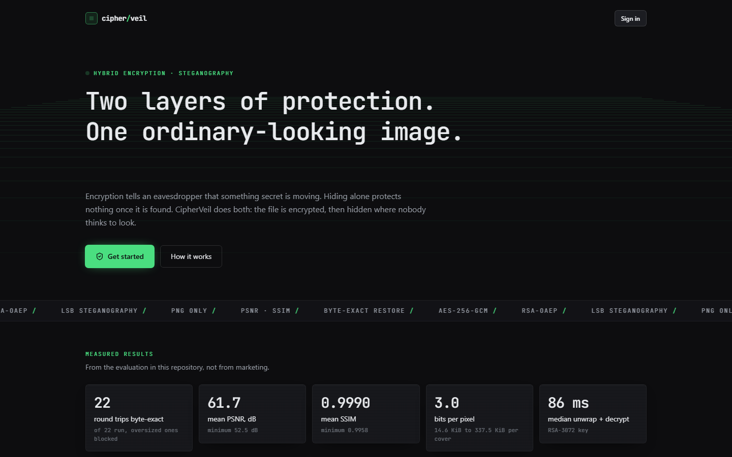  Figure 54: Additional screen: landing page, headline and the measured-results tiles. | 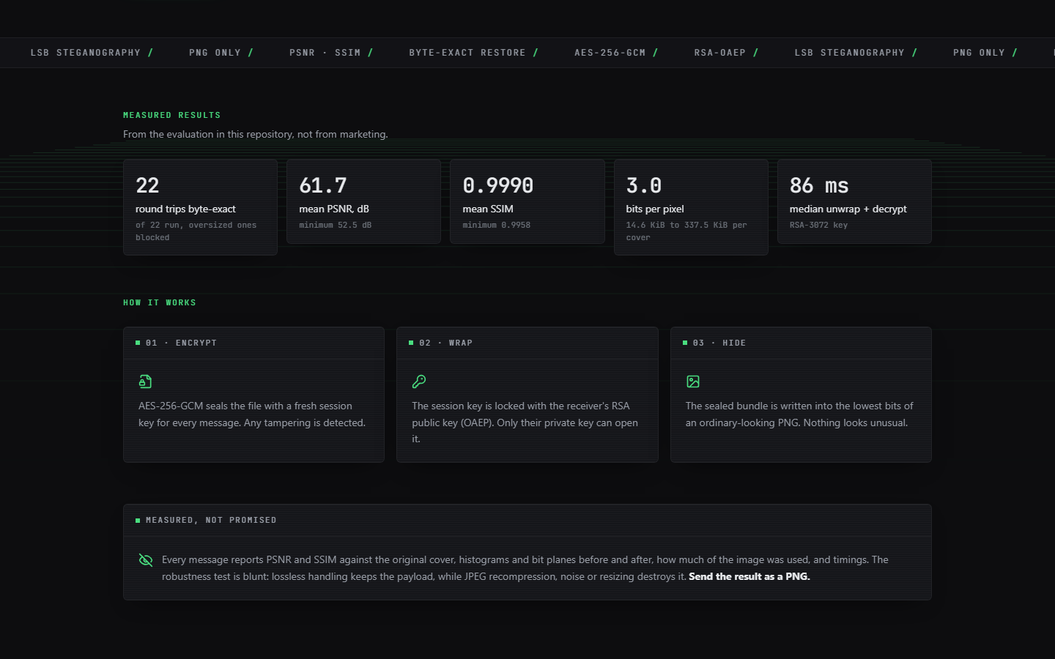  Figure 55: Additional screen: landing page, how it works and features.

The landing page is public. Its tiles repeat the headline results of the evaluation (22 round trips, mean PSNR 61.7 dB, mean SSIM 0.9990, 3.0 bits per pixel, 86 ms median unwrap and decrypt) and are labelled as measured in this repository.
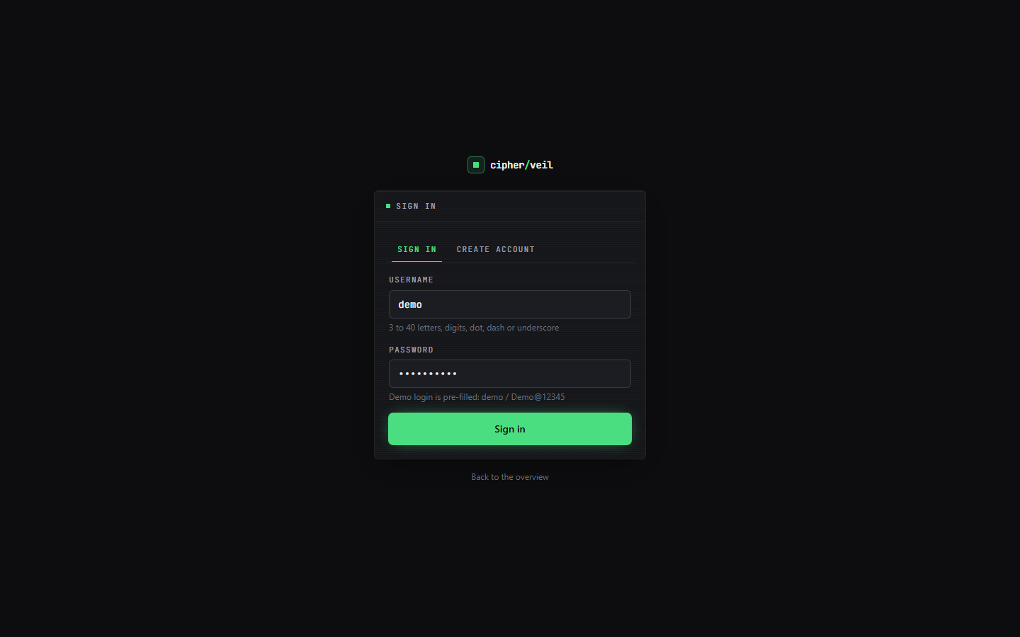
Figure 56: Additional screen: sign in and create account, with the demo credentials pre-filled.
The sign-in page offers the demo account and registration. The password is limited to 72 bytes because bcrypt ignores anything longer.
All 18 screens were captured in one session by scripts/capture_screens.py (1440 x 900, real data, fresh database); the files are in docs/screenshots/.

